Equality Screening Form

INTRODUCTION
The information contained in this Equality Screening Form has been extracted from the Equality Commission for Northern Ireland’s Guide for Public Authorities (2010). Additional information about the 5 parts of the form and a flowchart to demonstrate the process of completion is detailed in Appendix 1 of the form.
This template document and further guidance can be found by clicking the following link - www.equalityni.org/S75duties
PART 1- POLICY SCOPING

The first stage of the screening process involves scoping the policy under consideration. The purpose of policy scoping is to help prepare the background and context and set out the aims and objectives for the policy, being screened. At this stage, scoping the policy will help identify potential constraints as well as opportunities and will help the policy maker work through the screening process on a step by step basis.

Public authorities should remember that the Section 75 statutory duties apply to internal policies (relating to people who work for the authority), as well as external policies (relating to those who are, or could be, served by the authority).

Information about the policy
Name of Policy | Powered Transporter and e-bicycle policy
Is it existing, revised or a new policy? | Existing | ☐ | New | ☒ | Revised | ☐
If revised, please outline main updates:
What is it trying to achieve?  (Intended aims/outcomes) | This policy outlines the position of Translink regarding the use and carriage of powered transporters, e-bicycles, mobility scooters and powered wheelchairs at Translink to prevent fire hazards, injury, and damage to property. It applies to all staff, customers, and visitors on our premises and public transport services.
Are there any Section 75 categories which might be expected to benefit from the intended policy? If so, explain how. | This policy applies to:  - Buses, trains, and stations operated by Translink  - Company buildings, depots, and designated workspaces.  - Staff, customers, and visitors carrying or using lithium-ion battery-powered devices, including but not limited to e-scooters, e-bikes, mobile phones, laptops, and power banks.
Who initiated or wrote the policy? | Translink Group SHE department
Who owns and who implements the policy? | Translink Group SHE department

Implementation Factors
Yes | ☒ | No | ☐
Are there any factors which could contribute to/detract from the intended aim/outcome of the policy/decision?

If yes, are they: (Select all applicable)
☐ | Financial
☒ | Legislative
☐ | Other – please specify:

Main stakeholders affected
Who are the internal and external stakeholders (actual or potential) that the policy will impact upon?
☒ | Staff
☒ | Service Users
☒ | Other Public Sector Organisations
☐ | Voluntary/ Community/ Trade Unions
☐ | Other – please specify:

Other policies with a bearing on this policy (please list):
- SH&E Policy
- Accessible Travel Policy

Available Evidence
Evidence to help inform the screening process may take many forms. Public authorities should ensure that their screening decision is informed by relevant data. The following document should help you source data - Section 75 - Evidence Signposting Guide

What evidence/information (both qualitative and quantitative) have you gathered to inform this policy? Specify details for each of the Section 75 categories.
Section 75 category | Details of evidence/information
Religious belief | No evidence available to indicate correlation between this category and the policy.
Political opinion | No evidence available to indicate correlation between this category and the policy.
Racial group | No evidence available to indicate correlation between this category and the policy.
Age | A range of evidence has been considered during the policy development, including data from the Northern Ireland Census, which shows that mobility and dexterity difficulties increase with age.  We also drew on insights from the NICOLA Wave 1 Health Assessment Report, which highlights the link between age-related mobility limitations and chronic health conditions.  Additionally, we have taken into account the perspective of the Inclusive Mobility and Transport Advisory Committee (IMTAC), which recognises that some individuals with mobility impairments may prefer to use an e-bicycle rather than a traditional mobility scooter. This comprehensive evidence base has informed and supported our approach.
Marital status | No evidence available to indicate correlation between this category and the policy.
Sexual orientation | No evidence available to indicate correlation between this category and the policy.
Men and women generally | No evidence available to indicate correlation between this category and the policy.
Disability | In shaping our approach, we have taken into account a broad evidence base, including the views of the Inclusive Mobility and Transport Advisory Committee (IMTAC), which acknowledges that some individuals with mobility impairments may prefer to use an e-bicycle rather than a traditional mobility scooter.  We have also considered findings from Wheels for Wellbeing, whose research shows that 75% of disabled cyclists find cycling easier than walking, citing benefits such as reduced strain on joints, improved balance, and alleviation of breathing difficulties. These insights have been instrumental in informing a more inclusive and accessible approach in relation to e-bicycles, powered wheelchairs and mobility scooters.  During policy development comprehensive consultation has been carried out to inform our approach, including benchmarking against practices in regards carriage of powered transporters and e-bicycle on public transport internationally and also reviewing relevant legal frameworks, and engaging with key stakeholders. This process has ensured that our decision both evidence-based and aligned with current regulatory standards supporting a consistent and informed implementation.  Extensive research and benchmarking have been carried out across a range of cities and transport networks to inform this policy. The benchmarking indicates a widespread prohibition of e-scooters across both bus and rail services. For e-bicycles, there is a general trend towards prohibition on coach and bus services.  In developing this policy, we have also consulted with key stakeholder research including the Department for Transport, Rail Partners Group, and the National Transport Authority to ensure alignment with current guidance and best practice.  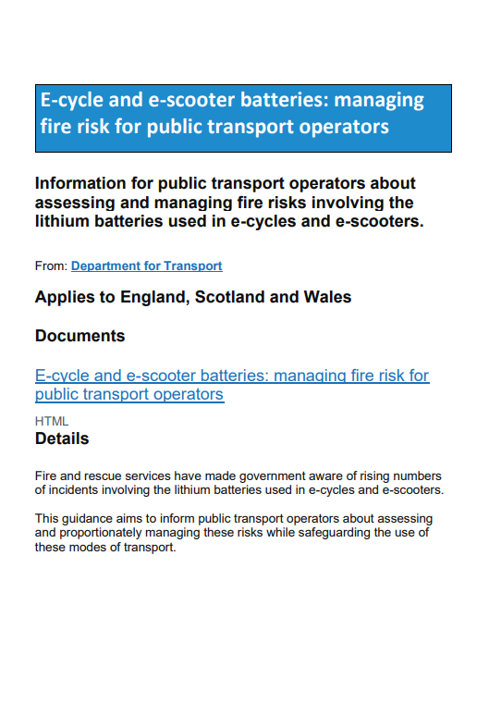  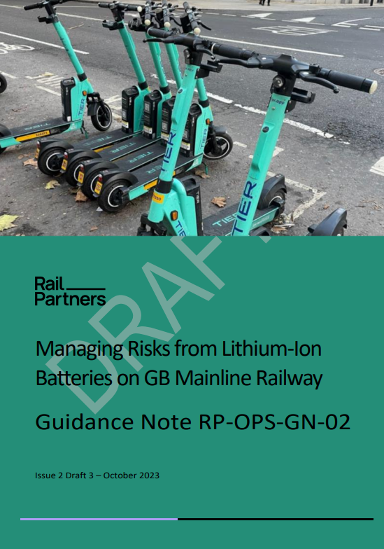  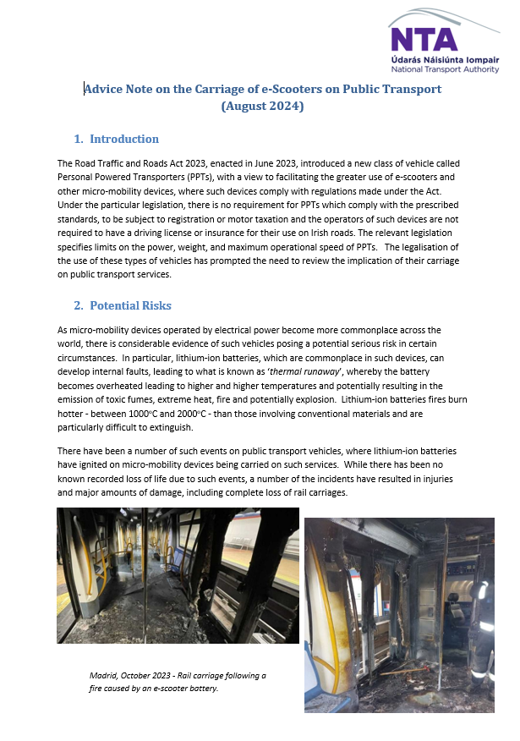
Dependants | No evidence available to indicate correlation between this category and the policy.

Needs, Experiences and Priorities
Taking into account the information referred to above, what are the different needs, experiences and priorities of each of the following categories, in relation to the particular policy/decision?
Specify details for each of the Section 75 categories
Section 75 category | Details of needs/experiences/priorities
Religious belief | There is no information to indicate that this category has any specific needs or priorities in relation to the policy.
Political opinion | There is no information to indicate that this category has any specific needs or priorities in relation to the policy.
Racial group | There is no information to indicate that this category has any specific needs or priorities in relation to the policy.
Age | Evidence shows that older individuals are more likely to experience mobility and dexterity challenges, and we recognise that preferences for mobility aids can vary. Some may find that an e-bicycle better meets their needs than a traditional mobility scooter.  We have taken this into account in shaping our policy, ensuring it reflects the diverse experiences, needs, and priorities of older people.  As part of this inclusive approach, we are allowing e-bicycles on our premises and rail services under the conditions of carriage.  At the same time, we remain committed to actively promoting the use of mobility scooters and powered wheelchairs, recognising their vital role in supporting independence and accessibility for many passengers.  To further support inclusive travel, accessible bike storage facilities are available and designed to accommodate reasonable adjustments, enabling safe and convenient use by all passengers.
Marital status | There is no information to indicate that this category has any specific needs or priorities in relation to the policy.
Sexual orientation | There is no information to indicate that this category has any specific needs or priorities in relation to the policy.
Men and women generally | There is no information to indicate that this category has any specific needs or priorities in relation to the policy.
Disability | We recognise that people with disabilities have a wide range of mobility needs and preferences. Evidence suggests that some individuals may find e-bicycles more suitable than traditional mobility scooters, and we have reflected these diverse experiences and priorities in our policy.  As part of this inclusive approach, we are making provisions to allow e-bicycles on our premises and rail services under the conditions of carriage. Due to limited storage space and safety considerations, e-bicycles will not be permitted on bus services.  We remain committed to promoting the use of mobility scooters and powered wheelchairs, which continue to play a vital role in supporting independence and accessibility for many of our passengers.  To further support inclusive travel, accessible bike storage facilities are available and designed to accommodate reasonable adjustments, enabling safe and convenient use by all passengers.
Dependants | There is no information to indicate that this category has any specific needs or priorities in relation to the policy.

PART 2 - SCREENING QUESTIONS

Introduction
In making a decision as to whether or not there is a need to carry out an equality impact assessment, the public authority should consider its answers to the questions 1-4 which are given on pages 66-68 of the Guide: Guide for Public Authorities April 2010

Taking into account the evidence presented above, consider and comment on the likely impact on equality of opportunity and good relations for those affected by this policy, in any way, for each of the equality and good relations categories, by applying the screening questions given overleaf and indicate the level of impact on the group i.e. minor, major or none.

Impact: Major / Minor / None
If the public authority’s conclusion is major in respect of one or more of the Section 75 equality of opportunity and/or good relations categories, then consideration should be given to subjecting the policy to the equality impact assessment procedure.

In favour of ‘MAJOR’ impact
A | The policy is significant in terms of its strategic importance;
B | Potential equality impacts are unknown, because, for example, there is insufficient data upon which to make an assessment or because they are complex, and it would be appropriate to conduct an equality impact assessment in order to better assess them;
C | Potential equality and/or good relations impacts are likely to be adverse or are likely to be experienced disproportionately by groups of people including those who are marginalised or disadvantaged;
D | Further assessment offers a valuable way to examine the evidence and develop recommendations in respect of a policy about which there are concerns amongst affected individuals and representative groups, for example in respect of multiple identities;
E | The policy is likely to be challenged by way of judicial review;
F | The policy is significant in terms of expenditure.

If the public authority’s conclusion is minor in respect of one or more of the Section 75 equality categories and/or good relations categories, then consideration should still be given to proceeding with an equality impact assessment, or to:

- Measures to mitigate the adverse impact; or
- The introduction of an alternative policy to better promote equality of opportunity and/or good relations.

In favour of ‘MINOR’ impact
A | The policy is not unlawfully discriminatory and any residual potential impacts on people are judged to be negligible;
B | The policy, or certain proposals within it, are potentially unlawfully discriminatory, but this possibility can readily and easily be eliminated by making appropriate changes to the policy or by adopting appropriate mitigating measures;
C | Any asymmetrical equality impacts caused by the policy are intentional because they are specifically designed to promote equality of opportunity for particular groups of disadvantaged people;
D | By amending the policy there are better opportunities to better promote equality of opportunity and/or good relations.

If the public authority’s conclusion is none in respect of all of the Section 75 equality of opportunity and/or good relations categories, then the public authority may decide to screen the policy out. If a policy is ‘screened out’ as having no relevance to equality of opportunity or good relations, a public authority should give details of the reasons for the decision taken.

In favour of ‘NONE’
A | The policy has no relevance to equality of opportunity or good relations.
B | The policy is purely technical in nature and will have no bearing in terms of its likely impact on equality of opportunity or good relations for people within the equality and good relations categories.

Screening Questions 1 - 4
Screening Question 1
What is the likely impact on equality of opportunity for those affected by this policy, for each of the Section 75 equality categories? Minor/ Major/ None
Section 75 category | Details of policy impact | Level of impact? Minor/Major/None
Religious belief | There is no identified impact for this category. | None
Political opinion | There is no identified impact for this category. | None
Racial group | There is no identified impact for this category. | None
Age | There is no identified impact for this category. | None
Marital status | There is no identified impact for this category. | None
Sexual orientation | There is no identified impact for this category. | None
Men and women generally | There is no identified impact for this category. | None
Disability | Further to consultation with IMTAC and Wheels for Wellbeing we have considered the research and developed the policy to allow and promote e-bicycles to be carried on trains and stored within designated bicycle parking areas. This promotes both accessible and sustainable travel supporting evidence from IMTAC suggesting that those with a disability may prefer to use an e-bicycle rather than a mobility scooter.  Whilst an e-bicycle is not permitted within bus/coach this is due to due to the confined storage arrangements and safety considerations, in line with our conditions of carriage.  Mobility scooters and powered wheelchairs are still widely supported and promoted for use on all public transport and premises as per the Accessible Travel policy. There has been no change in the Accessible Travel policy.  While powered transporters will be prohibited on board the bus and trains and within premises due to fire risk which is known across public transport authorities as an emerging and high risk, it should also be noted powered transporters are not legal to be used on roads and footpaths in Northern Ireland under the Road Traffic Order. While IMTAC supports inclusive transport, there is no evidence that it endorses powered transporters (e.g., e-scooters) as accessible mobility aids.  There is limited evidence of widespread use of powered transporters by disabled people in Northern Ireland, however we acknowledge that a small number of individuals may choose to use these devices to support their mobility. We have identified a potential minor impact on this group and have taken this into account in the development of our policy. Our approach remains focused on promoting and supporting established accessible transport options, including mobility scooters and powered wheelchairs, which are widely recognised and supported through schemes such as Shopmobility and the Disability Action Transport Scheme.  To further support inclusive travel, accessible bike storage facilities are available and designed to accommodate reasonable adjustments, enabling safe and convenient use by all passengers. | Minor
Dependants | There is no identified impact for this category. | None

Screening Question 2
Are there opportunities to better promote equality of opportunity for people within the Section 75 equalities categories?
Section 75 category | If Yes, provide details | If No, provide reasons
Religious belief |  | No, there is no further opportunity.
Political opinion |  | No, there is no further opportunity.
Racial group |  | No, there is no further opportunity.
Age |  | No, there is no further opportunity.
Marital status |  | No, there is no further opportunity.
Sexual orientation |  | No, there is no further opportunity.
Men and women generally |  | No, there is no further opportunity.
Disability |  | No, there is no further opportunity.
Dependants |  | No, there is no further opportunity.

Screening Question 3
To what extent is the policy likely to impact on good relations between people of different religious belief, political opinion or racial group? Minor/ Major/ None
Good relations category | Details of policy impact | Level of impact Minor/Major/None
Religious belief | There is no evidence to suggest an equality impact on this category. Therefore there is no opportunity to impact on good relations. | None
Political opinion | There is no evidence to suggest an equality impact on this category. Therefore there is no opportunity to impact on good relations. | None
Racial group | There is no evidence to suggest an equality impact on this category. Therefore there is no opportunity to impact on good relations. | None

Screening Question 4
Are there opportunities to better promote good relations between people of different religious belief, political opinion or racial group?
Good relations category | If Yes, provide details | If No, provide reasons
Religious belief |  | No, as this policy has no impact on this group.
Political opinion |  | No, as this policy has no impact on this group.
Racial group |  | No, as this policy has no impact on this group.

Additional Considerations

Multiple Identity
Generally speaking, people can fall into more than one Section 75 category. Taking this into consideration, are there any potential impacts of the policy/decision on people with multiple identities? (For example: disabled minority ethnic people; disabled women; young Protestant men; and young lesbians, gay and bisexual people).
Age and Disability has been identified

Provide details of data on the impact of the policy on people with multiple identities. Specify relevant Section 75 categories concerned.
Evidence is outlined above, and no additional needs or requirements have been found.

PART 3 - SCREENING DECISION

If the decision is not to conduct an equality impact assessment, please provide details of the reasons.
There is one minor impact identified for the category of disability and age. Extensive international benchmarking and consultation has been completed to develop this policy; therefore an equality impact assessment is not needed.

If the decision is not to conduct an equality impact assessment the public authority should consider if the policy should be mitigated or an alternative policy be introduced.
No additional mitigations have been identified. Mitigation has been completed through the policy design by allowing and promoting the use of e-bicycles, powered wheelchairs and mobility scooters.
To support this policy an employee and passenger campaign will be worked through with communications/PR team both internally and externally.

If the decision is to subject the policy to an equality impact assessment, please provide details of the reasons.
N/A

All public authorities’ equality schemes must state the authority’s arrangements for assessing and consulting on the likely impact of policies adopted or proposed to be adopted by the authority on the promotion of equality of opportunity. The Commission recommends screening and equality impact assessment as the tools to be utilised for such assessments. Further advice on equality impact assessment may be found in a separate Commission publication: Practical Guidance on Equality Impact Assessment.

Mitigation
When the public authority concludes that the likely impact is ‘minor’ and an equality impact assessment is not to be conducted, the public authority may consider mitigation to lessen the severity of any equality impact, or the introduction of an alternative policy to better promote equality of opportunity or good relations.

Can the policy/decision be amended or changed or an alternative policy introduced to better promote equality of opportunity and/or good relations?

If so, give the reasons to support your decision, together with the proposed changes/amendments or alternative policy.
N/A

Timetabling and Prioritising
Factors to be considered in timetabling and prioritising policies for equality impact assessment.

If the policy has been ‘screened in’ for equality impact assessment, then please answer the following questions to determine its priority for timetabling the equality impact assessment.

On a scale of 1-3, with 1 being the lowest priority and 3 being the highest, assess the policy in terms of its priority for equality impact assessment.

Priority Criterion | Rating (1-3)
Effect on equality of opportunity and good relations | Not Applicable
Social need | Not Applicable
Effect on people’s daily lives | Not Applicable
Relevance to a public authority’s functions | Not Applicable

Note: The Total Rating Score should be used to prioritise the policy in rank order with other policies screened in for equality impact assessment. This list of priorities will assist the public authority in timetabling. Details of the Public Authority’s Equality Impact Assessment Timetable should be included in the quarterly Screening Report.

Is the policy affected by timetables established by other relevant public authorities?
If yes, please provide details:
N/A

PART 4 - MONITORING

Public authorities should consider the guidance contained in the Commission’s Monitoring Guidance for Use by Public Authorities (July 2007).

The Commission recommends that where the policy has been amended or an alternative policy introduced, the public authority should monitor more broadly than for adverse impact (See Benefits, P.9-10, paras 2.13 – 2.20 of the Monitoring Guidance).

Effective monitoring will help the public authority identify any future adverse impact arising from the policy which may lead the public authority to conduct an equality impact assessment, as well as help with future planning and policy development.

This policy will be reviewed in line with the policy timetable. Where there are significant changes to this policy or legislation, the SHE team will review the equality impacts and present the revised equality screening document to the Equality Working Group.

PART 5 - APPROVAL AND AUTHORISATION
Policy Title: | Powered Transporter and E-bicycle safety policy | Version No: | 1
Print Name | Position/Job Title | Signature | Date
Screened By:
Catherine Winters | SH&E Advisor | C. Winters | 22/10/2025
Approved by:
John Thompson | Head of Safety and Corporate Responsibility |  | 22/10/2025

Note: A copy of the Screening Template, for each policy screened should be ‘signed off’ and approved by a senior manager responsible for the policy, made easily accessible on the public authority’s website as soon as possible following completion and made available on request.

APPENDIX 1

Part | Part Title | Description
1 | Policy Scoping | Asks public authorities to provide details about the policy, procedure, practice and/or decision being screened and what available evidence you have gathered to help make an assessment of the likely impact on equality of opportunity and good relations
2 | Screening Questions | Asks about the extent of the likely impact of the policy on groups of people within each of the Section 75 categories. Details of the groups consulted and the level of assessment of the likely impact. This includes consideration of multiple identity and good relations issues.
3 | Screening Decision | Guides the public authority to reach a screening decision as to whether or not there is a need to carry out an equality impact assessment (EQIA), or to introduce measures to mitigate the likely impact, or the introduction of an alternative policy to better promote equality of opportunity and/or good relations.
4 | Monitoring | Provides guidance to public authorities on monitoring for adverse impact and broader monitoring.
5 | Approval and Authorisation | Verifies the public authority’s approval of a screening decision by a senior manager responsible for the policy.

Policy Scoping
- Policy
- Available data
Screening Questions
- Apply screening questions
- Consider multiple identities
Screening Decision None/Minor/Major
Mitigate
Publish Template
Re-consider screening
Publish Template for information
Publish Template
EQIA
Monitor
‘None’
Screened out

‘Major’
Screened in for EQIA
‘Minor’
Screened out with mitigation
Concerns raised with evidence
Concerns raised with evidence re: screening decision

