

Annual Report & Accounts
2022/23
Better. Connected

Contents
Officers And Advisers 4
Chair’s Foreword 6
Northern Ireland Transport Holding Company (Nithc) Board 8
Strategic Report 11
Directors’ Report 32
Statement of Directors’ 41
Responsibilities in Respect of the Directors’ Report and the Financial Statements 41
Corporate Governance Statement 43
Audit and Risk Committee Report 53
Safety Oversight Committee Report 58
Project Oversight Committee Report 61
Directors’ Remuneration Report 63
Independent Auditor’s Report to the Members of Northern Ireland Transport Holding Company 68
Consolidated Income Statement 74
Consolidated Statement of Comprehensive Income 75
Consolidated Balance Sheet 76
Company Balance Sheet 78
Statement of Changes in Reserves 80
Consolidated Cash Flow Statement 81
Notes to the Consolidated Financial Statements 82

Officers and Advisers

Directors
Dr Michael Wardlow (Chair)
Mr Chris Conway (Group Chief Executive)
Mr Patrick Anderson (Chief Financial Officer)
Mr Gordon Milligan (Deputy Chief Executive)
Ms Sharon O’Connor
Ms Marie Mallon
Mr Michael Brown
Mr Edward Wills
Ms Tzvetelina Bogoina-Seenan

Company Secretary
Mrs Priscilla Rooney

Independent Auditor
KPMG
The Soloist Building
1 Lanyon Place
Belfast
BT1 3LP

Head Office
22 Great Victoria Street
Belfast
BT2 7LX

Bankers
Barclays
17 Castle Place
Belfast
BT1 1EL

Trading Subsidiaries
Ulsterbus Limited
Citybus Limited
Northern Ireland Railways Company Limited
NIR Operations Limited

Non-trading Subsidiaries
Flexibus Limited
Translink (NI) Limited
NIR Networks Ltd

Chair’s Foreword

I am very pleased to present the Annual Report and Accounts for the Northern Ireland Transport Holding Company (Translink) for the year ended 26 March 2023.

We continued our strong passenger journey recovery post COVID-19 carrying a total of 73.5m passenger journeys for the year (2021/22: 59.3m passenger journeys).This represents a 24% growth in public transport usage and indicates the vital role that public transport is playing in supporting the social, economic, and environmental wellbeing of Northern Ireland.

Translink has continued to develop the public transport network in support of changing travel patterns post COVID-19, whilst managing significant inflationary pressures. It has done this by drawing on reserves but there is now no capacity for this to continue into 2023-24, and if this commitment is to be sustained, the current uncertainty around future funding needs to be addressed urgently. Operating loss making, but socially necessary, rural services cannot be maintained over the long term without a clear, consistent, and multi-year commitment from the Executive and the Department for Infrastructure (“DfI”) to support and fund such services.

The Group’s loss for the financial year, before tax and accounting adjustments relating to pensions, impairment and derivatives, was £61m (see Review of the Business on page 12) against a budgeted loss of £75m, due primarily to above budget numbers of fare paying passenger journeys combined with increased bus PSO (Public Service Obligation) funding, and a range of efficiency and cost reduction measures.

I am pleased to report there has been a number of capital infrastructure milestones achieved in the year including considerable progress in the delivery of Belfast Grand Central Station which remains on schedule for completion in 2025 and rail infrastructure improvements which enhance the safety and reliability of the rail network.

The Board also welcomes the Executive’s and DfI’s commitment to invest in low/zero carbon emission technologies and to support Translink’s de-carbonisation strategy to migrate to a zero-emission fleet by 2040. Spending on new buses/coaches and enhanced train capacity during the year is a notable example of how public transport can be pivotal in the Executive’s response to the Climate Emergency.
I am particularly proud to be the Chair as we continue to deliver our 2030 strategy entitled “Better. Connected” which sets out a vision for Translink as ‘Your first choice for travel, today for tomorrow’ demonstrating commitment to the continued transformation of public transport.

We must continue to maintain and expand a comprehensive, high quality public transport network to help Northern Ireland recover from the current crisis and deliver a sustainable recovery that tackles climate change and improves air quality while also connecting communities and supporting economic growth. Public transport underpins our region’s ability to build back responsibly and sustainably.

I would like to take this opportunity to pay tribute to the Group Chief Executive and his senior team as well as all staff colleagues, past and present for their exemplary work. It is much appreciated.

Michael Wardlow
Chair
21 June 2023

Northern Ireland Transport Holding Company (NITHC) Board

- Dr. Michael Wardlow OBE Chair
Michael is currently Chair of Translink, Chair of the NI Police Fund, Member of OFCOM Consumer Panel and former Chair of the Public Sector Chairs’ Forum. In addition to being a graduate of Queen’s University Belfast, Michael is a Chartered Fellow of the Chartered Institute of Personnel and Development and a Fellow of the Chartered Insurance Institute. Michael is also a Visiting Scholar in George Mitchell Institute for Global Peace, Security and Justice. He was previously the Chief Commissioner for the Equality Commission for Northern Ireland, a public appointment he held from March 2012 to February 2020.
- Chris Conway Group Chief Executive
Chris Conway is Group Chief Executive of the Northern Ireland Transport Holding Company and its operating subsidiaries (Translink). Chris is also Chair of Business in the Community Northern Ireland and a member of the council of the Ulster University. He is a Chartered Company Director and a Fellow of the Institute of Directors and a Fellow of ICE (Institution of Civil Engineers).
- Patrick Anderson Chief Financial Officer
Appointed Chief Financial Officer in 2015, Paddy has an extensive range of experience at Board level in both the private and public sectors. A Fellow of Chartered Accountants Ireland, Paddy previously worked in Viridian Group PLC, where he held a number of senior Finance positions, and spent his early career with PricewaterhouseCoopers in Belfast. He is Chair of the Northern Ireland Chamber of Commerce and Industry’s Infrastructure Committee, a Fellow of the Institute of Directors and a member of the Bank of England’s Decision Maker Panel.
- Gordon Milligan Deputy Chief Executive

Having joined Translink in 2009 as Human Resources & Organisational Development Director, his role was extended when appointed Deputy Chief Executive in September 2015. He is Chair of the Institute of Directors in Northern Ireland, Chair of the Labour Relations Agency and is a visiting professor at the Ulster University Business School. Gordon has an MBA, is a Fellow of the Institute of Directors and is a Chartered Fellow of the Institute of Personnel and Development.

- Edward Wills Non-Executive Director
Appointed as a Non-Executive Director in October 2021, Edward has a background in Transport, including experience of bus operations. He is currently employed by the UK based transport company the Go-Ahead Group which has a number of international operations. He has held senior roles within the UK and Ireland and has commercial experience.
- Marie Mallon Non-Executive Director
Appointed as a Non-Executive Director in October 2021 Marie has a public service background as a former Deputy Chief Executive and Director of HR of the Belfast HSC Trust, with business transformation experience. She is an associate of the HSC Leadership Centre and a member of the NIAO Advisory Board. She was the former Chair of the Labour Relations Agency and has also served as Chair of the Public Sector Chairs Forum.
- Sharon O’Connor Non-Executive Director
Appointed as Non-Executive Director in October 2021, Sharon is a Fellow and Chartered Director of the Institute of Directors with senior leadership experience. She is a Chartered Fellow of the Institute of Personnel Development and professionally qualified in Marketing. The former Chair of the Education Authority and former Chief Executive of Derry City Council, Sharon has considerable experience in organisational development and business transformation. She is a Board member of the Sustainable Energy Authority of Ireland (SEAI) and David MacBrayne Ltd (Calmac).
- Michael Brown Non-Executive Director
Appointed as a Non-Executive Director in October 2021 Mike has many years executive experience in Transport in London where most recently, he was the Commissioner for Transport for London, responsible for the safe operation and capital programmes for all public transport across the city. He previously was the Managing Director of London Underground and London Rail, and also was the Managing Director of Heathrow Airport. He is the current Chair of the Delivery Authority responsible for the Restoration and Renewal of the Houses of Parliament / Palace of Westminster and he is the Chair of the RSSB (Railways Safety & Standards Board) in Great Britain.

- Tzvetelina Bogoina-Seenan Non-Executive Director
Appointed as a Non-Executive Director in October 2021, Tzvetelina has extensive governance, commercial and financial experience developing major infrastructure, regeneration and property investment projects in UK, Ireland and France. She is Capital Programme Director for National Museums NI with leadership responsibility for the delivery of major transformative investments across the organisation’s estate. Tzvetelina is a Development and Assets Committee member for Choice Housing Association and a Board Director for two of its commercial subsidiaries. She is also the Chairperson and Board Director for the Cathedral Quarter’s Business Improvement District, Destination CQ.

Strategic Report

As a Public Corporation constituted under the Transport Act (Northern Ireland) 1967, NITHC is not bound by The Companies Act 2006 (Strategic Report and Directors’ Report) Regulations 2013 (‘The Act’). However, consistent with corporate entities of a similar size to the organisation, the members have adopted the main provisions of the Companies Act 2006 and therefore present a Strategic Report.

Our Business
The Translink Group consists of a Public Corporation,
the Northern Ireland Transport Holding Company (NITHC) which owns and controls seven private limited subsidiary companies (together referred to as the Group or Translink). We are Northern Ireland’s main public transport provider.

According to the latest Office for National Statistics classifications, we are collectively referred to as a Public Non-Financial Corporation. This effectively means we are a market body with a degree of commercial independence that is governed in policy terms by the Department for Infrastructure (DfI or the Department).

Performance 2022/23
Translink’s performance in 2022/23 has been against a backdrop of significant passenger journey recovery post COVID-19, and cost reduction and efficiency measures whilst managing significant inflationary pressures.

Consolidated Loss for the year (before tax and accounting adjustments relating to pension, impairment and derivatives) was £61.0m, compared to a £15.1m profit for the prior year. (See Review of the Business on page 12).

There was a significant improvement in passengers travelling during 2022/23 as we build back post COVID-19 restrictions; a total of 73.5m passenger journeys was achieved for the year (2021/22: 59.3m passenger journeys). This represents a 24% growth in public transport usage and indicates the vital role that public transport is playing in supporting the social, economic, and environmental wellbeing of Northern Ireland.

Metro and Glider passenger journeys were 26.5m (27% above last year). Rail passenger journeys were 12.9m (48% above last year) and Ulsterbus passenger journeys were 34.1m (15% above last year), reflecting significant passenger journeys growth post COVID.

The Public Service Agreement (PSA), forms the basis for the relationship between Translink and DfI. The service agreement implements European and NI legislation on the provision of public transport. It establishes Translink as the main provider of timetabled services in NI with an obligation to manage and operate a comprehensive, integrated network of bus and train services and that DfI will compensate Translink for the discharge of this public service obligation. A new PSA was signed on 1 April 2022 for a minimum period of 5 years.

The Group buys forward a significant proportion of its fuel costs to provide stability in respect of such costs for both budgeting and its passenger fares; this is reflected in the financial statements and has proved very beneficial given the volatile fuel market due to the crisis in Ukraine.
The organisation is committed to continuing the transformation of public transport and has recently released its 2030 Strategy “Better. Connected”. This strategy has four key objectives:

- Continuous improvement;
- Customer focus;
- Climate action and,
- Connecting communities.

Review of the Business
A summary of key financial results is set out in the table below and discussed in this section.

Key Financials
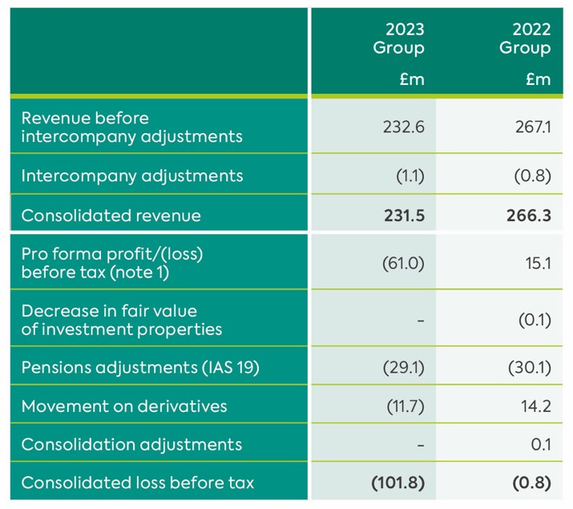
Note 1 - The pro forma profit is used by the DfI to assess profitability.

Financial Review
The UK-adopted International Accounting Standards (‘UK-Adopted IFRS’) results for the year are shown in the consolidated income statement on page 74.

The pro-forma loss before tax, i.e. profit for the year before tax and accounting adjustments for fair value of investment properties, pensions and derivatives, was £61.0m. This represents a significant improvement of £14m on budget (loss of £75m) due primarily to above budget numbers of fare paying passenger journeys combined with increased bus PSO (Public Service Obligation) funding, and a range of efficiency and cost reduction measures, whilst managing significant inflationary pressures.

The UK-Adopted IFRS consolidated loss before tax for the year of £101.8m has been adjusted to arrive at the pro-forma loss as follows:

- Pensions: £29.1m charge (2022: £30.1m charge). This is due to an increase in the long-term cost of providing and servicing pensions;
- Derivatives: £11.7m charge (2022: £14.2m credit).
- This reflects the application of the Group’s forward fuel procurement policy and reflects the significant increase in market value of oil since last year due to the war in Ukraine;
- Revaluation: nil (2022: £0.1m). Last year this reflected a further reduction in the value of investment property as COVID-19 had continued to depress retail site valuations.

The Group Balance Sheet was impacted by positive movements in the valuation of the Group’s net pension asset, which moved from £121.6m net liability to a surplus of £99.0m in the current year, primarily because of an increase in the discount rate from 2.8% to 4.8% offset by lower than expected return on plan assets during the year. This is a long-term commitment and does not affect the ability of the Group to pay its debts as they fall due or the ability of the Group to operate as a going concern.

Operational Review
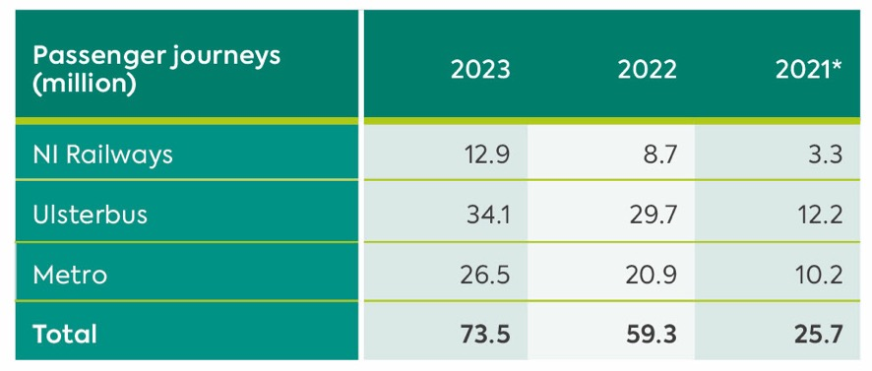
*Passenger journeys in 2021 exclude free health and social care worker journeys estimated at 33k per week

Capital Investment
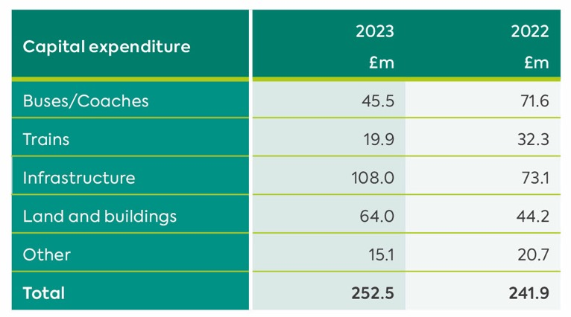
The investment in buses/coaches of £45.5m relates to the purchase of 28 Zero Emission single decks and 10 Zero Emission double deck buses for Foyle Metro, 6 Zero Emission minibuses for Coleraine. Deposits were also paid for a further 100 Zero Emission for the Ulsterbus (40) and Metro (60) networks.

Expenditure of £19.9m on trains relates to the overhaul of the Class 3000, Class 4000 and Enterprise trains, the progression of the Class 3000 and 4000 Mid Life Refresh projects and the delivery of the last 3 of the 21 additional Class 4000 carriages. All 21 carriages are now in service as part of 7 newly refurbished fixed 6 car Class 4000 trains.

Infrastructure expenditure of £108.0m includes £20.1m on Cullybackey Area Signalling and Level Crossing Renewals, £19.4m on Dargan to Yorkgate Track Renewals, £10.7m on Lisburn Station Interlocking Renewals, £8.3m on Structures Examination and Assessment Programme, and other infrastructure improvements. Works also commenced on the Rail Systems for the Belfast Transport Hub.

The investment in land and buildings of £64.0m includes progression of the Belfast Transport Hub (£40.0m), infrastructure works to support the introduction of the Zero Emission Buses in Metro, Foyle Metro and Coleraine (£4.0m), associated construction works for the Northern Ireland Regional Operating Centre (NIROC) (£2.7m), Yorkgate Station Redevelopment (£1.7m), and other enhancements. Park and Ride projects were progressed in the year.

Other projects being progressed during the year include £3.2m on the Future Ticketing System and £1.1m on charging equipment for the 38 Zero Emission Buses for Foyle Metro and Coleraine.

Key Performance Indicators (KPIs)
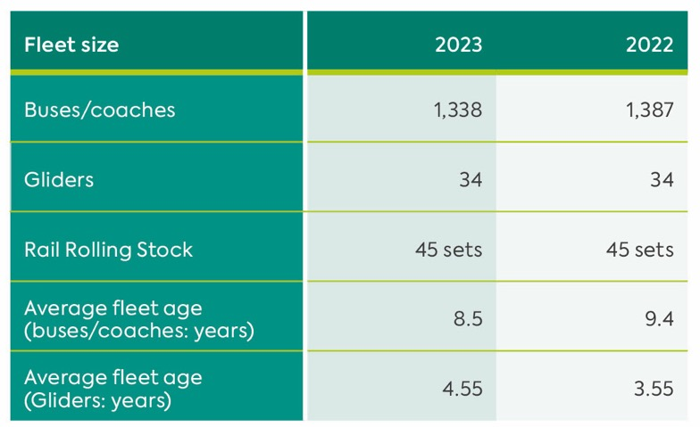

Our Strategy
Our strategy is aligned with Government policies as set out in the draft Programme for Government (PfG) including the NI Executive’s united aim ‘To improve the wellbeing for all of our people’. It is also closely aligned with the UN Sustainable Development Goals to promote prosperity while protecting the planet. It has been devised within the context of the Department for Infrastructure’s (DfI), Regional Development Strategy for 2035 and the Planning for the Future of Transport – Time for Change strategy and other emerging transportation plans.

An effective and successful public transport network is vital for the economic, social and environmental well-being of our society. Translink is committed to leading the transformation of transport in Northern Ireland.

Our 2030 strategy entitled ‘Better. Connected” sets out a vision for Translink as ‘Your first choice for travel, today for tomorrow’. Our mission is to lead the transformation of transport in Northern Ireland. We will create the advanced public transport services and integrated networks which connect people and communities, enhance the economy and improve health and the environment.

At Translink we are passionate about providing excellent public transport and we do this in the ‘Translink SPIRIT’ which embraces principles around Safety, People, Innovation, Responsibility, Integrity and Teamwork.

Our Translink Spirit underpins everything that we do and helps ensure we are Better. Connected. It shapes our culture and the way we do things. Our people are encouraged to be respectful and inclusive of everyone, to work together, to connect with customers and stakeholders, to motivate each other and to do things better. Our Spirit guides us to act responsibly, with integrity, and innovation and to succeed in delivering on our goals and creating ‘wellbeing for all’. Keeping customers and staff safe remains at the core of how we work.

Our People
We are a people business; we provide a service for people through our people. Our workforce is recognised within our industry and the broader business community for their achievements in delivering excellent services and innovation. We celebrate and embrace the benefits that diversity brings to our business and by working together to enhance our business environment, we create a culture that inspires the best – this is the ‘Spirit of Translink’.

We provide excellent learning and development opportunities in order to give employees the opportunity to stretch themselves and widen their experience.

Our leadership framework sets out competencies and objectives for management and professionals to:
- Lead – Accountability
- and Responsibility
- Engage – Communication
- Adapt – Continuous Improvement
- Deliver – Benefits Realisation

We will deliver results across four key objectives:
1. Continuous Improvement
2. Customer Focus
3. Climate Action
4. Connecting Communities

Continuous Improvement
This is how we’ll deliver an excellent service for all our passengers.

Even better safety performance
Safety is our number one priority. We will work to ensure everyone gets home safe and healthy every day. This includes customers, employees, contractors, the public and indeed anyone impacted by what we do.

Better reliability and timeliness
Our integrated transport system will ensure that all the parts come together to keep Northern Ireland moving forward and on time. We will invest in cutting edge technology to improve services, maximise resources and transform performance.

Better asset management
We will optimise effectiveness and performance by better planning, operation and maintenance, maximising the value of each asset over its lifecycle. This will bring improved efficiency across the organisation.

Investing in our people
Our people are the face of Translink. They provide the human connection with passengers and stakeholders. We will expand our Investor in People programme, helping to create a talented, diverse and inclusive workforce, empowered with the skills to ensure they are the best they can be.

Better benchmarking and monitoring
We will embed a continuous improvement culture in everything we do through benchmarking, analytics and use of technology.

Customer Focus
This is how we will meet and exceed customer expectations and attract new customers.

Better customer experience
We have set a target to achieve >90% customer satisfaction across all our services and work to continually improve our Net Customer Sentiment Score.

Better customer information
We will continue to improve the way we provide and receive information about our services.

Better handling of complaints
When things go wrong, we will do our best to put them right and will set out in our Passenger’s Charter our responsibilities and our commitments to respond to complaints.

Better facilities
We will continue to transform public transport through a programme of upgrades and enhancements.

Better fleet
We will continuously improve our fleet to deliver safe, clean, accessible and attractive public transport for our customers. Our fleet renewal programme will ensure buses, coaches and trains are leading edge and high quality.

Better ticketing and fares
We will develop customer led, innovative ticketing solutions with a focus on, ease of use, integration, convenience and value. As a key part of this commitment, we will roll out Account Based Ticketing/ Contactless Tap On Tap Off ticketing and continue to expand our mobile app technologies.
We will continue to innovate to offer best value with new products, fare offers, new payment options and the capping of fares to offer customers flexibility, integration, convenience and simplicity to attract more users.

Better accessibility
We will work to ensure our services and facilities are accessible to all. This includes enhancements to our vehicles, station improvements, introducing new changing places facilities, upgrades to rail halts and employee training.

Customer-led branding
Our brand strategy will be customer led, informed by research. Our branding will aim to visually connect our modes and services across Northern Ireland.

Climate Action
This is how we will reduce emissions by 50% by 2030 and play a leading role in promoting zero emission transport across NI.

Urgent action on climate change
Translink will lead the transformation towards net zero emissions in public transport in NI. This will create a path for a healthier, greener and more sustainable future for generations to come.

Although we aim to make significant progress during the next strategy period, we are looking beyond 2030 and far into the future. We want to be net zero by 2040, climate positive by 2050 and we will promote zero emission technology across the transport sector.

We have been benchmarked as Platinum status in the Business in the Community Northern Ireland Environmental Benchmarking Survey and we will continue to benchmark Translink with the very best organisations in carbon emission reduction.

Action on sustainable infrastructure
Incorporating the potential for electric and hydrogen technologies, we will develop a rail infrastructure plan focused on decarbonising the rail network.

Our energy strategy will seek to reduce emissions for buildings, facilities and infrastructure, such as signalling and telecommunications. We aim to change the way we design, build and operate our infrastructure and assets so we can minimise our whole-life carbon and air pollution emissions.

Action on sustainable bus fleet
We will embrace zero/low emission technology and innovations to decarbonise public transport. This will build on the programme of zero emission bus replacement which started in 2021/22. In 2022, we introduced over 100 Zero Emission vehicles, (80 Battery Electric and 23 Hydrogen Fuel Cell Electric Vehicles) - the first of their kind in Ireland. A further 44 Battery Electric vehicles are due to enter service in mid-2023 whilst orders have been place for a further 100 zero emission buses which will be added to the fleet in 2024. We will develop a bus procurement plan, to meet the target of net zero by 2040.

Action on sustainable rail fleet
Our rail fleet will transition from diesel to electric/hydrogen technology. We will identify and embrace zero emission technology to create a cleaner fleet with the aim to meet the target of net zero by 2040.

Climate Resilience
In preparing for climate changes, we are taking steps to assess, plan, design, build and upgrade our infrastructure to ensure we can operate in a way that anticipates, prepares for, and adapts to changing climate conditions such as flooding and other impacts of extreme weather such as high temperatures.

Connecting Communities
This is how we will connect people and opportunities through our infrastructure and services.

Connecting with stakeholders
We are committed to the NI Executive’s draft Programme for Government and the United Nation’s Sustainable Development Goals. We recognise the importance of working closely with our stakeholders to deliver these shared goals for the people of NI and for future generations.

Connected network development
Our goal is to provide high levels of network coverage across Northern Ireland ensuring more than 80% of people in Northern Ireland have access to a public transport connection.

Connected services
We will work with key stakeholders including the DfI, local Councils, Public Health Agency and Sustrans to improve the integration of public transport and active travel.
Enhancing accessibility will also be a key focus as will providing cost effective rural services to help sustain local towns across the region.

Connected infrastructure
In line with industry standards, we will maintain and enhance our infrastructure to deliver a safe and sustainable public transport network today and for future generations.

Rail Network
In conjunction with the DfI and other stakeholders we will input to the ‘All Island Strategic Rail Review’, to consider the rail network and to view how it can be improved for everyone.

Bus Network
In conjunction with the DfI, we will work to promote and extend bus priority schemes, park and ride and Glider phase 2.

Belfast Transport Hub
We will work to deliver the Belfast Transport Hub and Weavers Cross, a transport led regeneration project which is a hugely important NI Executive Flagship Project and a key driver of economic growth. It will have immense environmental significance and social value for Belfast and Northern Ireland.

These network enhancements will ensure the development of a connected and sustainable public transport network for future generations.

Key Achievements 2022-2023
Bus Fleet
In October 2022 we welcomed the Department’s announcement of funding for a further 100 new zero-emission buses and electric vehicle charging infrastructure which will be transformational in delivering a zero-emission public transport future for Northern Ireland.

The new battery electric buses will be a mix of single-deck and double-deck vehicles and the single deck buses being supplied will offer an extended journey range on a single charge.

All the new buses are due to enter service by summer 2024 and this announcement follows the successful roll-out of 100 zero-emission buses on Belfast Metro services during 2022, along with the planned conversion of Foyle Metro services in Derry~Londonderry to be completely zero-emissions by summer 2023.

This further significant investment in zero-emission buses supports our plans to decarbonise our fleet and lead the transformation of transport in Northern Ireland for a cleaner, greener and healthier future for generations to come.

It enables us to deliver the benefits of zero-emission technology to more areas across NI. We will continue to enhance the existing zero-emission Metro fleet in Belfast and to Ulsterbus services, including in the North-West area, Coleraine and Craigavon.

All the new buses will run on sustainably sourced “green” electricity and offer the latest standards in comfort, quality and accessibility with in-seat USB chargers, WiFi and low-floor accessibility features.

Rail Fleet
In September 2021 we launched the first new longer walk-through train into passenger service as part of a £66million project to further transform Northern Ireland’s railway infrastructure.

With around 1,600 additional seats available every day, these new trains are also greener and more energy efficient. This investment will help encourage even more people on board supporting NI’s low carbon economy, protecting the environment and ensuring a better, more inclusive and resilient future for everyone.

The remaining trains were phased into service with the last one operational by summer 2022.

Yorkgate Train Station Transformation
In December 2022 the first sod was cut on the new high quality, sustainable train station at York Street in North Belfast. Station development works are currently underway with the project expected to complete late 2024. This new station will deliver modern, more accessible facilities for passengers with better links to walking and cycling. Externally the area will also be transformed with high quality landscaping and a new public realm area.

With connectivity also enhanced, this station will be a key gateway to access the new Ulster University campus and the planned City Quays development, and will be vital for the regeneration of the local area.

It will provide the people of North Belfast with connections that can improve the area’s liveability and the community’s employability. We will continue to work with all our stakeholders as the development progresses.

Consultation on Glider phase 2
In October 2022 the Department published its report on the BRT2 consultation.

The route selection process included assessments to identify the route options capable of delivering a scheme which fulfils the following key objectives of BRT2:

- Provide a safe, efficient and high-quality public transport service;
- Support sustainable economic growth and regeneration;
- Provide equality through enhanced accessibility; and
- Support social inclusion and the integration of communities.

The Glider’s success has been acknowledged both nationally and internationally. Its popularity boosted passenger journeys to record levels, prior to the onset of COVID-19. The introduction of the new North to South routes for phase 2 will further improve connectivity across the city and inspire even more people to make public transport their first choice for travel, today, for tomorrow. We will continue to work with the Department for Infrastructure and key stakeholders to progress this important and exciting scheme for the city.

Progress on Belfast Grand Central Station
Work continues at pace on the construction site of Belfast Grand Central.

Major piling operations have been completed for the new state-of-the-art integrated station and an impressive new concourse is emerging at the construction site.

These milestones represent significant progress in the delivery of this world-class transport hub which will deliver an enhanced customer experience. Set to be the largest integrated transport facility on the island of Ireland, it will showcase public transport in Northern Ireland.

It will deliver a high-class customer experience and enhanced cross border connectivity for up to 20 million passenger journeys annually. With the added benefits of active travel options, it will also play a major part in tackling the climate emergency, reduce congestion for better air quality, leading to a healthier, smarter and more sustainable city for everyone.
Translink is delighted to see this project continuing to progress on schedule and we look forward to completion in 2025.

Weavers Cross
In August 2022 we welcomed Belfast City Council’s decision to approve plans for Weavers Cross, a significant transport-led regeneration project around the site of the new Belfast Grand Central station, which promises to bring circa 1.3 million square feet of mixed-use space to a strategic location in central Belfast.

As a key economic driver for the city, the project is a once-in-a-generation opportunity for regeneration through reconnection, delivering both spatial and social regeneration of both the area and the wider city, as well as encouraging and enabling a modal shift away from private cars as a primary means of travel.

The long-term redevelopment presents an opportunity to unlock £1bn of additional spend in the economy and to create a legacy of wider regeneration of surrounding areas of the city.

Workplace Diversity and Inclusion – Silver Diversity Mark Awarded
In October 2022 Translink was awarded the Silver Diversity Mark for advancing Diversity and Inclusion in the Workplace by the awarding body Diversity Mark NI Ltd.

The assessors looked for significant progress against Translink’s plan and critiqued goals that will continue to address gender, disability, race and ethnicity.

We are very proud to have reached the high standards required for the Silver Diversity Mark. This accreditation is important to us as it not only acknowledges our achievements so far but demonstrates our ongoing commitment to enhancing diversity and inclusion in Translink, where all employees can feel valued, safe and respected.

We are a people business, and we understand the benefits of having a diverse and inclusive culture in terms of attracting and retaining the best talent, better business decision making and helping us to understand our customers better.

Ticketing progress and plans
In November 2022 we celebrated the landmark of one million journeys using contactless payment methods being made across Translink Metro services in Belfast since the new technology was introduced earlier this year.
Passengers can use their smart watches, phones, credit or debit cards to ‘Tap On’ board any Metro services with fares capped to offer affordability and flexibility. Our innovative “Tappiness” Marketing campaign encouraged Metro passengers to move away from other payment methods to the very simple ‘Tap and Travel’ message using contactless.

In January 2023, we further enhanced our acceptance of contactless payments on bus by introducing contactless as a pilot in Ulsterbus Newtownabbey and Carrickfergus. The next steps will be rolling out contactless payments on all Ulsterbus and Goldline services across Northern Ireland.

This will be closely followed by installation of Ticket Vending Machines and Platform Validators at all rail stations to allow customers to purchase tickets, or validate their smartcard, before they board the train.

Ticket Vending Machines will also be installed at key Bus stations, Bus stops and Park & Ride facilities where customers can buy paper tickets, top-up smartcards and collect online tickets.

This will mark significant milestones in Translink’s Future Ticketing System roll-out, transforming public transport to future-proof services for full network ticket integration and to support passenger growth.

Official Opening of new Active Travel Centre in Derry~Londonderry
In September 2022 we welcomed the official opening of Sustrans’ new Active Travel Centre in Derry-Londonderry.

The new facility, based at the North-West Transport Hub is in partnership with Life Cycles, a Zero Waste North-West initiative to save bikes from landfill and get people cycling through lessons, leading rides and cycle fix sessions.

Individuals and organisations throughout the border region are encouraged to get involved and use the Active Travel Centre, Bike Workshop and Community Space to get more people walking, wheeling and cycling to combat climate change and a growing health crisis.

Late Night Festive Public Transport Services
Over ten thousand people travelled on the late-night bus and train services that operated in both Belfast and Derry~Londonderry during the festive period in December 2022.

We provided a range of later departures from Belfast on Metro, Goldliner, Urby and train services right across the network with Foyle Metro also operating late night services in Derry~Londonderry on selected routes.

We were pleased to work with a range of organisations to develop the package of additional Christmas services which have really helped to support the night-time economy.

The numbers travelling were very encouraging with many telling us that having a reliable and safe bus or train home gave them the confidence and comfort to travel and enjoy a night out.

We will continue to work with all stakeholders with an interest in developing and improving the night-time economy to secure funding for a financially sustainable late-night network providing safe, attractive and low-cost travel options for those who work at night and those who want to enjoy the great hospitality on offer.

Park & Ride and Bus Priority Measures
Translink is working with DfI to develop the first Carbon Action Plan for transport in NI. The ongoing investment made in the development of Park & Ride facilities, coupled with the provision of more extensive bus priority and enhanced integration of active travel and public transport, will play a significant role in efforts to reduce the carbon emissions generated by transport.
These elements will also be key enablers for change within the emerging Transport Plans and Local Development Plans being produced by DfI and councils, respectively.

A whole system approach, including new fleet, ticketing, passenger information, service planning and infrastructure, will provide the basis for more people to choose sustainable transport.

Rail Infrastructure Improvements
Translink has continued to invest in its rail infrastructure in order to enhance the safety and reliability of the network. Significant track renewals have taken place at Dargan Bridge and Dark Arches with signalling and track upgrades currently underway at Lisburn.

The programme to reduce risk at level crossings has continued, with upgraded crossings installed at Cullybackey and new overbridges constructed to allow existing crossings to be closed at a number of locations. In order to build a comprehensive register of all infrastructure assets, structural examinations have been completed for all bridges, platforms and retaining walls, with culvert surveys ongoing.

A new signalling control centre is being constructed at Lanyon Station, with the first phase opening in parallel with Belfast Grand Central Station in 2025.

Progress towards Translink’s net zero targets has continued across Translink’s property estate and a programme to decarbonise the rail network has commenced.

The Translink SPIRIT
We are committed to taking responsibility for the impact of our activities on customers, suppliers, employees, stakeholders and communities as well as our environment. We have a full range of activities based on the following key themes; Safety, Health and Wellbeing, Environment, Community Engagement and Our People.

The safety and wellbeing of our customers, employees and the general public remains central to Translink’s operations. We work with the local community to instil long term support and engagement through specific projects and initiatives. These have included: rail safety campaigns, community projects, agricultural safety, interagency safety events, safety bus activity, seatbelt campaigns and regional school initiatives.

We are committed to delivering workplace health and wellbeing initiatives to help our employees lead fit and healthy lifestyles. Employee welfare is enhanced by organisational culture as well as attitudes, values, beliefs and daily practices that affect their mental and physical wellbeing.

We continue to support local communities through stakeholder engagement, disability awareness, charity activity, supporting community projects and festivals, youth initiatives, events and sponsorships.

Translink holds a Platinum CORE standard for Corporate Responsibility from Business in the Community (BTIC) and again retained its Platinum status in BITC’s Environmental Benchmarking Survey, Northern Ireland’s leading environmental benchmarking exercise.

The Translink SPIRIT is embedded in everything we do, underpinning our efforts to achieve our key objectives.

Safety
The safety and wellbeing of our customers, staff and the general public is central to our operations, particularly as we build back responsibly post COVID-19 pandemic.

We are guided by our Safety Management System and are constantly developing our safety capabilities and preparedness. We aim for zero staff or passenger safety incidents.

People
We value and seek to develop our people.

We have won a number of awards for Investors in People (IIP) and strive to achieve the gold standard.

We are committed to creating a diverse workforce as we recognise the value this brings to our organisation. We were awarded the silver diversity mark which acknowledges our achievements so far but demonstrates an ongoing commitment to diversity and inclusion.

Innovation
We have worked to instil a culture of continuous improvement throughout the organisation which challenges everyone to focus on what we do, or could do, to provide an excellent service for our customers and wider stakeholders.

Further formal processes are being introduced to improve service delivery and drive efficiencies throughout the Group.

Responsibility
We believe that Corporate Social Responsibility (CSR) is an important strategic tool for our business.

We continue to deliver a comprehensive CSR programme based on the four key themes of Go Safe, Go Eco, Go Healthy and Go Together and have been recognised as one of Northern Ireland’s leading businesses in this area.

Along with our continued commitment to our employees’ health through our occupational health programmes, we continue to engage with and contribute to the local community to protect and enhance safety, wellbeing and the environment.

Integrity
We act with integrity in everything we do within a robust Corporate Governance Framework.

We will continue to work collaboratively with our sponsor Department and other regulators and stakeholders and governing authorities to ensure compliance with relevant regulations.

Teamwork
We are committed to creating the right conditions for all our people to contribute as part of a team to deliver our Vision and Values and to be an advocate for public transport.

We are committed to taking responsibility for the impact of our activities on customers, suppliers, employees, stakeholders and communities as well as our environment.

The safety and wellbeing of our customers, employees and the general public remains central to Translink’s operations. We work with the local community to instil long term support and engagement through specific projects and initiatives.
These have included: rail safety campaigns, community projects, agricultural safety, interagency safety events, safety bus activity, seatbelt campaigns and regional school initiatives.

We are committed to delivering workplace health and wellbeing initiatives to help our employees lead fit and healthy lifestyles.

Employee welfare is enhanced by organisational culture as well as attitudes, values, beliefs and daily practices that affect their mental and physical wellbeing.

We continue to support local communities through stakeholder engagement, disability awareness, charity activity, supporting community projects and festivals, youth initiatives, events and sponsorships.

Translink holds a Platinum CORE standard for Corporate Responsibility from Business in the Community (BITC) and again retained its Platinum status in BITC’s Environmental Benchmarking Survey, Northern Ireland’s leading environmental benchmarking exercise.

The Translink SPIRIT is embedded in everything we do, underpinning our efforts to achieve our key objectives.

Principal risks and uncertainties
The business faced a number of risks and uncertainties, both internal and external. These encompass:

- Impact of funding shortfall on Translink’s viability as a going concern in the short to medium term and longer term;
- Whole Lifecycle asset management funding (maintenance, refurbishment, renewal and replacement);
- COVID-19 pandemic;
- Failure to optimally manage and secure sufficient benefit from key service delivery partnerships (such as Education Authority school services and Irish Rail);
- Key supplier failure/unavailability;
- Failure to maintain good employee relations;
- Planning delivery and assurance of Portfolio, Programmes and Projects (e.g. Belfast Transport Hub);
- Failure to avoid a catastrophic or major incident;
- Cyber security;
- Potential impact of Brexit;
- Climate change;
- Inflation and supply chain disruption; and
- Need to protect and enhance our Corporate Brand and reputation.

Further information on the key risks and uncertainties faced by the Group are set out in more detail within the Group’s Corporate Risk Register and also the Corporate Governance statement on page 43.

Directors’ Report

The Directors present their annual report on the affairs of the Group and parent company, together with the financial statements and auditor’s report, for the year ended 26 March 2023.

An indication of likely future developments in the business of the Group and Parent Company is included in the strategic report.

Directors
The Directors, who served throughout the year and up to the date of approval of the accounts are noted on page 3.

Directors’ Indemnities
The Company has made qualifying third-party indemnity provisions for the benefit of its Directors which were made during the year and remain in force at the date of this report.

Equal Opportunities
The Group is committed to equality of opportunity for job applicants and within the workforce and values diversity.

Applications for employment by disabled persons are always fully considered, bearing in mind the aptitudes of the applicant concerned. In the event of members of staff becoming disabled every effort is made to ensure that their employment with the Group continues and that appropriate training is arranged. It is the policy of the Group that the training, career development and promotion of disabled persons should, as far as possible, be identical to that of other employees.

Employee Consultation
This year we have been able to reintroduce some face to face events, where appropriate including a leadership conference, the Health and Safety Conference and have our Annual Business Review, for all Management and Professional/Technical staff planned for June. Throughout the year, we have continued to provide employees with information and regular updates
about the Group via, Group Chief Executive emails, videos and podcasts.

We continue to extend our reach of communications through our digital platforms with 81% of employees now registered on the employee app. We bolster this digital approach by providing key updates via staff briefs, posters, employee news bulletins and continue to use MS Teams, to provide monthly leadership briefings and hold employee events focusing on, safety, wellbeing and inclusion.

Engagement with suppliers, customers, and others in a business relationship with the Company
A number of initiatives were undertaken by the Company to proactively engage with its supply base – both strategically and in response to the continued impact of Brexit and the Ukraine war. Strategic supplier reviews are conducted with key suppliers to ensure business continuity and to identify any emerging risks in the marketplace through the proactive use of supplier relationship management (SRM) to create higher levels of supply chain resilience. Translink have attended numerous supplier engagement and industry specific events including Meet the Buyer events in Derry and Belfast, promoting tender and contracting opportunities with Translink.

Translink have proactively engaged with local SME’sand Social Enterprises including promoting Social Value opportunities and have awarded its first reserve contract to a Social Enterprise.

The lessons learned from the COVID-19 global pandemic has increased our focus on the need to engage with the market and gather intelligence to inform decision-making. We also promoted the importance of being commercially aware and gave advice, guidance and examples to encourage this.

To address the rapidly increasing, global issue of price rises in material costs, we developed rules for dealing with requests for increases and introduced ‘claim back’ clauses for relevant contracts; thereby allowing us to benefit from cost reductions as market conditions improve.

In order to help us further develop and improve our service to our internal customers, we undertook a bi-annual customer survey in 2022 to determine whether we were meeting our customers’ expectations and delivering effectiveness and efficiency. Using the – generally very positive – feedback, we reviewed and re-developed our team structure to meet our customers’ needs.

Translink’s Procurement Department also represented the NI Utilities CoPEs on the NI Procurement Board.

The Group previously independently monitored customer satisfaction twice each year up until the COVID-19 pandemic in March 2020, in spring and autumn, so we can continue to learn and understand where our services could be improved.

These surveys were restricted in the following two years due to the restrictions imposed by COVID-19.

During 2022/23 Translink conducted two detailed customer satisfaction reviews using an existing omnibus survey framework which utilised on-line panels. These interviews were conducted with current passengers and non-users which was helpful in identifying any significant difference in perceptions of various aspects on our performance and delivery of services.

For 2023/24 and beyond Translink will be once again undertaking a detailed programme of customer satisfaction monitoring. The Group overseeing this work consists of representatives of Translink, DfI and the Consumer Council for NI.

Along with regular passenger panel sessions and Translink Youth Forum workshops, regular communication with Consumer Council NI and IMTAC who represent customer needs, we also openly engage through social media and invite feedback from all customers as part of our commitment to provide a network and services that benefits the people of Northern Ireland. We have continued with monitoring of social media feedback and sentiment to ensure we can quickly identify and respond to customer needs.

Corporate Governance Code
During the year, the Group has voluntarily complied with applicable provisions contained within the UK Corporate Governance Code 2018, including reporting in the Annual Report and adherence to the five principles and associated provisions.

Greenhouse Gas Emissions UK Energy Use and Total Emissions
The Group’s total energy consumption and the respective emissions associated for 2022/23 and 2021/22 is summarised below; 2018/19 is assumed to be an appropriate baseline year:

Energy
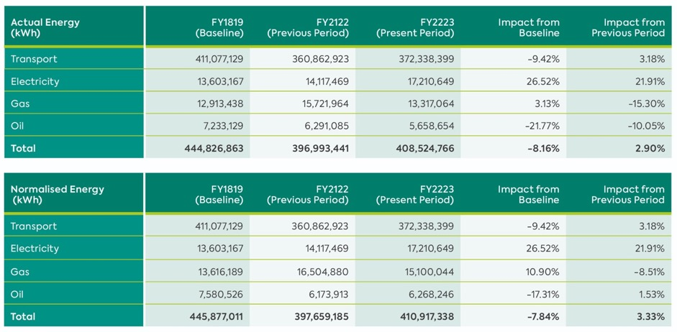
There has been a 8.16% reduction in actual energy consumption within the Translink Organisation Boundary, in relation to the baseline figures. When adjustments such as Degree Day Normalisation is applied this reduction in energy consumption equates to 7.84%.

Due to the COVID-19 passenger recovery and reinstatement of passenger service timetable the annual energy usage has increased in comparison to FY2022.

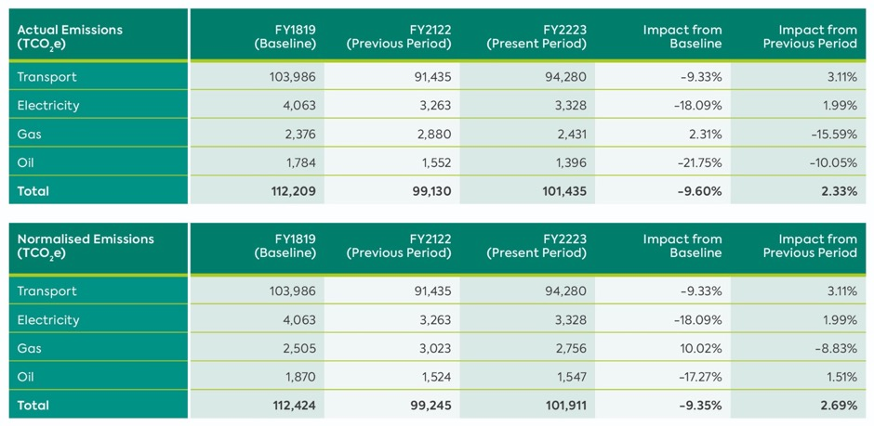
There has been a 9.60% reduction in actual emissions within the Translink Organisation Boundary, against the baseline figures. When adjustments such as Degree Day Normalisation is applied this reduction in emissions equates to 9.35%.

Due to the COVID-19 passenger recovery and reinstatement of passenger service timetable the annual emissions have increased in comparison to FY2022.

Intensity Ratio
The utilisation of an Intensity Ratio allows Translink to in theory compare input against output, through the production of a Key Performance Indicator (KPI). The metric to be utilised is, Passenger Numbers against the overall emissions, this will result in a figure detailing “kgCO2e / Passenger”.
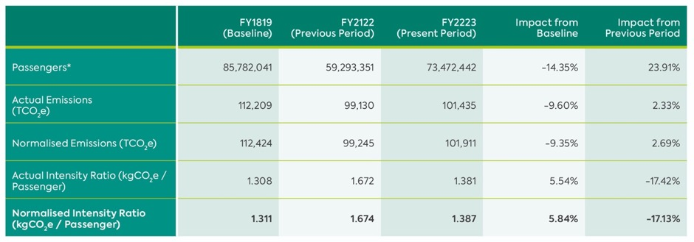
There has been an increase of 5.84% against the baseline energy consumption, which is due a passenger number reduction in the region of 14.35%.

Energy Efficiency
The Group is committed to reducing carbon emissions and has a number of energy savings actions underway across bus & rail fleet, infrastructure and buildings. Further details are found in the Climate Action section on page 18.

Methodology
Electricity - Figures sourced from downloaded data from the supplier. Over 99% of the electricity consumed is via Half Hourly Meters.
Gas - Figures sourced from downloaded data from the supplier. 100% of the gas consumed is via Half Hourly Meters.
Oil - Oil delivery information is detailed within a central database in relation to site, quantity and date.
Vehicle Fuel - Vehicle Fuel information is detailed within a central database (Fuel Fleet Report) in relation to site (delivery), vehicle no (refuelling), quantity and date.
Passenger Numbers - Passenger numbers travelling including fare paying, concessions and school children.
Free travel given to health and social care workers during COVID-19 pandemic are excluded.
Emissions Conversion Factors - The emissions conversion factors have been sourced for each respective year via the UK Government GHG Conversion Factors for Company Reporting.
Normalisation - Normalisation of thermal related fuel in compliance with CIBSE TM41.
Degree Day - Heating Degree Day data sourced from degreedays.net.

S172(1) Compliance Statement
The company complies with section 172(1) of the Companies Act 2006 through engagement with its various stakeholders. The Company’s strategy has been informed by and its implementation continues to be informed by interaction with stakeholders. It is the intention of the Company to act responsibly towards its stakeholders.

Whistleblowing / Fraud Reporting
The Group’s whistleblowing procedures ensure that arrangements are in place to enable colleagues, suppliers and service providers to raise concerns about possible improprieties on a confidential basis. Whistleblowing events are monitored by the Audit and Risk Committee.

Disclosure of Information to Auditor
Each of the persons who is a Director at the date of approval of this annual report confirms that:

- so far as the Director is aware, there is no relevant audit information of which the Company’s auditor is unaware; and
- the Director has taken all the steps that he/she ought to have taken as a Director in order to make himself/herself aware of any relevant audit information and to establish that the Company’s auditor is aware of that information.

Pursuant to Section 487 of the Companies Act 2006, KPMG will not be seeking reappointment as auditor.

Political Contributions
Neither the Company nor any of its subsidiaries made any political donations or incurred any political expenditure during the year (2022: £nil).

Financial Instruments
The Group’s principal financial instruments comprise cash, trade debtors, trade creditors, fuel derivatives and certain other debtors and accruals. The main risks associated with these financial assets and liabilities are set out below.

Dividends
The Directors do not recommend payment of a dividend (2022: £nil).

Market Risk
Market risk is the risk that changes in market prices, such as commodity prices, interest rates and exchange rates will affect the Group’s financial performance and/or financial position. The objective of the Group’s management of market risk is to manage and control market risk exposures within acceptable parameters. The Group does not consider currency risk or interest rate risk to be material due to the low levels of foreign currency transactions.

The Group enters into derivative financial instruments in the ordinary course of business in order to manage market risk, in the form of fuel price risk. All such transactions are carried out within guidelines set by the Board. Market risk exposures are measured using sensitivity analysis.
Under IFRS the derivative financial instruments are recognised in the Group’s financial statements at fair value with full disclosure at note 23 to the financial statements.

There has been no change to the Group’s exposure to market risks or the manner in which these risks are managed and measured.

Credit Risk
Credit risk arises on trade debtors and certain other debtors, a significant element of which relate to amounts owed by UK government bodies and in relation to which the Directors consider the credit risk to be insignificant. Group and Company policy is aimed at minimising credit risk and requires that deferred terms are granted only to non-government customers who demonstrate an appropriate payment history and satisfy creditworthiness procedures.

Individual exposures are monitored with customers subject to credit limits to ensure that the Group exposure to bad debts is not significant. The credit risk on liquid funds and derivative financial instruments is limited because the counter parties are banks with high credit ratings assigned by international credit-rating agencies.

Liquidity Risk
Liquidity risk arising in respect of the Company’s subsidiary undertakings is managed through the Group’s central purchasing and treasury function, with flexibility maintained by retaining surplus cash in readily accessible bank accounts and control of Group indebtedness. Further, significant capital projects are normally funded by grant aid, with such projects requiring approval by both the Board and Department.

Going Concern
The Directors acknowledge the guidance on the ‘Going Concern Basis of Accounting and Reporting on Solvency and Liquidity Risks 2016’ published by the Financial Reporting Council in April 2016, the FRC guidance “Update for Audit Committees: Issues arising from Current Economic Conditions”, published in November 2010, and the June 2012 publication by the Panel of the Sharman Inquiry entitled ‘Final Report and Recommendations on Going Concern and Liquidity Risk’, the content of which was incorporated by the FRC into its September 2014 update to the UK Corporate Governance Code.

The Group’s business activities, together with the factors likely to affect its future development, performance and funding are set out in the Strategic Report. Principal risks and uncertainties are referenced above and detailed in the Corporate Governance Statement on page 43. As a Public Corporation, whose legal status is not expected to change in the immediate future, the Group receives financial support from Government in the form of a Public Service Obligation, route subsidy and capital grant support. In addition, the Group receives recompense for the carriage of concession groups.

Due to the reduction in government funding available within the NI Assembly and the absence of a functioning executive, the Group has budgeted to generate a trading loss for 2023/24.

It has received notification of indicative funding from The Permanent Secretary, Department for Infrastructure and a commitment that DfI will continue to work with Translink, and with the Department of Finance to protect public transport as a core public service, as far as possible.
The Consolidated Balance Sheet shows shareholders’ funds of £145.4m (2022: funds of £25.5m).

The employee benefit obligation (pensions) in the balance sheet reduced from £121.6m (net liability) in 2022 to £99.0m (surplus) in the current year, primarily because of an increase in the discount rate from 2.8% to 4.8%, combined with lower-than-expected return on plan assets during the year. This is a long-term commitment and does not affect the ability of the Group to pay its debts as they fall due or the ability of the Group to operate as a going concern.

Given the Group’s strategic objectives and future developments the Directors recognise that security of a long-term funding strategy is key. In April 2022 Translink and DfI signed a Public Service Agreement for the provision of public transport services for at least five years.

This agreement (with the Department for Infrastructure) includes a commitment that payment for these services will be maintained at such a level to ensure that as a minimum Translink is able to meet its going concern obligations. This has been a key consideration for the Directors in assessing whether the accounts can be prepared on a going concern basis. On this basis, the Directors believe that it is reasonable to assume that the Group has and will continue to have adequate resources to meet its anticipated liabilities as they fall due and to enable it to continue in operational existence for the foreseeable future. Accordingly, the Board has concluded that it is appropriate that the accounts are prepared on a going concern basis.

Post Balance Sheet Events
There have been no events subsequent to the balance sheet date, up to the date of this report, that requires adjustment to or disclosure in the financial statements.

Approved by the Board of Directors on 21 June 2023 and signed on behalf of the Board:

Mrs Priscilla Rooney
Company Secretary

Statement of Directors’

Responsibilities in Respect of the Directors’ Report and the Financial Statements

The Directors are responsible for preparing the Directors’ report, Strategic report and the Group and Company financial statements in accordance with applicable law and regulations.
Company law requires the Directors to prepare Group and Company financial statements for each financial year. Under that law they have elected to prepare the Group financial statements in accordance with international accounting standards in conformity with the requirements of the Companies Act 2006 and the Company financial statements in accordance with FRS 101 Reduced Disclosure Framework and applicable law.

Under Company law the Directors must not approve the financial statements unless they are satisfied that they give a true and fair view of the state of affairs of the Group and Company and of the Group’s profit or loss for that period.

In preparing the Group and Company financial statements, the Directors are required to:

- select suitable accounting policies and then apply them consistently;
- make judgements and estimates that are reasonable and prudent;
- state whether applicable Accounting Standards have been followed, subject to any material departures disclosed and explained in the financial statements;
- assess the Group and Company’s ability to continue as a going concern, disclosing, as applicable, matters related to going concern; and
- use the going concern basis of accounting unless they either intend to liquidate the Group or Company or to cease operations or have no realistic alternative but to do so.

The Directors are responsible for keeping adequate accounting records that are sufficient to show and explain the Company’s transactions and disclose with reasonable accuracy at any time the financial position of the Company and enable them to ensure that its financial statements comply with the Companies Act 2006. They are responsible for such internal controls as they determine is necessary to enable the preparation of financial statements that are free from material misstatement, whether due to fraud or error, and have general responsibility for taking such steps as are reasonably open to them to safeguard the assets of the Group and to prevent and detect fraud and other irregularities.
The Directors are responsible for the maintenance and integrity of the corporate and financial information included on the Company’s website. Legislation in the UK governing the preparation and dissemination of financial statements may differ from legislation in other jurisdictions.

The Directors confirm that to the best of their knowledge:

- the financial statements, prepared in accordance with the relevant financial reporting framework, give a true and fair view of the assets, liabilities, financial position and profit or loss of the Company and the undertakings included in the consolidation;
- the strategic report includes a fair review of the development and performance of the business and the position of the Company and the undertakings included in the consolidation taken as a whole, together with a description of the principal risks and uncertainties that they face; and
- the annual report and financial statements, taken as a whole, are fair, balanced and understandable and provide the information necessary for shareholders to assess the Company’s position and performance, business model and strategy.

This responsibility statement was approved by the Board of Directors on 21 June 2023 and is signed on its behalf by:

Chris Conway
Chief Executive Officer

Patrick Anderson
Chief Financial Officer

Corporate Governance Statement
Introduction
The Translink Group (the ‘Group’) consists of a public corporation, the Northern Ireland Transport Holding Company (established under the Transport Act (Northern Ireland) 1967), which owns and controls seven private limited subsidiary companies including Citybus Limited, Ulsterbus Limited, Northern Ireland Railways Company Limited and NIR Operations Limited, together branded as ‘Translink’. The operating subsidiaries represent the main passenger transport companies which passengers, communities and stakeholders have come to know, trust, and rely upon.

Classified as a Public Corporation, this effectively means Translink carries out its operational activities with a degree of commercial independence, whilst within its statutory remit and governed in policy terms by the Department for Infrastructure (‘DfI’ or “the Department”). Translink operates under a hybrid governance model. This means that the organisation is subject to public sector governance, private sector governance, and a very broad set of laws and regulations which come from both sectors. For example, as a public body, Translink is subject to the Freedom of Information Act 2000 and public procurement regulations, yet equally (as a group of private limited subsidiary companies), its Directors are bound by the Companies Act and common law Directors’ duties.

Translink is committed to good corporate governance and has voluntarily complied with applicable provisions contained within the UK Corporate Governance Code
2018, to the extent practical for a sponsored public corporation. There is an important additional layer of public sector governance set out in the Management Statement and Financial Memorandum (“MSFM”). The MSFM sets a bespoke corporate governance framework for the organisation, and in so doing applies relevant provisions of Managing Public Money NI due to the receipt of public funds both in capital grants and public service obligation revenue.

Relationship with the Department
The Minister for Infrastructure is accountable to the Assembly for the activities and performance of Translink. The Minister sets regional infrastructure and transport policy and performs the following functions:

- Approves strategic objectives and corporate plan.
- Approves the accountability, policy, and performance framework within which Translink operates (as detailed in the MSFM and associated documents).
- Keeps the Assembly informed as to Translink’s performance.
- Approves the amount of grant/subsidy or other funds to be paid to Translink; and
- Performs responsibilities specified in the Transport Act (Northern Ireland) 1967, including making appointments to the Board and laying the annual report and accounts before the Assembly.
- There are periodic meetings which form the top-level governance arrangements between Translink and the Department. These interfaces include:
- Meetings between the Minister and the Translink Chair and/or Group Chief Executive.
- Bi-Annual Board-level governance meetings (led by the Permanent Secretary) with the full Board.
- Bi-Monthly Departmental monitoring meetings, where senior sponsor branch officials meet with Translink’s Chief Financial Officer and General Counsel & Company Secretary.
- Ad hoc meetings and interfaces between different management teams to keep both organisations up to date and ensure early engagement on issues arising.

The Role of the Board
The Board’s aim is to ensure that Translink functions innovatively and efficiently, taking a collaborative approach with relevant stakeholders in public transport, providing integrated services which connect communities, enhance the economy and improve the environment, enabling a thriving Northern Ireland.

The Board collectively supports and scrutinises management against its strategic objectives thereby ensuring that Translink continues to perform successfully by providing strategy leadership, financial and business scrutiny, risk management, while endorsing the Translink SPIRIT values of Safety, People, Innovation, Responsibility, Integrity and Teamwork.

The Board had ten scheduled meetings during the year and is supported in its activities by four Non- Executive Director led sub-committees:

- Group Remuneration and Pensions Committee
- Project Oversight Committee
- Safety Oversight Committee; and
- Audit and Risk Committee.

We ensure that all Board members irrespective of their committee memberships are made aware of the key discussions and decisions of each of the other committees of which they are not members. In this way, the full Board is routinely updated with respect to its knowledge base and company-awareness.

Division of Responsibilities
Chair
There is a clear division of responsibilities between the Chair and the Chief Executive. The Chair, Michael Wardlow, is currently responsible for leadership of the Board, ensuring its effectiveness and for setting its agenda. He facilitates the contribution of the Non-Executive Directors, through a culture of openness and debate, ensuring constructive relations between Executive and Non-Executive Directors. The Chair’s distinctive duties are set out in the MSFM.

Senior Independent Director
The role of Senior Independent Director, Tzvetelina Bogoina-Seenan, is to act as a sounding board for the Chair and as a trusted intermediary for the other Directors. In addition, the Senior Independent Director meets with the other Non-Executive Directors at least once a year to undertake a review of the Chair’s performance.

Appointment of Non-Executive Directors
Translink’s Non-Executive Directors are appointed by the Minister to serve for one or more terms, typically for four years each.

Group Chief Executive and Accounting Officer
The Group Chief Executive is responsible for the day-to-day management of the Group and executing its strategy. In addition to retaining an Executive Board position as Group Chief Executive, I also fulfil the distinctive public sector role of Accounting Officer. The Accounting Officer has responsibility for ensuring that the Group operates effectively and to a high standard of probity. The Accounting Officer retains a reporting line direct to the Permanent Secretary within the Department regarding particular aspects of the role (focused on regularity, propriety and value for money).

Board Effectiveness
Composition
The Board comprises three Executive Directors, the Chair and four Non-Executive Directors. The General Counsel & Company Secretary supports the Board and attends every meeting. The Non-Executive Directors bring wide and varied commercial experience to Board and Committee deliberations.

Independence and Conflicts
Each of the Directors has a duty under the Companies Act 2006 to avoid a situation where he/she has, or can have, a direct or indirect interest that conflicts (or may be perceived to conflict) with the Group’s interests. The Board has established procedures for the disclosure of conflicts by Directors at every meeting but also through regular recorded declarations throughout the financial year. In accordance with the spirit of the Companies Act 2006, the Board considers, manages, and documents all conflicts of interests. From this pro-active analysis, the Board is content to confirm that all Non-Executive Directors are independent as set out in the terms of the UK Corporate Governance Code.

Board Development, Workshops and Continuous Improvement
During the year, the Directors receive training on current issues and operational updates on various aspects of the business.

Information and support
The Board receives regular updates on business performances against the Corporate Plan and Strategy. These come in the form of results-based “SMART” key performance obligations shaped from a range of corporate objectives and Departmental objectives set out in the Public Service Agreement.

There is an established procedure whereby the Board or any of its committees may take independent professional advice when appropriate. Any individual Director may take independent professional advice at the Company’s expense where they judge it necessary to discharge their responsibilities as Directors.

Board Evaluation
The Board undertakes a formal review of its performance and that of its committees on an annual basis.

The Chair is responsible for evaluation of individual Board Directors. This assessment is supplemented by the Department for Infrastructure who undertake their own assessment in consultation with the Permanent Secretary and the Chair. This includes an assessment whether Directors are able to allocate sufficient time to the Group in order to discharge their responsibilities effectively.
All of Translink’s Directors routinely satisfy the requirements of these effectiveness assessments.

Attendance at Board and Committee Meetings during 2022/23
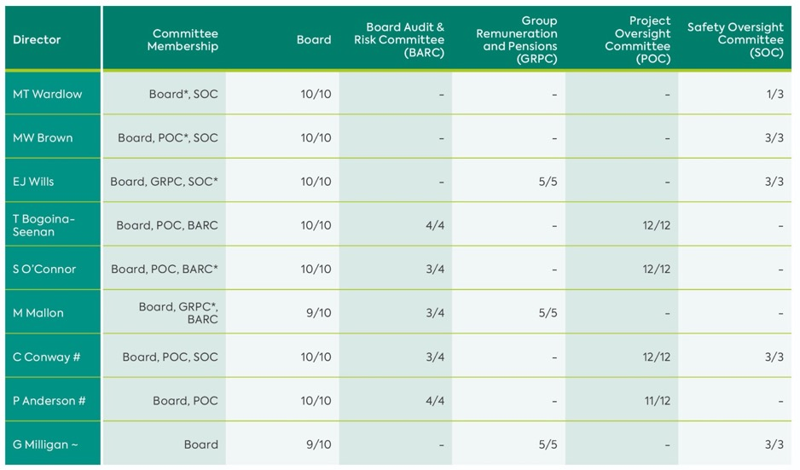
* Denotes Present Chair of Committee
# The Group Chief Executive and Chief Financial Officer attend Audit and Risk Committee meetings
~ The Deputy Chief Executive attends Group Remuneration and Pensions Committee meetings

Sources of Assurance and Risk Management Controls
Effective internal controls
The Board acknowledges that it is responsible for Translink’s Risk Management Strategy and Framework. Though the Audit and Risk Committee, the Board carry out an annual review of the Group’s risk framework, to ensure that it accurately reflects the current Group’s operating environment and adequacy of the risk management process. This year the General Counsel and Company Secretary provided the Board with risk management training on Translink’s Risk and Assurance Strategy and Framework.

Translink has implemented an appropriate Corporate Risk and Assurance Framework (“Corporate RAF”) which simultaneously functions as a risk-identification and management tool as well as an assurance-mapping tool. It plays a key part in Translink’s Risk Management Strategy (reserved to the Board) and ultimately its Corporate Governance Framework of controls. This integrated approach to risk management and assurance to ensure that its review of risk is used to inform the internal audit plan, accountability and assurance gaps, future corporate planning, and the continuous improvement of internal controls. The General Counsel and Company Secretary presents the Corporate RAF to the Board during the year.

Internal Audit
Internal audit services, including Head of Internal Audit, are provided by an independent organisation. Internal audit conducts a comprehensive programme of audit review and ad-hoc advisory services on various control items throughout the year. The results, recommendations and significant findings are reported to senior executive management at the quarterly Executive Audit & Risk meetings. Management agrees and implements actions, which are tracked through to completion by Internal Audit and the Board Audit and Risk Committee.

At the end of the year, the Head of Internal Audit produces his formal opinion and provides an annual assurance rating for the Company. This provides an important element of assurance to the Accounting Officer, Board Audit and Risk Committee, and Board.

External Audit
The external auditors provide the Board Audit and Risk Committee with reports, including a regulatory opinion, in connection with the annual accounts and general financial performance. Through their annual management letter and advice to the Company, key recommendations are considered and implemented.

Risk Management Processes
The Board and Executive team are responsible for delivering improved levels of service, ensuring the proper use of public money, stewardship of publicly funded assets and the key public service which Translink provides. In meeting these commitments, the associated risk of proposed actions and decisions must be properly identified, evaluated, and managed to ensure that the exposure
is within an acceptable range. Translink’s tolerable range of exposure and general boundaries for risk have been set by the Board and senior managers within their risk strategy, to reflect the Translink’s risk appetite.

The risk assessment process which has been developed, reviews risk from the perspective of likelihood and impact on business. The risk management process facilitates the identification and recording of risks at both senior management and divisional level. The system of internal control enables Translink to respond to a variety of operational, financial, strategic, and commercial risks.

The Corporate RAF is underpinned by a series of divisional risk registers developed across the organisation, along with an Emerging Risk register and Near Miss Register. The divisional registers aid the Executive Committee to inform the Corporate RAF. Project Risk Registers are also utilised for all capital projects.

Translink uses an innovative and digital solution to assist the business with effectively recording and managing risk. The web-based solution provides a live risk management tool to aid with decision making and strategic planning, driving continuous improvement of internal controls and the highest standards of reporting, business integrity and ethics. The digital tool links key risks with the business objectives and encourages the embedding of risk management into all areas of the organisation.

Risk Champions within each division work closely with General Counsel in quarterly forums, which act as early warning signals for changing risk profiles or emerging risks. Risk Champions escalate risks from their divisional registers for discussion at the Risk Champion forum.

The Group Chief Executive and General Counsel take the lead in sponsoring and preserving the Corporate RAF. The Corporate RAF is reviewed by the Board Audit and Risk Committee at each meeting.

Assurance Mapping
Prior to completing this Corporate Governance Statement, the Group Chief Executive requires all members of the Executive Committee to sign individual assurance letters in respect of relevant areas of their responsibility under the MSFM and risk management strategy.

Executive Audit and Risk Meetings
The Group Chief Executive chairs the quarterly Executive Audit and Risk meetings attended by executive management and Internal Audit, where consideration is given to any risks escalated from the divisional registers to the Corporate RAF, along with the Emerging Risk Register and Near Miss Register. The meetings inform the overall assurance framework. They also help to shape the work of Internal Audit during the year and contribute to the progress of the annual audit plan.

Financial Reporting
The Group has comprehensive planning, budgeting, and forecasting processes in place, which include detailed operational budgets for the year ahead, and the delivery of Key Performance Obligations (KPOs). The Board, the Department for Infrastructure and the Minister review and approve these.

Investment Appraisal
Capital expenditure is regulated tightly through budgetary processes and authorisation levels. All appropriate appraisals are escalated to the relevant Committee or Board and to DfI as appropriate, for consideration and approval, in line with Translink’s Scheme of Delegation.

The work of the Board’s Sub-Committees
An important part of the Group’s assurance and accountability framework during the period was the role played by each of the Board Sub-Committees. These Committees each have an annual cycle of work and provide additional scrutiny of the work and activity of management throughout the year. Each Committee Chair provides key updates to the Board at relevant Board meetings.

The above internal control systems have been in place for the year under review and up to the date of approval of the annual report and accounts.

Principal Risks and Uncertainties
The Board has carried out a robust assessment of the principal risks facing Translink, including those that would threaten its business model, future performance, solvency or liquidity.

Translink notes the following corporate risks that will continue to pose challenges for the foreseeable future. These particular risks require ongoing attention in order to maintain the risks at tolerable levels.

Funding Shortfalls
Uncertainty regarding government funding, exacerbated by the ongoing political uncertainty remains a significant ongoing risk and is highlighted in the Group’s risk registers. A Public Service Contract is in place between Translink and DfI to ensure that Translink is adequately funded for the network it is required to deliver, this is subject to ongoing discussions with DfI/DoF and Translink has management controls in place to manage revenues, costs and cash.

Delivery of Major Projects
Translink is responsible for the delivery of a large number of high value and transformational infrastructure projects including the Belfast Transport Hub and the Translink Future Ticketing System, which have a number of complex interdependencies. Translink has been careful to ensure that assessment of potential risks are identified, categorised and evaluated in consultation with key project stakeholders at the commencement of projects, and also over the lifetime of the project. To supplement this, independent gateway reviews are held for all major capital projects. A business change programme is in place to mitigate identified risks associated with project interdependencies.

Other risks which appear on the Corporate Risk and Assurance Framework include:
- Pandemic;
- Employee Relations;
- Commercial challenges with related risk to income;
- Cyber security;
- Incident management; and
- Climate change.

Liaison with Regulatory Authorities
The Group has committed to preparing Regulatory Accounts for Northern Ireland Railways Company Limited for the year ended 26 March 2023, in compliance with Office of Rail and Road.

Assessment of Internal Control
The Company’s principal risks are tested and probed on an ongoing basis by myself as Accounting Officer but also by the Board of Directors, Executive Committee and the Risk Champions.

In this statement, I have provided an outline of the most significant risks which have affected our business during the financial year balanced with the assurance I take from the range of controls and processes in place to manage these risks. For the period, my assessment is that the relevant systems of internal control and risk management are operating effectively. Significant risks are identified, recorded, managed, and targeted for response as appropriate.

Internal Control Divergences
There have been no major internal control divergences which have arisen during the financial year.

Conclusion
Translink has a rigorous system of accountability which I rely upon to form an opinion on the control framework. Assurances and written confirmations provided to me by Executive Committee colleagues inform my assessment of risk. I am pleased to report that I am content that Translink has operated a system of good governance and internal control during the reporting period.

Chris Conway
Accounting Officer and Group Chief Executive
21 June 2023

Audit and Risk Committee Report

Summary of the Role of the Audit Committee
The Audit and Risk Committee is a formally constituted committee of the Board. The primary responsibilities and tasks undertaken by the Committee are to:

- Monitor the integrity of the financial statements;
- Review the Group’s internal financial controls;
- Monitor and review the effectiveness of the Group’s internal audit function;
- Make recommendations to the Board in relation to the appointment and removal of the External Auditors including remuneration and terms of engagement;
- Ensure that effective risk management procedures and process are in place;
- Develop and implement policy on the engagement of the Internal and External Auditors to supply non-audit services; and
- Advise the Board on whether the annual report and financial statements, taken as a whole, are fair, balanced and understandable.

The Terms of Reference of the Committee are reviewed annually, most recently in June, and are available on the Translink website.

Composition of the Audit Committee
The Audit and Risk Committee is appointed by the Chair of the Company and approved by the Board. The members during 2022/23 were non-executive Directors and comprised of:

Sharon O’Connor (Chair)
Marie Mallon
Tzvetelina Bogoina-Seenan

The Committee is independent of management and its membership has an appropriate range of skills in relation to governance, risk and control and also meets the requirements for recent and relevant financial experience sufficient to allow them to competently analyse the financial statements and understand good financial management disciplines.

Other Attendees
In addition to members, the Group Chief Executive, the Chief Financial Officer, General Counsel and Company Secretary, the Head of Internal Audit, the External Auditors, a representative from the Department for Infrastructure (Dfl) and the Committee Secretary attend committee meetings, along with any other invitees called by the Chair to attend from time to time.

Meetings
The Committee met on four occasions in 2022/23.

Governance
The Board is kept informed of the work of the Committee by means of summaries of meetings, the approved minutes of meetings and reports from the Committee Chair at subsequent Board meetings. On an annual basis, the Committee considers its own effectiveness and the effectiveness of the external audit function. The last such review took place in September 2022 when the Committee considered that its performance was compliant with good practice.

The Group continues to operate under the Management Statement and Financial Memorandum (MSFM), agreed with Dfl.

Following an open procurement competition, KPMG were appointed as External Auditors, for an initial term of three years which commenced with the audit of the 2017/18 accounts. Their tenure has been extended until June 2023 by the exercise of optional extensions to the contract.

A procurement exercise has commenced to appoint External Auditors for the 2023/24 and subsequent accounting years.

The term of PricewaterhouseCoopers LLP as internal auditors came to an end on 31 March 2022. Following an open procurement competition, EY were appointed as Internal Auditors, for an initial term of three years commencing on 1 April 2022.

The Committee only permits the Internal and External Auditors to undertake non-audit services when it considers that the nature and extent of the services and related fees do not compromise audit objectivity and independence and has regard to the Financial Reporting Council’s Revised Ethical Standard 2019 which introduced new restrictions around the provision of non-audit services.

Activities in Respect of the Year
The Committee undertook the following activities in respect of the year:

Internal Audit
- Reviewed and approved the Internal Audit Strategy and Plan for the year;
- Received and reviewed a report from the Head of Internal Audit at each quarterly meeting including a summary of progress against the plan, recommendations arising from reviews undertaken and progress made in the implementation of such recommendations;
- Reviewed the Annual Report and opinion by the Head of Internal Audit and noted that the overall level of assurance was satisfactory;
- Followed up prior year Internal Audit reviews to ensure that recommendations were implemented;
- Monitored and reviewed the effectiveness of the internal audit function; and
- Considered all instances of fraud, theft and whistleblowing.

External Audit
- Engaged with the External Auditors at all stages of their work including review of the audit strategy, audit progress and conclusions, including a review of the final Management Letter; and
- Reviewed the independence and objectivity and the effectiveness of the External Auditors.

Financial Management and Reporting
- Considered a comprehensive review of the financial statements prepared by the Chief Financial Officer;
- Considered the appropriateness of key accounting policies, whether the accounts give a true and fair view, the appropriateness of the going concern assumption, and disclosures and key judgements in the financial statements;
- Considered significant matters in relation to the production of financial statements, including disclosures in relation to Going Concern;
- Considered the report of the auditors on the financial statements and matters for those charged with governance raised by them; and
- Reviewed the 2022/23 annual financial statements, along with the documents issued with them, including the Corporate Governance Statement, and recommended the adoption of these by the Board.

Risk Management
- Regularly considered, and challenged management on, the Corporate Risk and Assurance registers, including emerging risks and near misses, the fraud and theft register and the whistleblowing register. The key risks considered by the Committee and their response are set out in the section Principal Risks and Uncertainties on page 30 of the Annual report; and
- Provided input and feedback on revisions to the format, structure and presentation of the Corporate Risk Register.

Governance
- Reviewed and updated its Terms of Reference;
- Approved additional work by the External Auditors
- in accordance with the policy;
- At each meeting reviewed any new and revised guidance from Department of Finance, Dfl and the Northern Ireland Audit Office; and
- Highlighted significant issues raised at BARC in the Committee Chair’s reports to Board meetings in advance of circulation of minutes.
- The Committee also:
- Received a presentation on Cyber Security from the Head of Information Services;
- Met separately with the External Auditors and the Head of Internal Audit in the absence of executive management as part of its annual programme; and
- Met with the Group Chief Executive and Chief Financial Officer as part of its annual programme.

Conclusion
The Audit and Risk Committee considers that for the 2022/23 financial year it has discharged its responsibilities in full in accordance with its remit.

The Committee’s view of the effectiveness of the system of internal control is informed by the assurances provided through the maintenance and reporting of the risk registers and the documented assurance framework, the work of the Internal Auditors, the External Auditors in their Report to those charged with Governance, and by the work of the Group Chief Executive and the Executive Committee who have responsibility for the development and maintenance of the internal control framework.

The Committee is satisfied that:

- Throughout the year there was ongoing progress made in relation to Internal Audit recommendations made;
- The system of internal control in operation throughout the period is satisfactory and that there have been no material breaches of internal control brought to the attention of the Committee by either management or the Internal or External Auditors;
- There are effective risk management processes and procedures in place:
- Both the Internal Auditors and the External Auditors provide effective independent challenge to management; and
- The key accounting policies applied in the preparation of the financial statements are appropriate and that the financial statements have been properly prepared in accordance with them and give a true and fair view of the Group’s results for the year and state of affairs at the year end.

Sharon O’Connor
Chair
Audit and Risk Committee
21 June 2023

Safety Oversight Committee Report

Introduction
Translink’s Safety Oversight Committee is appointed by Translink’s Board to promote and monitor the Group’s safety, health, and environmental performance.

The Committee meets three times per year to review the findings of reports, presentations, safety audits, accident inquiries, incident management reports and related information to reinforce best practice and to ensure lessons are learned and embedded for the future. The Committee has been active in challenging and satisfying itself of the adequacy and effectiveness of the safety, health, and environmental management systems, reporting as appropriate to the Board regarding corporate responsibility strategy and overall safety-related performance.

The Committee regularly reviews its terms of reference. The Board demonstrates leadership in this area by engaging with Senior Managers to help drive safe behaviour and culture and to demonstrate commitment to continually improving Translink’s safety, health, and environmental performance.

Safety Management System (SMS)
The Translink Safety Management System ensures that Translink’s bus and rail services, engineering, infrastructure, corporate services, and all supporting functions are under the control of a single management system. Its practical application and the outworkings of the safety, health and environmental policies are steered by the Translink Safety Management System and its 14 principles which ensure that management is in line with international standards for safety, health, and environmental management.

Compliance with our SMS is monitored by a continuous internal assurance process. This is an essential and prominent feature of our internal reporting throughout the business and is reviewed by the Committee.

Corporate Responsibility Strategy and the Environment
Translink touches the lives of everyone in Northern Ireland and the Committee recognises the importance of placing a strong emphasis on corporate responsibility, delivering projects and initiatives which make us a leading business in this area. The Committee is actively engaged, influencing, and driving strategic direction through the development and delivery of the Translink Better.Connected Strategy.

Translink holds a Platinum CORE standard for Corporate Responsibility from Business in the Community, upgraded from gold, and again retained its Platinum status in BITC’s Environmental Benchmarking Survey, Northern Ireland’s leading environmental benchmarking exercise, attracting organisations from more than 14 industry sectors including participants from some of Northern Ireland’s top companies and leading public sector organisations.

Regulators and other Agencies
Translink continues to work closely with regulators, including holding knowledge-sharing events with the Department for Infrastructure, the Health and Safety Executive for Northern Ireland, the Rail Accident Investigation Branch, the Police Service of Northern Ireland, the Northern Ireland Environment Agency, the Commission for Railway Regulation, and others.

The Committee welcomes the exchange of information and knowledge through Translink’s work with regulators and other agencies and through contacts with the bus and rail operating industry within Europe and more widely through our links with international trade associations.

Health and Wellbeing
The Health and Wellbeing strategy plays a vital role helping to protect the physical, emotional, and social wellbeing of employees. This is complemented with an engagement and communications plan. Translink’s Employee App ensured easy access to information, advice, and assistance.

Future Focus
The Committee will continue to oversee Safety and Corporate Responsibility key performance indicators for the Group, when possible visiting locations to review safety practices and procedures and to demonstrate safety leadership, assessing progress of various safety initiatives/programmes and monitoring progress of implementation of group safety standards.

Keeping safety as Translink’s first priority, the Committee will oversee the continual development and implementation of the Safety Management System with a clear focus on leadership, behavioural safety, and assurance.

Embedding the Translink SPIRIT in everything we do, we will continuously develop our corporate social responsibility through the Go Safe, Go Eco, Go Healthy and Go Together programmes.

Edward Wills
Chair
Safety Oversight Committee
21 June 2023

Project Oversight Committee Report

Summary of the Role of the Project Oversight Committee
The Project Oversight Committee (the “Committee”) is a formally constituted sub-committee of the Board. The Terms of Reference of the Committee determine that its primary responsibilities are, subject to predetermined thresholds, to:

- Review and where appropriate, approve spending and disposal proposals made by the Group’s Executive Team;
- Review and where appropriate, approve procurement proposals made by the Group’s Executive Team;
- Scrutinise and where appropriate, approve proposals by the Group’s Executive Team to make Direct Award Contracts;
- Monitor and track major capital projects and approve Post Benefit / Project Evaluations; and
- Review the performance of the Group’s treasury function against the Treasury Management Policy (TMP) and, where appropriate, make recommendations on this
- to the Board;

The Group mitigates commodity price risk through a comprehensive fuel hedging programme. All fuel hedges are scrutinised by the Project Oversight Committee. The Committee receives regular updates and market analysis though its oversight of the Group’s Treasury Management Policy.

In exercising these responsibilities, the Committee has the full delegated authority of Board.

Composition of the Committee
The Committee is chaired by Mike Brown (Non-Executive Director). Other members are Sharon O’Connor (Non-Executive Director), Tzvetelina Bogoina-Seenan (Non-Executive Director), the Group Chief Executive, and the Chief Financial Officer. Committee meetings are also attended by the Director of Service Operations and the Director of Infrastructure and Projects Delivery and the Committee Secretary.

The Committee may invite any member of staff to attend part or all of any of its meetings. The Committee normally meets monthly.

Governance
The minutes of each Committee meeting are circulated to the Board. Any matters deemed novel and/or contentious are highlighted therein. Minutes are also circulated to the Department for Infrastructure after each meeting.

Activities Undertaken
The Committee met on 12 occasions during the year ended 26 March 2023 and:

- Approved a range of actions regarding spending and disposal proposals, procurement proposals and Post Benefit / Project Evaluations in accordance
- with its mandate;
- Monitored and tracked progress on all major capital projects at each meeting;
- Scrutinised fuel hedges and received regular updates and market analysis; and
- Reviewed the performance of the Group’s treasury function against the requirements of the Treasury Management Policy (TMP).

The Committee seeks confirmation as to the value for money concept on all projects and looks for specific assurance where there is a limited range of potential suppliers.

In addition to the application of an agile Supplier Relationship Management (SRM) model with key critical suppliers, there is proactive engagement with the wider supply base - both strategically and as the result of supplier health and supply chain issues resulting from Brexit, the COVID-19 pandemic and the Ukraine war. There is also an increased focus on the need to gather market intelligence to inform decision-making and on the importance of commercial awareness – particularly when dealing with requests for price increases and making provision for future benefits from cost reductions when market conditions improve.

Conclusion
The Project Oversight Committee considers that for the 2022/23 financial year, it has discharged its responsibilities in full in accordance with its remit.

Mike Brown
Chairman
Project Oversight Committee
21 June 2023

Directors’ Remuneration Report

The Group Remuneration and Pensions Committee (the “Committee”)
Role of the Committee
The Committee’s principal responsibilities are to:

- Annually review remuneration for senior executives and other executives;
- Review the objectives set for senior executives;
- Review senior executive performance;
- Review the succession plans in place for senior executives;
- Oversee the process of appointing to the position of Group Chief Executive and other senior executive posts;
- Consider and recommend to the Board any changes to the operation or funding of the Group’s pension schemes;
- Consult periodically with the Trustees of the Group pension schemes on relevant statutory matters concerning the schemes; and
- Recommend to the Board appointments of Trustees to the Group pension schemes.

Terms of Reference
The Committee’s terms of reference are reviewed annually by the Committee and approved by the Board. They are available on request from the General Counsel and Company Secretary.

Membership
The Committee is appointed by the Chair of the company and approved by the Board.

The members during 2022/23 were non-executive Directors and comprised of:

Marie Mallon (Chair)
Edward Wills

Members’ individual attendance at Committee Meetings for the year under review can be found on page 47.

Other Attendees
In addition to members, the Deputy Chief Executive (Chief Human Resources and Corporate Services Officer) and Human Resources Manager (Committee Secretary) attend Committee meetings along with other invitees (including the Group Chief Executive) called by the Chair to attend from time to time.

Meetings
The Committee met five times during the year under review.

Governance
The Committee issues a set of agreed minutes to the Board Chair for information along with a short report to the Board after each meeting which provides a summary of the business discussed. Supplementary briefings are also provided to the Board as and when required.

The Committee is of the view that it has discharged its oversight responsibilities in accordance with its remit, considers that it is operating effectively.

Committee Activities During the Year
In line with its remit, the Committee considered and discharged its responsibilities on the following matters:

- Approved remuneration for senior executives and other executives;
- Reviewed the objectives set for senior executives and also their performance;
- Considered pension related matters;
- Considered arrangements for succession planning;
- Reviewed and approved the Directors’ Remuneration Report;
- Reviewed its terms of reference; and
- Reviewed its own effectiveness and training requirements.

Executive Director Appointments
Executive Director appointments are made on the basis of open competition and the merit principle. Furthermore, as Executive Director posts entail the receipt of a Board position, the particular requirements contained within the Transport Act (Northern Ireland) 1967 are also observed – this includes the requirement to obtain the approval of the Minister for Infrastructure.
Subsequent to the year end, the Committee oversaw the process of appointment of a Chief People and Corporate Services Officer. The appointee, Mrs J Kennedy took up position on 1 June 2023.

Executive Directors
The executive Directors of the Company who served during the year were:

Chris Conway (Chief Executive)
Patrick Anderson (Chief Financial Officer)
Gordon Milligan (Deputy Chief Executive)

Remuneration Policy
The key policy objectives are to ensure that individuals are fairly rewarded for their contribution to the Group’s overall performance, to provide remuneration which is designed to attract, retain and motivate executives of the right calibre and to ensure that due regard is given to guidance from the Department.

Executive Director Emoluments
The emoluments of the Executive Directors during each of the current and previous financial years were as follows:
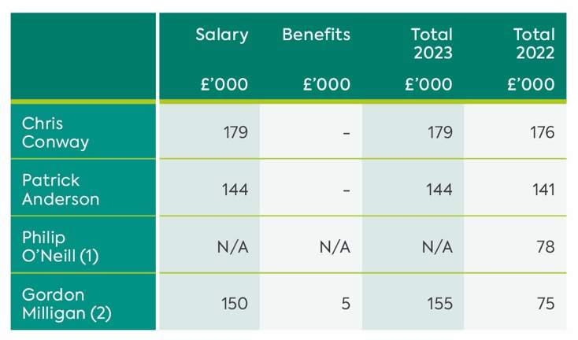
(1) 2022: To date of resignation (30 September 2021)
(2) From date of appointment (1 October 2021)
Executive Directors do not receive bonuses.

Pensions
Accrued benefits of the Executive Directors in respect of their defined benefit pension scheme entitlements in relation to their employment services to the Group were as follows:
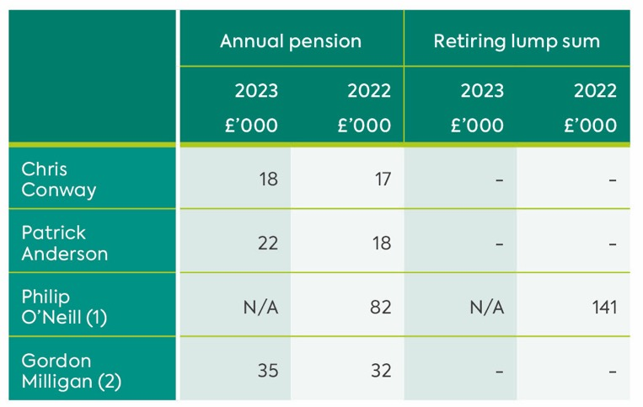
(1) 2022: To date of resignation (30 September 2021)
(2) From date of appointment (1 October 2021)

Excluding the effect of inflation, the accrued benefits of the Directors increased/(decreased) by:
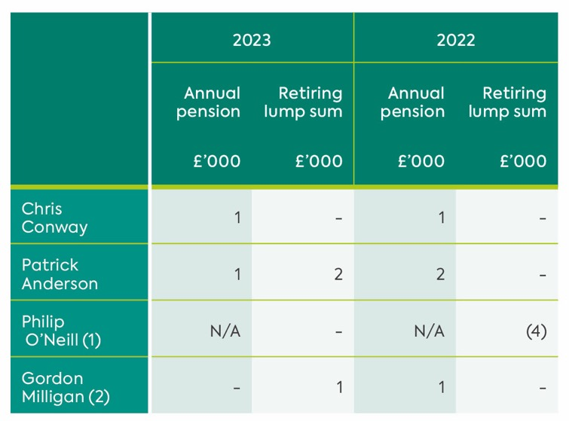
(1) 2022: To date of resignation (30 September 2021)
(2) From date of appointment (1 October 2021)

The executive Directors paid pension contributions in the period as follows:
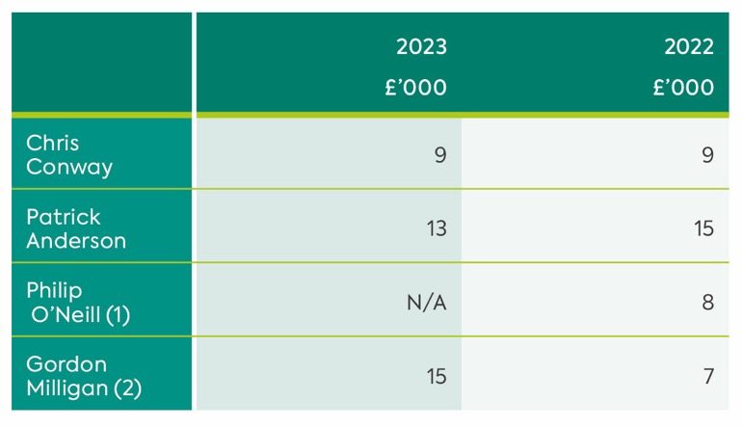
(1) 2022: To date of resignation (30 September 2021)
(2) From date of appointment (1 October 2021)

Non-Executive Directors
The appointment and remuneration of non-executive Directors is determined by the Department for Infrastructure. The non-executive Directors do not have service contracts, are not members of any of the Company’s pension arrangements and do not participate in any performance-related payment arrangements.

Details of the non-executive Directors’ emoluments are given in note 22 to the financial statements.

Marie Mallon
Chair
Remuneration and Pensions Committee
21 June 2023

Independent Auditor’s Report to the Members of Northern Ireland Transport Holding Company

Report on the Audit of the Financial Statements
Opinion
We have audited the financial statements of Northern Ireland Transport Holding Company (‘the Company’) and its consolidated undertakings (‘the Group’) for the year ended 26 March 2023 set out on pages 82 to 126 which comprise the consolidated income statement, consolidated statement of comprehensive income, consolidated balance sheet, company balance sheet, statement of changes in reserves, consolidated cash flow statement and related notes, including the summary of significant accounting policies set out in note 2. The financial reporting framework that has been applied in the preparation of the Group financial statements is UK Law, UK adopted international accounting standards and, as regards the Company financial statements, UK Law and FRS 101 Reduced Disclosure Framework.

In Our Opinion:
- the financial statements give a true and fair view of the state of the Group’s and of the Company’s affairs as at 26 March 2023 and of the Group’s loss for the year then ended;
- the Group financial statements have been properly prepared in accordance with UK
- adopted international accounting standards;
- the Company financial statements have been properly prepared in accordance with FRS 101 Reduced Disclosure Framework issued by the UK’s Financial Reporting Council; and
- the financial statements have been prepared in accordance with the requirements of the Companies Act 2006.d

Basis For Opinion
We conducted our audit in accordance with International Standards on Auditing (UK) (ISAs (UK)) and applicable law. Our responsibilities under those standards are further described in the Auditor’s responsibilities for the audit of the financial statements section of our report. We are independent of the Group in accordance with ethical requirements that are relevant to our audit of financial statements in the UK, including the Financial Reporting Council (FRC)’s Ethical Standard, and we have fulfilled our other ethical responsibilities in accordance with these requirements.
We believe that the audit evidence we have obtained is sufficient and appropriate to provide a basis for our opinion.

Conclusions Relating to Going Concern
The Directors have prepared the financial statements on the going concern basis as they do not intend to liquidate the Group or the Company or to cease their operations, and as they have concluded that the Group and the Company’s financial position means that this is realistic. They have also concluded that there are no material uncertainties that could have cast significant doubt over their ability to continue as a going concern for at least a year from the date of approval of the financial statements (“the going concern period”).

In our evaluation of the Directors’ conclusions, we considered the inherent risks to the Group and the Company’s business model and analysed how those risks might affect the Group and the Company’s financial resources or ability to continue operations over the going concern period.

In auditing the financial statements, we have concluded that the Directors’ use of the going concern basis of accounting in the preparation of the financial statements is appropriate.

Based on the work we have performed, we have not identified any material uncertainties relating to events or conditions that, individually or collectively, may cast significant doubt on the Group or the Company’s ability to continue as a going concern for a period of at least twelve months from the date when the financial statements are authorised for issue.

Our responsibilities and the responsibilities of the Directors with respect to going concern are described in the relevant sections of this report.

However, as we cannot predict all future events or conditions and as subsequent events may result in outcomes that are inconsistent with judgements that were reasonable at the time they were made, the absence of reference to a material uncertainty in this auditor’s report is not a guarantee that the Group or the Company will continue in operation.

Detecting Irregularities Including Fraud
We identified the areas of laws and regulations that could reasonably be expected to have a material effect on the financial statements and risks of material misstatement due to fraud, using our understanding of the entity’s industry, regulatory environment and other external factors and inquiry with the Directors. In addition, our risk assessment procedures included: inquiring with the Directors as to the Group’s policies and procedures regarding compliance with laws and regulations and prevention and detection of fraud; inquiring whether the Directors have knowledge of any actual or suspected non-compliance with laws or regulations or alleged fraud; inspecting the Group’s regulatory and legal correspondence; and reading Board/audit committee minutes.

We discussed identified laws and regulations, fraud risk factors and the need to remain alert among the audit team.

The Group is subject to laws and regulations that directly affect the financial statements including companies and financial reporting legislation. We assessed the extent of compliance with these laws and regulations as part of our procedures on the related financial statement items, including assessing the financial statement disclosures and agreeing them to supporting documentation when necessary.

The Group is subject to many other laws and regulations where the consequences of non-compliance could have a material effect on amounts or disclosures in the financial statements, for instance through the imposition of fines or litigation. We identified the following areas as those most likely to have such an effect: health and safety, environmental law.

Auditing standards limit the required audit procedures to identify non-compliance with these non-direct laws and regulations to inquiry of the Directors and other management and inspection of regulatory and legal correspondence, if any. These limited procedures did not identify actual or suspected non-compliance.

We assessed events or conditions that could indicate an incentive or pressure to commit fraud or provide an opportunity to commit fraud. As required by auditing standards, we performed procedures to address the risk of management override of controls. On this audit we do not believe there is a fraud risk related to revenue recognition. We did not identify any additional fraud risks.

In response to risk of fraud, we also performed procedures including identifying journal entries to test based on risk criteria and comparing the identified entries to supporting documentation; evaluating the business purpose of significant unusual transactions; assessing significant accounting estimates for bias; and assessing the disclosures in the financial statements.

Owing to the inherent limitations of an audit, there is an unavoidable risk that we may not have detected some material misstatements in the financial statements, even though we have properly planned and performed our audit in accordance with auditing standards. For example, the further removed non-compliance with laws and regulations (irregularities) is from the events and transactions reflected in the financial statements, the less likely the inherently limited procedures required by auditing standards would identify it.

In addition, as with any audit, there remains a higher risk of non-detection of irregularities, as these may involve collusion, forgery, intentional omissions, misrepresentations, or the override of internal controls. We are not responsible for preventing non-compliance and cannot be expected to detect non-compliance with all laws and regulations.

Other Information
The Directors are responsible for the other information presented in the Annual Report together with the financial statements. The other information comprises the information included in the strategic report and the Directors’ report, Directors’ responsibilities, corporate governance statement, audit and risk committee report, safety oversight committee report, project oversight committee report, and Directors’ remuneration report. The financial statements and our auditor’s report thereon do not comprise part of the other information. Our opinion on the financial statements does not cover the other information and, accordingly, we do not express an audit opinion or, except as explicitly stated below, any form of assurance conclusion thereon.

Our responsibility is to read the other information and, in doing so, consider whether, based on our financial statements audit work, the information therein is materially misstated or inconsistent with the financial statements or our audit knowledge. Based solely on that work we have not identified material misstatements in the other information.

Opinions on Other Matters Prescribed by the Companies Act 2006
Based solely on our work on the other information undertaken during the course of the audit:

- we have not identified material misstatements in the Directors’ report or the strategic report;
- in our opinion, the information given in the Directors’ report and the strategic report is consistent with the financial statements;
- in our opinion, the Directors’ report and the strategic report have been prepared in accordance with the Companies Act 2006.

Matters on which we are required to report by exception
Under the Companies Act 2006 we are required to report to you if, in our opinion:

- adequate accounting records have not been kept by the Company, or returns adequate for our audit have not been received from branches not visited by us; or
- the Company financial statements are not in agreement with the accounting records and returns; or
- certain disclosures of Directors’ remuneration specified by law are not made; or
- we have not received all the information and explanations we require for our audit.
- we have nothing to report in these respects.

Respective Responsibilities and Restrictions On Use
Responsibilities of Directors for the Financial Statements
As explained more fully in the Directors’ responsibilities statement set out on page 41, the Directors are responsible for: the preparation of the financial statements including being satisfied that they give a true and fair view; such internal control as they determine is necessary to enable the preparation of financial statements that are free from material misstatement, whether due to fraud or error; assessing the Group and Company’s ability to continue as a going concern, disclosing, as applicable, matters related to going concern; and using the going concern basis of accounting unless they either intend to liquidate the Group and Company or to cease operations, or have no realistic alternative but to do so.

Auditor’s Responsibilities for the Audit of the Financial Statements
Our objectives are to obtain reasonable assurance about whether the financial statements as a whole are free from material misstatement, whether due to
fraud, other irregularities or error, and to issue an opinion in an auditor’s report. Reasonable assurance is a high level of assurance but is not a guarantee that an audit conducted in accordance with ISAs (UK) will always detect a material misstatement when it exists. Misstatements can arise from fraud, other irregularities or error and are considered material if, individually or in the aggregate, they could reasonably be expected to influence the economic decisions of users taken on the basis of these financial statements.

A fuller description of our responsibilities is provided on the FRC’s website at: www.frc.org.uk/auditorsresponsibilities.

The Purpose of Our Audit Work and to Whom We Owe Our Responsibilities
Our report is made solely to the Company’s members, as a body, in accordance with Chapter 3 of Part 16 of the Companies Act 2006. Our audit work has been undertaken so that we might state to the Company’s members those matters we are required to state to them in an auditor’s report and for no other purpose. To the fullest extent permitted by law, we do not accept or assume responsibility to anyone other than the Company and the Company’s members, as a body, for our audit work, for this report, or for the opinions we have formed.

Opinion on Regularity
In our opinion, in all material respects, the expenditure (dispersed) and income (received) have been applied to the purposes intended by, and the financial transactions confirm to, the authorities which govern them.

John Poole
Senior Statutory Auditor
23 June 2023

For and on behalf of
KPMG Statutory Auditor
The Soloist Building
1 Lanyon Place
Belfast
BT1 3LP

Consolidated Income Statement

for the 52 weeks ended 26 March 2023
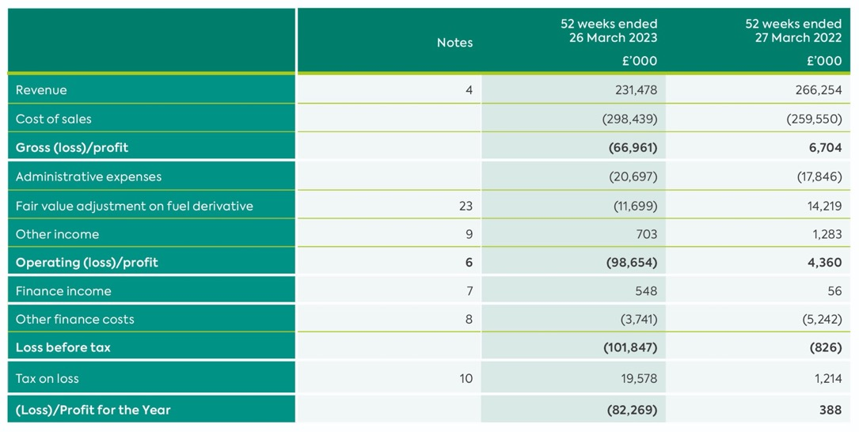
All reported results arise from continuing operations.
The notes on pages 82 to 126 form part of these consolidated financial statements.

Consolidated Statement of Comprehensive Income

for the 52 weeks ended 26 March 2023
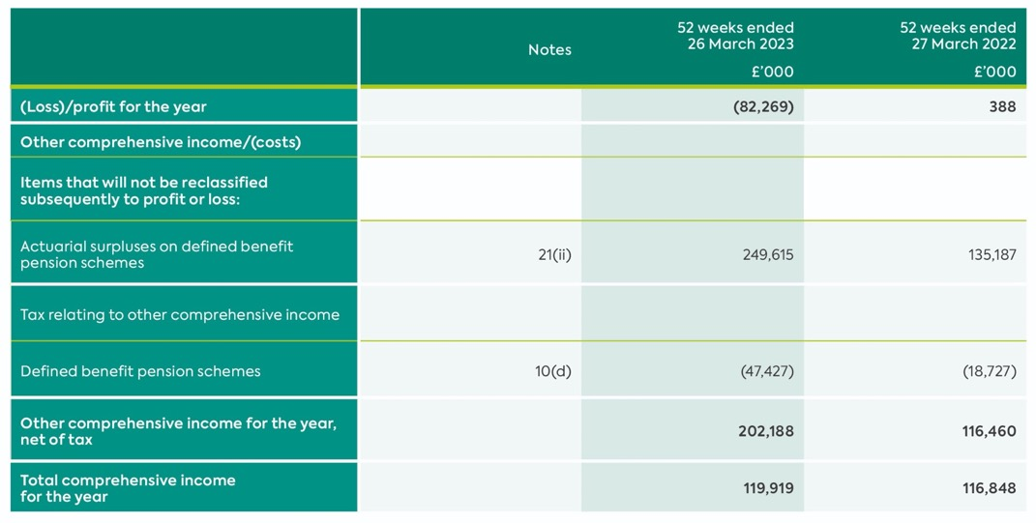
All reported results arise from continuing operations.
The notes on pages 82 to 126 form part of these consolidated financial statements.

Consolidated Balance Sheet

at 26 March 2023
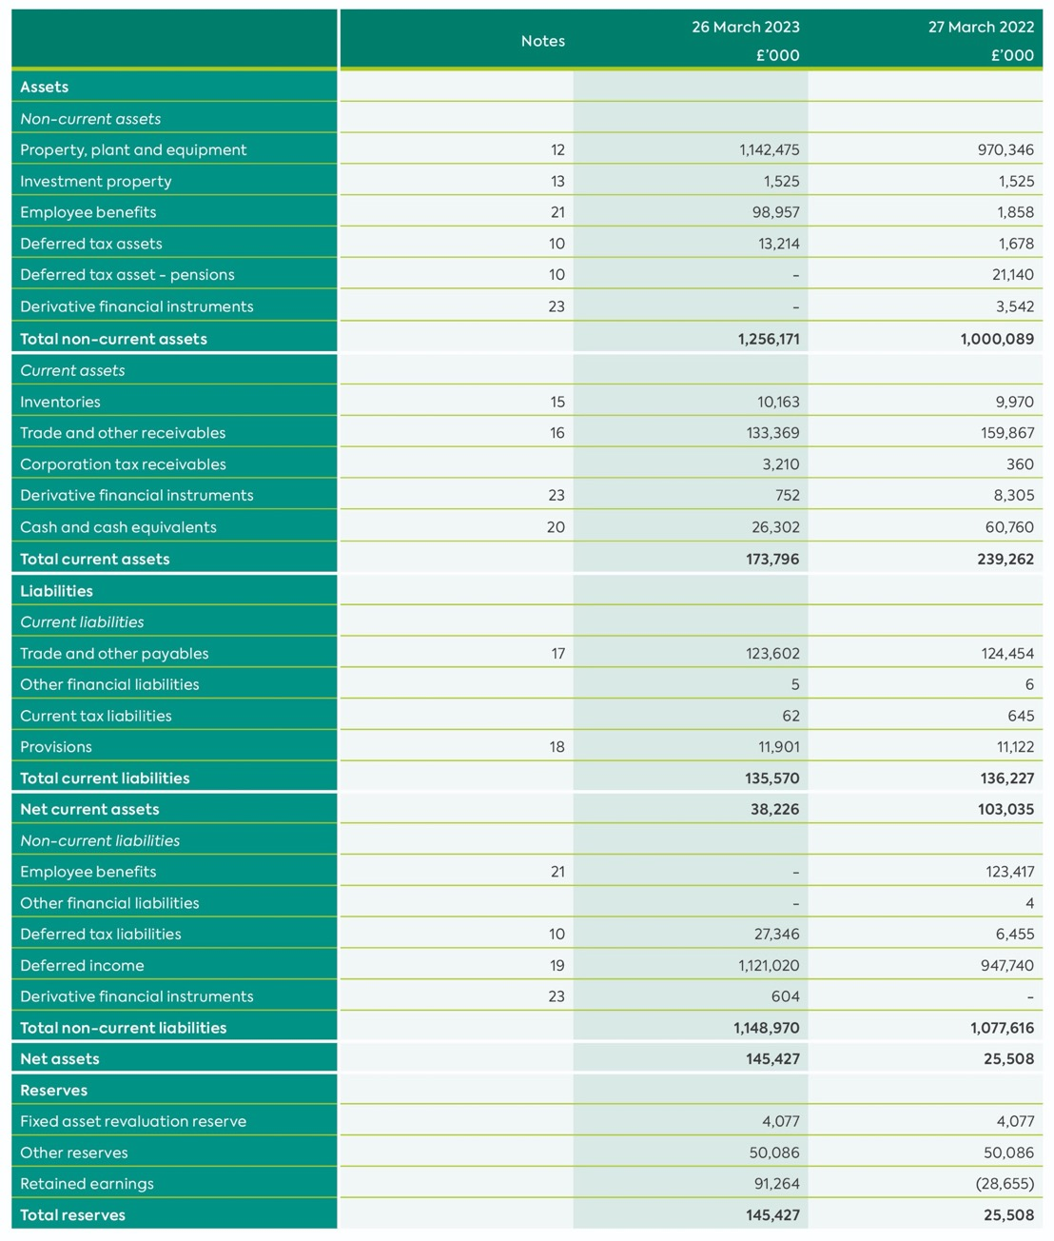
The financial statements were approved by the board of Directors and authorised for issue on 21 June 2023.

They were signed on its behalf by:
M Wardlow (Chair)
C Conway (Group Chief Executive)
The notes on pages 82 to 126 form part of these consolidated financial statements.

Company Balance Sheet

at 26 March 2023
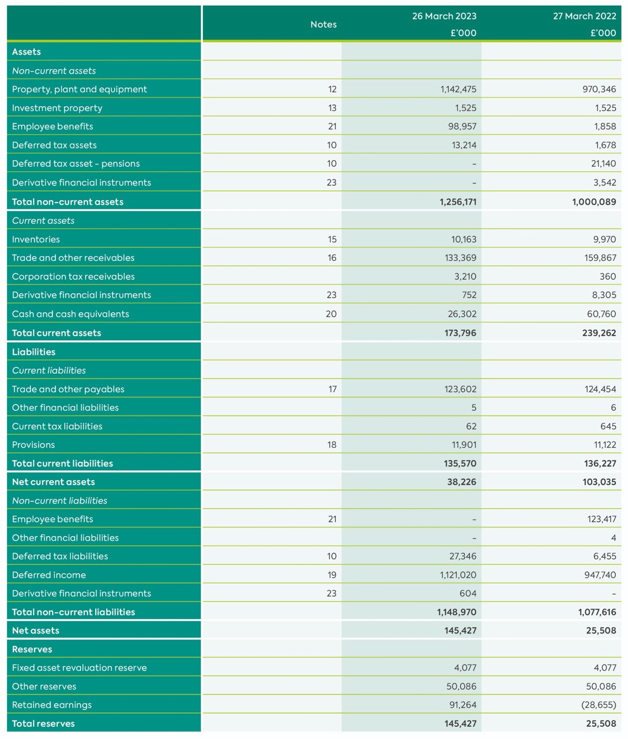
As permitted by s408 of the Companies Act 2006, the profit and loss account of the parent Company is not presented as part of these financial statements. The parent Company’s loss for the financial period amounted to £478,000 (2022: Loss of £2,476,000).
The financial statements were approved by the board of Directors and authorised for issue on 21 June 2023.

They were signed on its behalf by:

M Wardlow (Chair)
C Conway (Group Chief Executive)

The notes on pages 82 to 126 form part of these consolidated financial statements.

Statement of Changes in Reserves

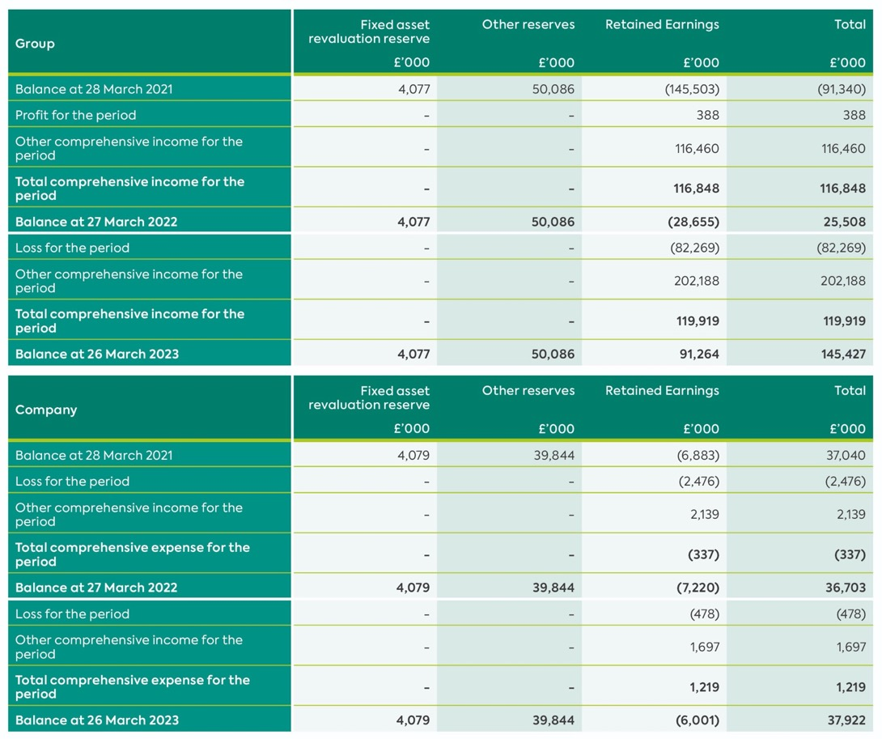

Consolidated Cash Flow Statement

for the 52 weeks ended 26 March 2023
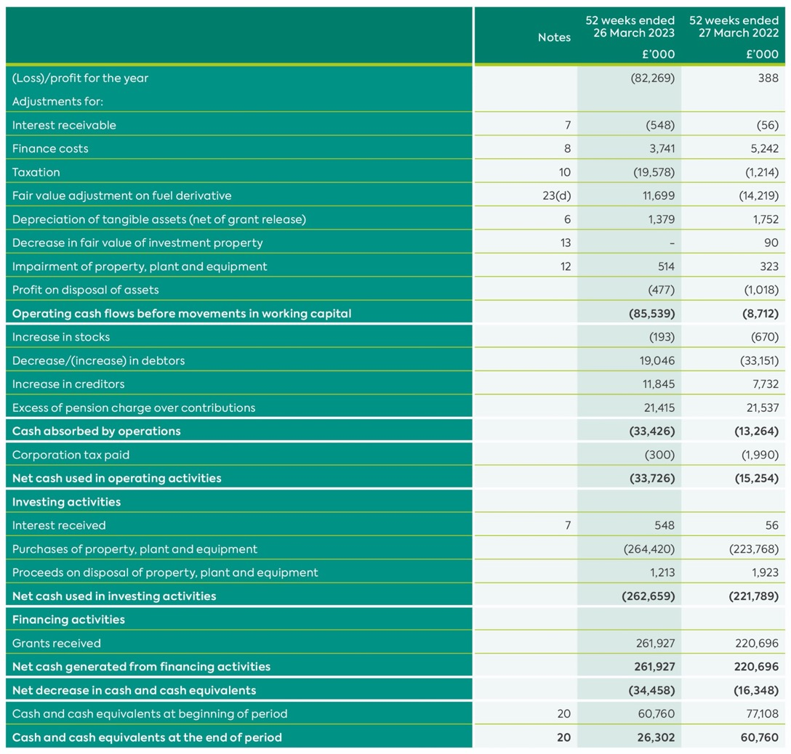

Notes to the Consolidated Financial Statements

1. General Information
The Northern Ireland Transport Holding Company (the Company) is a Public Corporation incorporated in Northern Ireland under the Transport Act (Northern Ireland) 1967, which requires compliance with Companies legislation with regard to accounts and audit. It follows that presentation requirements of IFRS and disclosure requirements of the Companies Act 2006 apply.
The addresses of its registered office and principal place of business are disclosed on page 3. The principal activities of the Company and its subsidiaries (the Group) are described in the Strategic Report on page 10.

All references in the financial statements to “the Department” relate to the Department for Infrastructure.

2. Significant Accounting Policies
Statement of Compliance
The Group financial statements have been prepared and approved by the Directors in accordance with Companies Act 2006 and UK-adopted international accounting standards in conformity with the requirements of the Companies Act 2006 (‘UK Adopted IFRSs’)”.

Basis of Preparation
The principal accounting policies adopted in the preparation of these financial statements are set out below. These policies have been consistently applied to the Group and parent company unless otherwise indicated and to all years presented, unless otherwise stated.

The financial statements are prepared in accordance with UK Adopted International Financial Reporting Standards (“UK Adopted IFRS”) and with those parts of the Companies Act applicable to companies reporting under IFRS.

The parent company meets the definition of a qualifying entity under FRS 100 (Financial Reporting Standard 100) issued by the Financial Reporting Council. The financial statements have therefore been prepared in accordance with FRS 101 (Financial Reporting Standard 101) ‘Reduced Disclosure Framework’ as issued by the Financial Reporting Council.
As permitted by FRS 101, the company has taken advantage of the disclosure exemptions available under that standard in relation to business combinations, share-based payment, non-current assets held for sale, financial instruments, capital management, presentation of comparative information in respect of certain assets, presentation of a cash-flow statement, standards not yet effective, impairment of assets, transactions with wholly owned subsidiaries, compensation for key management personnel and certain disclosures required by IFRS 17 Fair Value Measurement and the disclosures required by IFRS 7.

On publishing the Group financial statements together with the Company financial statements, the Company is taking advantage of the exemption in Section 408 of the Companies Act 2006 not to present its individual income statement and related notes that form a part of those approved financial statements.

The financial statements have been prepared under the historical cost convention as modified by investment properties, financial assets and financial liabilities (including derivative instruments) at fair value.

The financial statements are presented in pounds sterling, being the functional currency of the Company and each of its subsidiaries and all values are rounded to the nearest one thousand pounds except where otherwise noted.

Basis of consolidation
The consolidated financial statements incorporate the financial statements of the Company and entities controlled by the Company (its subsidiaries) for the 52 weeks to 26 March 2023 (52 weeks to 27 March 2022). Control is achieved where the Company, is expected to, or has rights to variable returns from its involvement with the entity and has the ability to affect those returns through its power over the entity.

All intra-group transactions, balances, income and expenses are eliminated in full on consolidation.

Going concern
The Company’s business activities together with factors likely to affect its future developments are set out in the Directors’ report. On the basis of their assessment, the Directors believe that the Company is well placed to manage its risks successfully.

After making enquiries, the Directors have reasonable expectation that the Company has adequate resources to continue in operational existence for the foreseeable future. Accordingly, they continue to adopt the going concern basis in preparing the annual report and financial statements.

Inherited pension and compensation payments
The Company has a statutory responsibility for the administration and payment of various pension and compensation liabilities inherited from the Ulster Transport Authority and the Belfast Corporation Transport Department. The Department reimburses the deficit of £87,000 (2022: £116,000) and have confirmed that it is the intention to fund this deficit going forward and in consequence, none of the inherited pension and compensation expenditure has been included in the financial statements.

Presentation of income statement and exceptional items
Where applicable, income statement information has been presented in a format which separately highlights exceptional items. Exceptional items include those which individually, or, if similar in nature, in aggregate, need to be disclosed by virtue of their nature, size or incidence in order to allow a proper understanding of the financial performance of the Group.

Revenue recognition
Revenue represents gross revenue earned from public transport services operated in accordance with the Public Service Agreement, including amounts receivable from concessionary fares schemes, for Public Service Obligation compensation and route subsidy, as well as rental income from investment properties and operational properties. Where appropriate, amounts are shown net of rebates and VAT. Revenue is measured at the fair value of the consideration received or receivable.

Revenue is recognised by reference to the stage of completion of the customer’s travel. Cash received for the sale of season tickets, travelcards and multi-journey smartcards is deferred within liabilities and recognised in the income statement over the period of the relevant ticket.

Income from advertising and other activities is recognised as income is earned.

Finance income is recognised using the effective interest method as interest accrues.

Property, plant and equipment
Property, plant and equipment held for use in the supply of goods or services to customers or for administration purposes are stated at cost less accumulated depreciation and accumulated impairment losses.

Depreciation is charged to the profit and loss account on a straight-line basis, over the useful lives of each tangible fixed asset. The estimated useful lives are as follows:

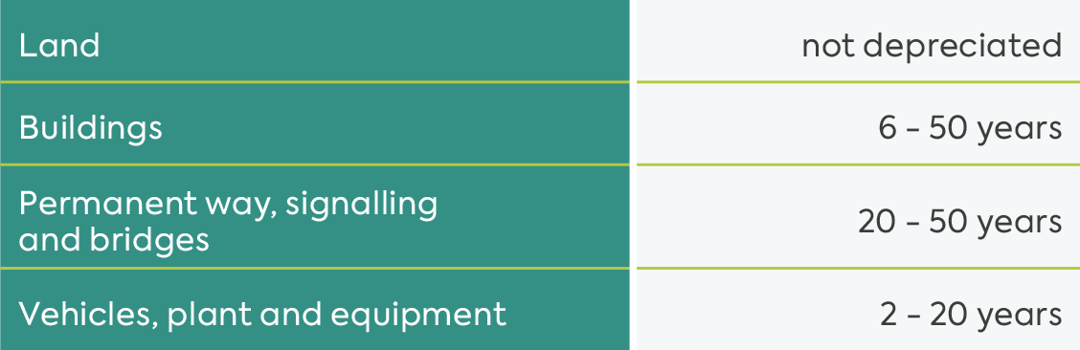

The carrying values of property, plant and equipment are reviewed for impairment at each balance sheet date, if events or changes in circumstances indicate the carrying value may not be recoverable. An impairment loss is recognised in profit or loss for the amounts by which the carrying value of the asset exceeds its recoverable amount, which is the higher of fair value less costs to sell and value in use.

Where an impairment loss subsequently reverses, the carrying amount of the assets is increased to the revised estimate of its recoverable amount, but so that the increased carrying amount does not exceed the carrying amount that would have been determined had no impairment loss been recognised in prior years. A reversal of an impairment loss is recognised immediately in the income statement unless the relevant asset is carried at a revalued amount, in which case the reversal is treated as a revaluation increase.

Depreciation commences when assets are ready for their intended use. Depreciation methods, useful lives and residual values are reviewed at each balance sheet date.

Subsequent expenditure is capitalised only if it is probable that the future economic benefits associated with the expenditure will flow to the Group.

Prior to March 2000 the Group obtained valuations of certain properties (other than investment properties). The valuations have not been updated since this date and due to the age of the properties and the fact that a substantial portion were inherited, it is not practicable to state the difference between such valuations and historic cost. The March 2000 carrying values have therefore been adopted as deemed cost as the directors are of the view that the fair value of such assets cannot be reliably measured.

Investment in subsidiaries
In the parent company financial statements, investments in subsidiaries are shown at cost less provision for impairment.

Investment property
Investment properties are properties held to earn rentals and/or for capital appreciation (including property under construction for such purposes). Investment properties are measured initially at cost, including transaction costs. Subsequent to initial recognition, investment properties are measured at fair value at the balance sheet date. Gains and losses arising from changes in the fair value of investment properties are included through revenues in profit or loss in the period in which they arise.

An investment property is derecognised upon disposal or when the investment property is permanently withdrawn from use and no future economic benefits are expected from it. Any gain or loss arising on derecognition of the property (calculated as the difference between the net disposal proceeds and the carrying amount of the asset) is included in profit or loss in the period in which the property is derecognised.

Government grants
Government grants are not recognised until there is reasonable assurance that the Group will comply with the conditions attaching to them and that the grants will be received.

Government grants are recognised in the consolidated income statement on a systematic basis over the periods in which the Group recognises as expenses the related costs for which the grants are intended to compensate. Specifically, government grants whose primary condition is that the Group should purchase, construct or otherwise acquire non-current assets are recognised as deferred revenue in the consolidated balance sheet and transferred to income on a systematic and rational basis over the useful lives of the related assets.

Government grants that are receivable as compensation for expenses or losses already incurred or for the purpose of giving immediate financial support to the Group with no future related costs are recognised as income against the expense line in which the related cost was incurred in the consolidated income statement in the period in which they become receivable.

Inventories
Inventories represent consumable stores and are valued at the lower of weighted average cost and estimated net realisable value.

Employee benefit costs
The majority of employees of the Group are members of the Northern Ireland Local Government Officers’ Superannuation Scheme which is a ‘multi-employer’ defined benefit pension scheme.

For defined benefit retirement plans, the cost of providing benefits is determined using the Straight-Line Method, with updates to formal actuarial valuations being carried out at the end of each reporting period. Remeasurement comprising actuarial gains and losses, and the return on scheme assets (excluding interest) are recognised immediately in the balance sheet with a charge or credit to the statement of comprehensive income in the period in which they occur. Remeasurement recorded in the statement of comprehensive income is not recycled. Past service cost is recognised in income in the period of scheme amendment. Net interest is calculated by applying a discount rate to the net defined liability or asset.

Defined benefit costs are split into three categories:
- current service cost, past service cost and losses on curtailments and settlements;
- net interest expense or income; and
- remeasurement.

The Group presents the first component of defined benefit costs within cost of sales and administrative expenses (see note 21) in its consolidated income statement. Curtailment gains and losses are accounted for as past service cost.

Net interest expense or income is recognised within other finance costs (note 8).

The employee benefit obligation recognised in the consolidated balance sheet represents the deficit or surplus in the defined benefit schemes.

Leases
At the inception of a contract, the Company assesses whether a contract is, or contains, a lease. A contract is, or contains, a lease if the contract conveys the right to control the use of an identified asset for a period of time in exchange for consideration.

As a lessee at commencement or on modification of a contract that contains a lease component, along with one or more other lease or non-lease components, the Company accounts for each lease component separately from the non-lease components. The Company allocates the consideration in the contract to each lease component on the basis of its relative stand-alone price and the aggregate stand-alone price of the non-lease components. The Company recognises a right-of-use asset and a lease liability at the lease commencement date. The right-of-use asset is initially measured at cost, which comprises the initial amount of the lease liability adjusted for any lease payments made at or before the commencement date, plus any initial direct costs incurred, less any lease incentives received. The right-of-use asset is subsequently depreciated using the straight-line method from the commencement date to the end of the lease term, unless the lease transfers ownership of the underlying asset to the Company by the end of the lease term or the cost of the right-of-use asset reflects that the Company will exercise a purchase option.

In that case the right-of-use asset will be depreciated over the useful life of the underlying asset, which is determined on the same basis as those of property and equipment. In addition, the right-of-use asset is periodically reduced by impairment losses, if any, and adjusted for certain remeasurements of the lease liability. The lease liability is initially measured at the present value of the lease payments that are not paid at the commencement date, discounted using the interest rate implicit in the lease or, if that rate cannot be readily determined, the Company's incremental borrowing rate, this has been assessed as 5%. Lease payments included in the measurement of the lease liability comprise the following: - fixed payments, including in-substance fixed payments; - variable lease payments that depend on an index or a rate, initially measured using the index or rate as at the commencement date - amounts expected to be payable under a residual value guarantee; and - the exercise price under a purchase option that the Company is reasonably certain to exercise, - lease payments in an optional renewal period if the Company is reasonably certain to exercise an extension option, and - penalties for early termination of a lease unless the Company is reasonably certain not to terminate early.

The lease liability is measured at amortised cost using the effective interest method. It is remeasured when there is a change in future lease payments arising from a change in an index or rate, there is a change in the Company's estimate of the amount expected to be payable under a residual value guarantee, if the Company changes its assessment of whether it will exercise a purchase, extension or termination option or if there is a revised in substance fixed lease payment. When the lease liability is remeasured in this way, a corresponding adjustment is made to the carrying amount of the right-of-use asset, to the extent that the right-of-use asset is reduced to nil, with any further adjustment required from the remeasurement being recorded in profit or loss. The Company presents right-of-use assets that do not meet the definition of investment property in 'property, plant and equipment' and lease liabilities in 'loans and borrowings' in the statement of financial position.

Short-term leases and leases of low-value assets
The Company has elected not to recognise right-of-use assets and lease liabilities for lease of low-value assets and short-term leases. The Company recognises the lease payments associated with these leases as an expense on a straight-line basis over the lease term.

Taxation
Current tax, including UK corporation tax, is provided at amounts expected to be paid (or recovered) using the tax rates and laws that have been enacted or substantively enacted by the balance sheet date. The amount of current tax receivable or payable reflects the best estimate.

Deferred tax is recognised in respect of all temporary differences that have originated but not reversed at the balance sheet date where transactions or events have occurred at that date that will result in an obligation to pay more, or a right to pay less tax in the future, with the following exception:

- deferred tax assets are recognised only to the extent that the directors consider that it is more likely than not that there will be suitable taxable profits from which the future reversal of the underlying temporary differences can be deducted.

Deferred tax is measured on an undiscounted basis at the tax rates that are expected to apply in the periods in which timing differences reverse, based on tax rates and laws enacted or substantively enacted at the balance sheet date.

Third party claims provisions
Provisions are recognised when the Group has a present obligation (legal or constructive) as a result of a past event, it is probable that the Group will be required to settle that obligation and a reliable estimate can be made of the amount of the obligation.

Any surplus realised or expected to be realised on the settlement of claims, is included in the results for the period. Consequential loss claims, under criminal injuries legislation, are estimated and taken into account in determining the operating results, pending agreement with the Department of Justice.

The Group receives claims in respect of traffic incidents and employee claims. The Group protects against the cost of such claims through third party insurance policies. An element of the claims is not insured as a result of the “excess” or “deductible” on insurance policies.

Provision is made on a discounted basis for the estimated cost to the Group to settle claims for incidents occurring prior to the balance sheet date. The estimate of the balance sheet insurance provisions is based on an assessment of the expected settlement of known claims together with an estimate of settlements that will be made in respect of incidents occurring prior to the balance sheet date but for which claims have not yet been reported to the Group.

The provision is set after taking account of advice from third party insurers and solicitors.

As the timing of settlement cannot be predicted with reasonable reliability, all liabilities are classified as current.

Corporate Social Responsibility Provision
Provision is made for obligations arising from the Group’s Health and Safety obligations and current Environmental Contamination policy. The provision is set after taking advice from third party environmental technical advisors.

Restructuring provisions
Provisions for restructuring are recognised when the Company has a present legal or constructive obligation as a result of past events and a reliable estimate of associated costs can be made.

Foreign Currency
Transactions in foreign currencies are translated into sterling at the rate of exchange ruling at the date of the transaction. Monetary assets and liabilities denominated in foreign currencies are translated into sterling at the rates of exchange ruling at the balance sheet date. Foreign exchange differences arising on translation are recognised in the profit and loss account.

The principal rates of exchange applied to the financial statements were:
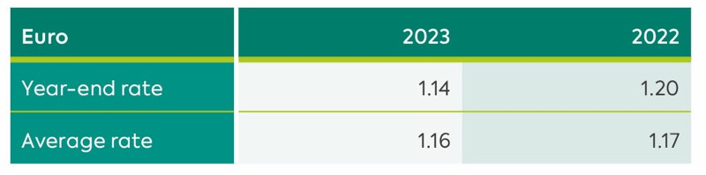

Financial Instruments
Financial assets and financial liabilities are recognised in the Group’s balance sheet when the Group becomes a party to the contractual provisions of the instrument.

Financial Assets
The Group measures its financial assets on initial recognition at fair value and determines the classification of such assets at initial recognition. Where there is no active market for a financial asset, fair value is determined using valuation techniques including recent commercial transactions and discounted cash flows. Otherwise, financial assets are carried at amortised cost.

Financial assets that have fixed or determinable payments and are not quoted in an active market are classified as loans and receivables.

Financial Assets at Amortised Cost
Loans and receivables are measured at amortised cost using the effective interest method less any impairment. The carrying amount of these assets approximates to their fair value.

Impairment of Financial Assets
Financial assets are assessed for indicators of impairment at each balance sheet date. Financial assets are impaired where there is objective evidence that, as a result of one or more events that occurred after the initial recognition of the financial asset, the estimated future cash flows
of the asset have been negatively affected.

For financial assets carried at amortised cost, the amount of the impairment is the difference between the asset’s carrying amount and the present value of estimated future cash flows, discounted at the financial asset’s original effective interest rate.

The carrying amount of the financial asset is reduced by the impairment loss directly for all financial assets with the exception of trade receivables, where the carrying amount is reduced through the use of a provisions account. When a trade receivable is considered uncollectible, it is written off against the related provisions account. Subsequent recoveries of amounts previously written off are credited to the profit and loss account. Changes in the carrying amount of the provisions account are recognised in profit or loss.

The company recognises loss allowances for expected credit losses (ECLs) on financial assets measured at amortised cost.

The company measures loss allowances at an amount equal to lifetime ECL, except for other debt securities and bank balances for which credit risk (i.e. the risk of default occurring over the expected life of the financial instrument) has not increased significantly since initial recognition which are measured as 12-month ECL.

Derecognition of Financial Assets
The Group derecognises a financial asset only when the contractual rights to the cash flows from the asset expire, or when it transfers the financial asset and substantially all the risks and rewards of ownership of the asset to another entity.

If the Group neither transfers nor retains substantially all the risks and rewards of ownership and continues to control the transferred asset, the Group recognises its retained interest in the asset and an associated liability for amounts it may have to pay.

If the Group retains substantially all the risks and rewards of ownership of a transferred financial asset, the Group continues to recognise the financial asset and also recognises a collateralised borrowing for the proceeds received.

On derecognition of a financial asset in its entirety, the difference between the asset’s carrying amount and the sum of the consideration received and receivable is recognised in profit or loss.

Financial Liabilities
Derivative Financial Instruments
Derivative financial instruments are initially recognised at fair value on the date on which a derivative contract is entered into and are subsequently re-measured at fair value at each balance sheet date. The resulting gain or loss is recognised in profit or loss immediately unless
the derivative is effective as a cashflow hedging instrument, in which event the timing of the recognition in profit or loss depends on the nature of the hedge relationship. Derivatives are carried as financial assets when the fair value is positive and as financial liabilities when the fair value is negative.

A derivative is presented as a non-current asset or a non-current liability if the remaining maturity of the instrument is more than 12 months and it is not expected to be realised or settled within 12 months. Other derivatives are presented as current assets or current liabilities.

Other Financial Liabilities
Other financial liabilities, including borrowings, are initially measured at fair value, net of transaction costs.
Other financial liabilities are subsequently measured at amortised cost using the effective interest method, with interest expense recognised on an effective yield basis.

The effective interest method is a method of calculating the amortised cost of a financial liability and of allocating interest expense over the relevant period. The effective interest rate is the rate that exactly discounts estimated future cash payments through the expected life of the financial liability, or, where appropriate, a shorter period, to the net carrying amount on initial recognition.

Derecognition of Financial Liabilities
The Group derecognises financial liabilities when, and only when, the Group’s obligations are discharged, cancelled or have expired. The difference between the carrying amount of the financial liability derecognised and the consideration paid and payable is recognised in profit or loss.

Cash and Cash Equivalents
For the purposes of the cash flow statement, cash and cash equivalents comprise cash on hand, deposits held at call with banks and other short-term highly liquid investments.

Use of Estimates and Critical Judgements
The presentation of financial statements in conformity with IFRS requires the use of estimates and assumptions that affect the reported amounts of assets and liabilities at the date of the financial statements and the reported amounts of revenues and expenses for the period. Although these estimates are based on management’s best knowledge, actual results may ultimately differ from those estimates and assumptions used.

The key sources of estimation uncertainty that have a significant risk of causing material adjustments to the carrying amounts of assets and liabilities within the next financial year are:

- the measurement of tax assets and liabilities (including recoverability of deferred tax assets). The measurement of tax assets and liabilities requires an assessment to be made of the potential tax consequences of certain items that will only be resolved when agreed by the relevant tax authorities (see note 10).
- the measurement of retirement obligations. The measurement of retirement benefit obligations requires the estimation of life expectancies, future changes in salaries, inflation, the expected return on scheme assets and the selection of a suitable discount rate (see note 21).
- the measurement of investment property carrying values. The measurement of investment properties fair values requires estimate of appropriate yields and forecast rental values (see note 13).
- the measurement of impairment of fixed assets. The measurement of impairment requires the comparison of book value with market value (see note 12).
- the measurement of the fair value of derivative financial instruments is based on information provided by banking institutions with high credit ratings (see note 23)
- the measurement of third party and other claims provisions. The estimation of the third party claims provision is based on an assessment of the expected settlement of known claims together with an estimate of settlements that will be made in respect of incidents occurring prior to the balance sheet date but for which claims have not yet been reported to the Group (see note 18).

3. Application of New and Revised International Financial Reporting Standards (IFRSs)
Newly Adopted Standards
The following standards were effective for the Company for the first time from 28 March 2022 and have no transitional adjustments:

- COVID-19-Related Rent Concessions beyond 30 June 2021 (Amendment to IFRS 16)
- Onerous Contracts Cost of Fulfilling a Contract (Amendments to IAS 37)
- Annual Improvements to IFRS Standards 2018-2020
- Property, Plant and Equipment: Proceeds before Intended Use (Amendments to IAS 16)
- Reference to the Conceptual Framework (Amendments to IFRS 3)

4. Revenue
Revenue comprises mainly income from passenger carriage, rents, the reimbursement by the Department of concessionary fares and public service obligation compensation. Revenue excludes value added tax where applicable.
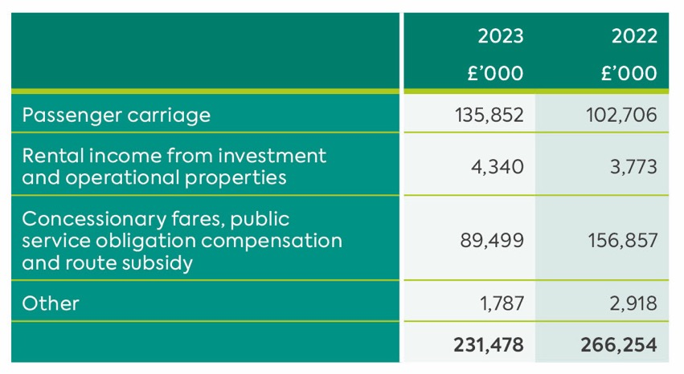

No geographical analysis of turnover across markets is provided as the Directors consider that such disclosure would be seriously prejudicial to the interests of the Group. Further details of revenue funding from the Department are given in note 24.

5. Impairment
In accordance with International Accounting Standard 36 “Impairment of Assets”, and as a consequence of the historic loss-making status of Northern Ireland Railways Company Limited, and the current loss-making status of Ulsterbus Limited and Citybus Limited, the Directors have performed an impairment review and as a consequence, assets that are not fully grant funded have been impaired to the extent that the carrying amount may not be recoverable.

Impairment losses recognised in previous periods may be reversed in the current period as a result of improved valuations, asset disposals or adjustments to related grant funding.

In the current year, the total amount of the charge for impairment amounts to £514,000 (2022: £323,042).

6. Operating (Loss)/Profit

Operating (loss)/profit for the year has been arrived at after charging/(crediting):

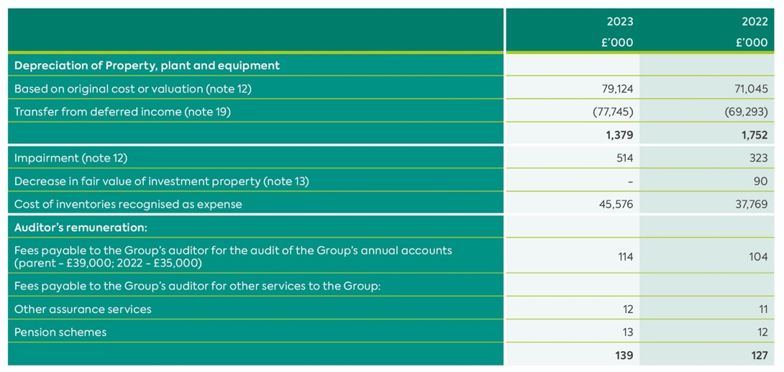

7. Finance Income
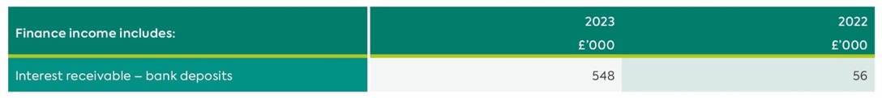

8. Other Finance Costs
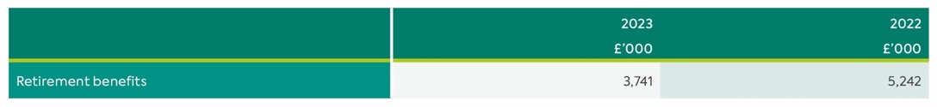

9. Other Income
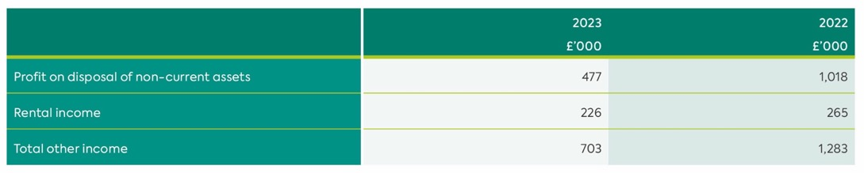10. Taxation
(a) Analysis of tax credit for year

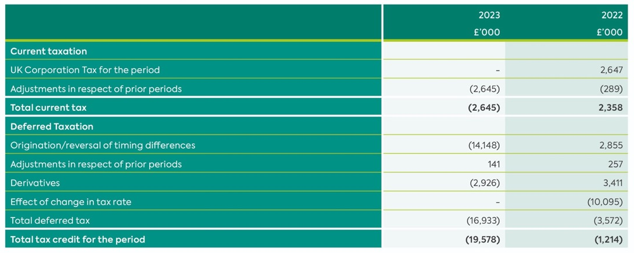

(b) Factors Affecting Tax Credit for the Year
The credit for the year can be reconciled to the result per income statement as follows:

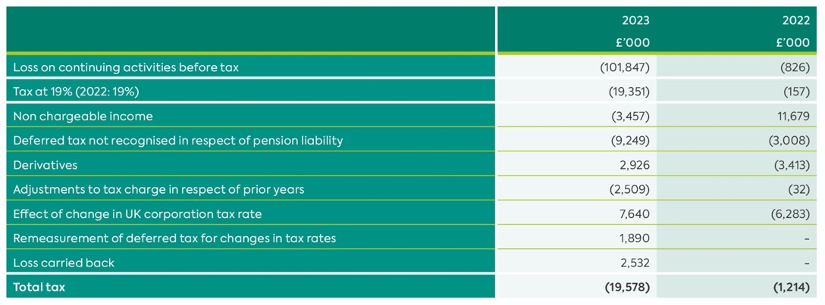

(c) Factors That May Affect Future Tax Charges
On 3 March 2021 the Chancellor of the Exchequer announced the intention to increase the corporation tax rate from 19% to 25% effective from 1 April 2023. This has now been substantively enacted and as a result a rate change adjustment has arisen in respect of deferred tax which is expected to unwind at the higher rate of 25%.

(d) Tax On Items Taken Directly To Other Comprehensive Income
In addition to the amount charged to the income statement, the following amounts relating to tax have been recognised in other comprehensive income:

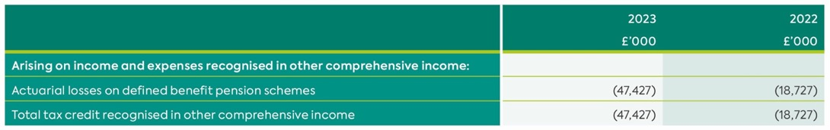

Deferred Tax
The following are the major tax liabilities and assets recognised by the Group and Company and movements thereon during the current and prior reporting period:

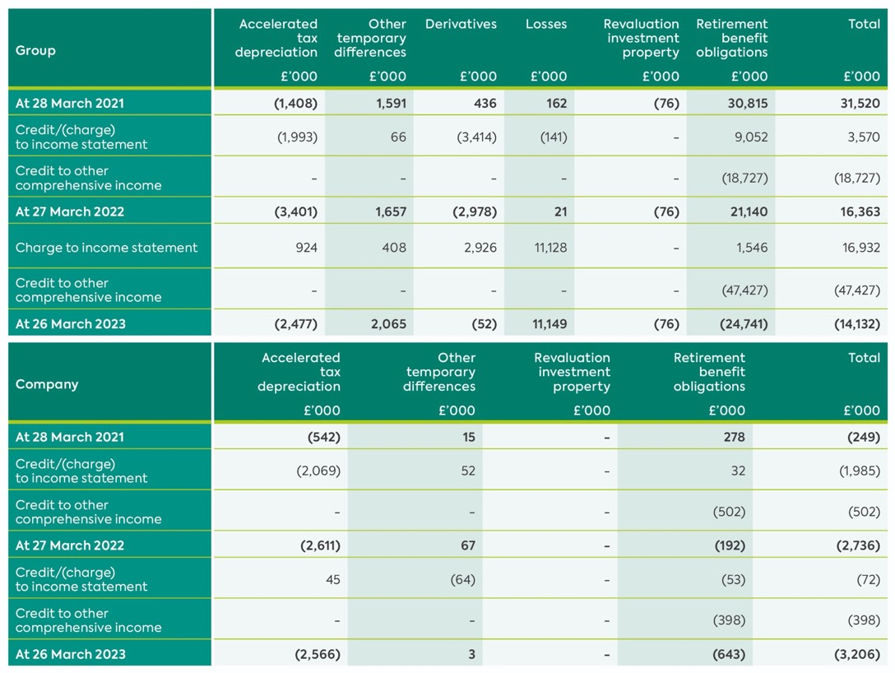

Deferred tax assets and liabilities are offset where the Group has a legally enforceable right to do so.

The following is the analysis of the deferred tax balance (after offset) for financial reporting purposes:

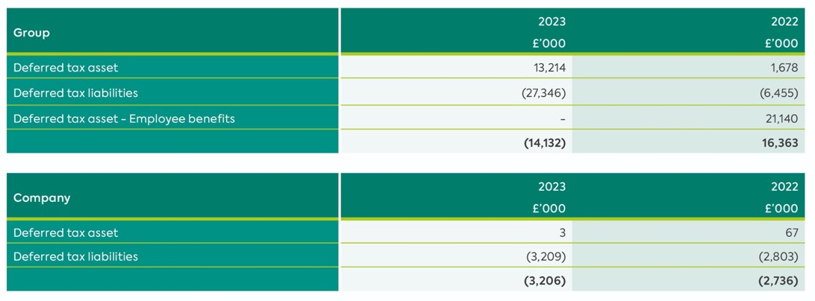

11. Profit of Parent Company
As permitted by s408 of the Companies Act 2006, the profit and loss account of the parent Company is not presented as part of these financial statements. The parent Company’s loss for the financial period amounted to £478,000 (2022: Loss of £2,476,000).

12. Property, Plant and Equipment
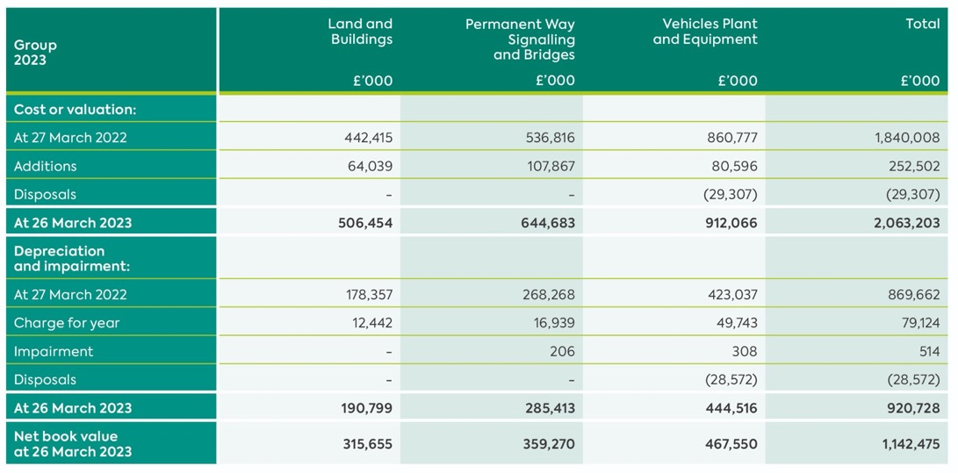
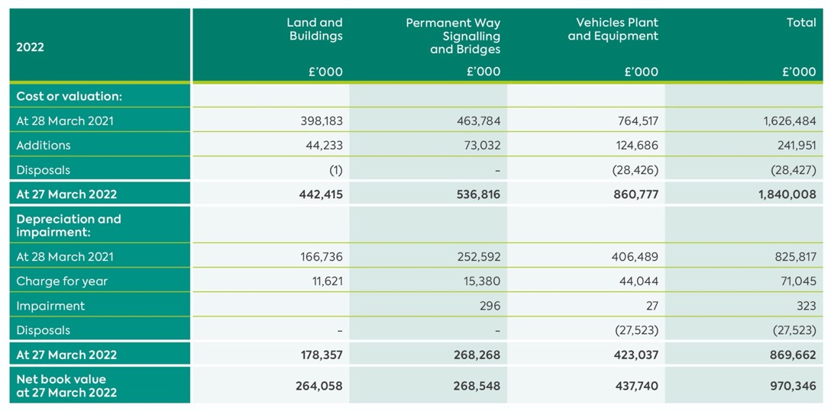

Included within the categories above are assets in the course of construction totalling £362.6m (2022: £346.8m), which are not being depreciated as they were not fully commissioned at the balance sheet date.

Right-of-Use Assets
At 26 March 2023, property, plant and equipment includes right-of-use assets as follows: Vehicles net book value £4,000 (2022: £10,000).

In accordance with the transitional provisions of IFRS, prior valuations of property, plant and equipment of the Group (other than investment properties) have not been updated. Due to the age of the property, plant and equipment included at valuation and the fact that a substantial portion were inherited, it is not practicable to state the difference between such valuation and the historical cost of these assets.

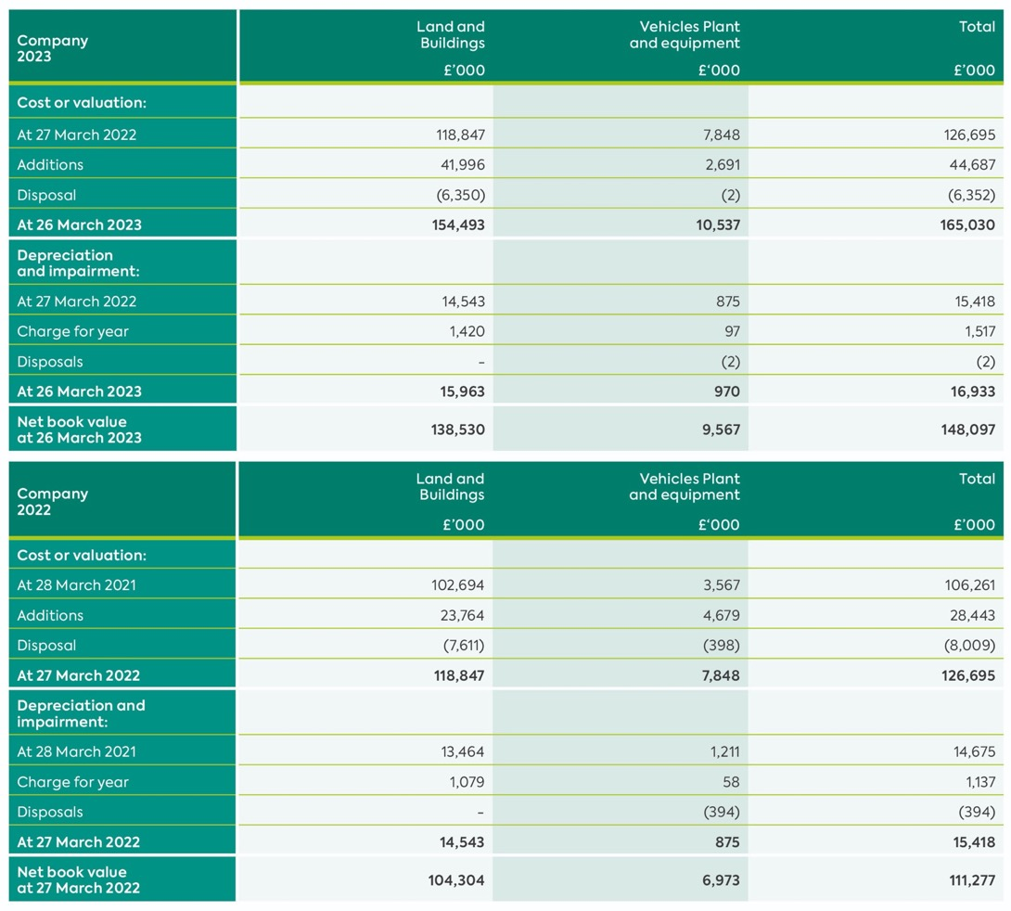

In accordance with the transitional provisions of International Accounting Standard 16 Property, Plant and Equipment, prior valuations of property, plant and equipment of the Company (other than investment properties) have not been updated. Due to the age of the tangible assets included at valuation and the fact that a substantial portion were inherited, it is not practicable to state the difference between such valuation and the historical cost of these assets.
Capital Commitments
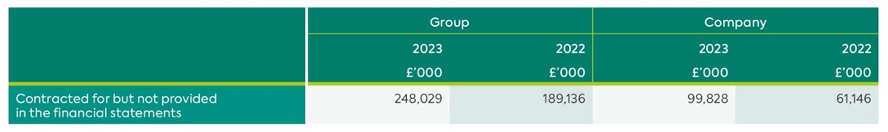

13. Investment Property
Fair Value
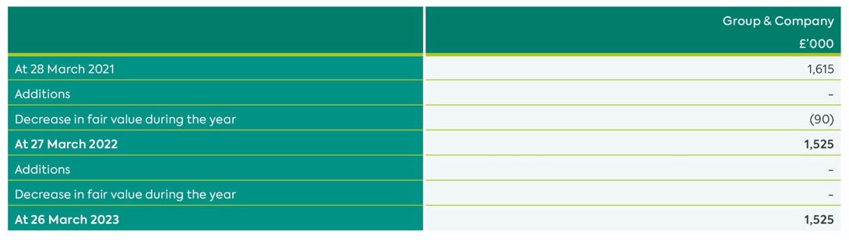
The investment properties were valued at their market value at 26 March 2023 by a qualified valuer who is an employee of the company. All valuations were carried out in accordance with the Valuation Standards published by the Royal Institution of Chartered Surveyors.

Details of the Group’s investment properties and information about the fair value hierarchy as at 26 March 2023 are as follows:

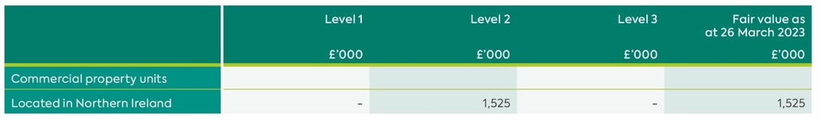

There were no transfers between levels 1 and 2 during the year.

Level 2 inputs applied when valuing the investment property comprise market rental value capitalised at a market yield rate.

Direct operating expenses arising on the investment property in the period amounted to £ nil (2022: £nil).

14. Investment in Subsidiaries
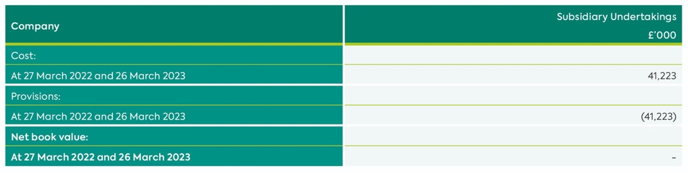
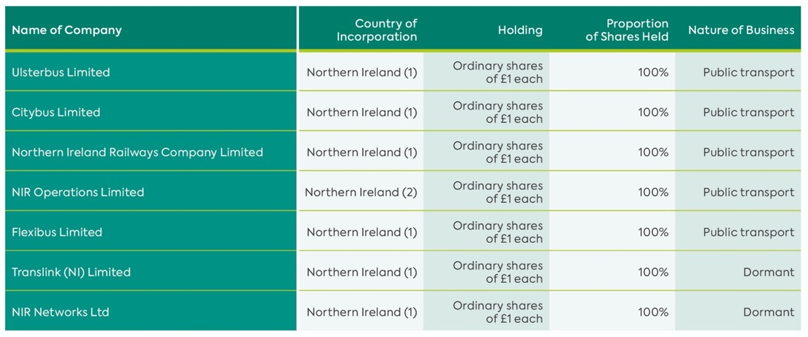
(1) Registered office 22 Great Victoria Street Belfast BT2 7LX
(2) Registered office 47 East Bridge Street Belfast BT1 3PB

15. Inventories
Inventories consist of various types of consumable stores relating to engineering and infrastructure parts and fuel. Inventories expense is recognised in cost of sales. Inventories cost is net of provision for obsolescence of £1.5 million (2022: £1.6 million). The replacement cost of these inventories is not materially different from the valuation stated.

16. Trade and Other Receivables
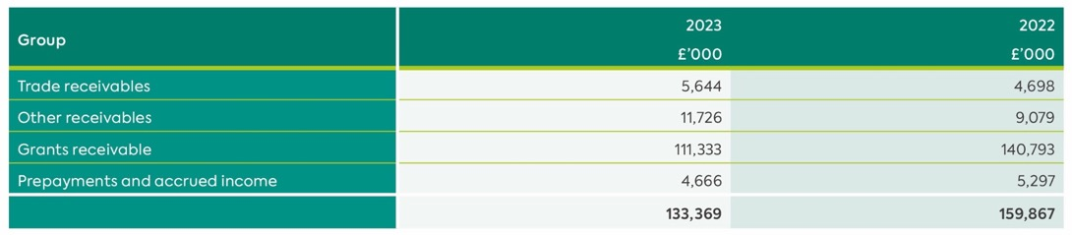
The following financial assets were past due, but not impaired at the balance sheet date because there has not been a significant change in credit quality and the amounts are still considered recoverable:

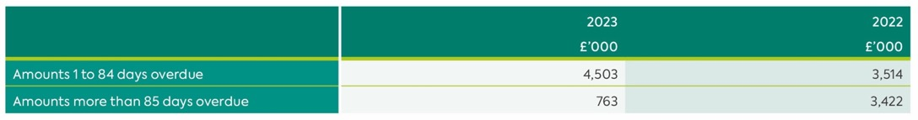

The Group does not hold any collateral in respect of its credit risk exposures set out above (2022: Nil) and has not taken possession of any collateral it holds or called for other credit enhancements during the year ended 26 March 2023.

Movement in the Allowance For Doubtful Debts
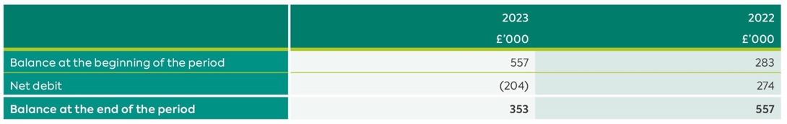

Ageing of Impaired Trade Receivables
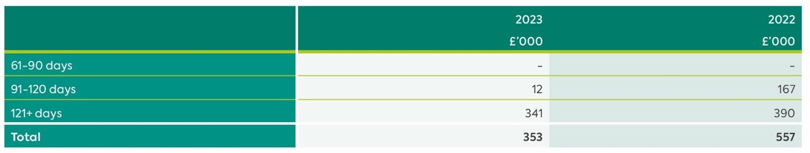

The Directors consider that the carrying amount of trade and other receivables is approximately equal to their fair value.

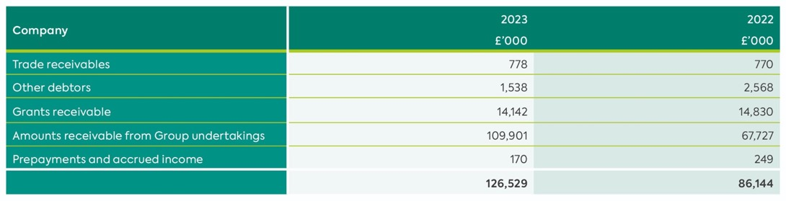

Company trade debtors are stated after provisions of £304,000 (2022: £485,000).
Amounts due from Group undertakings are interest free, unsecured and repayable on demand.

17. Trade and Other Payables
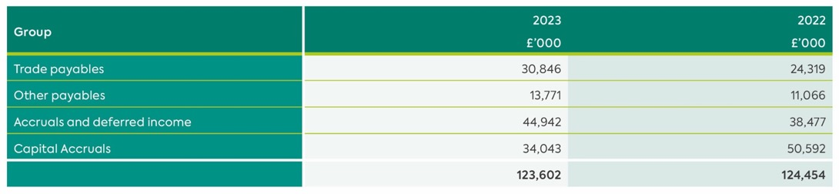

Included in other creditors is £4,051,000 (2022: £3,417,000) relating to outstanding contributions payable to the NILGOS Pension Scheme.

Creditors are paid within 7 days of approval of invoice.

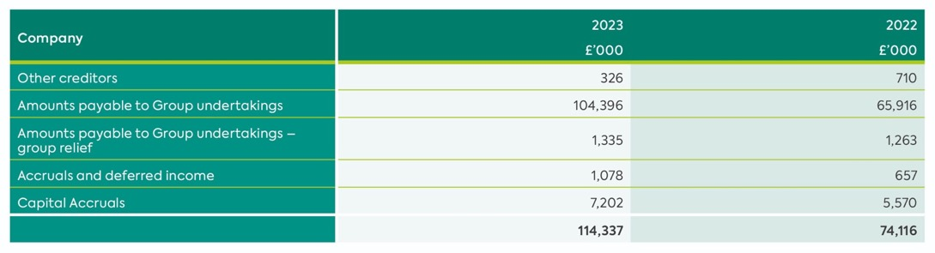

Included in other creditors is £54,355 (2022: £5,751) relating to outstanding contributions payable to the NILGOS Pension Scheme.

The Directors consider that the carrying amount of trade and other payables is approximately equal to their fair value.

Amounts payable to Group undertakings are interest free, unsecured and repayable on demand.

18. Provisions
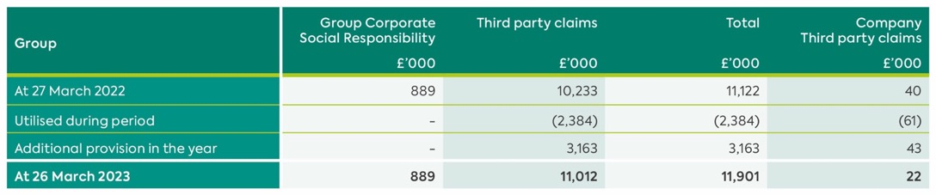

The corporate social responsibility provision relates to anticipated clean-up costs due to land contamination at various fuelling points, estimated costs of decommissioning obsolete rolling stock in an environmentally compliant manner and provision to address the risk of damage to the railway track from the spread of invasive species. The obligations giving rise to the requirement for the provision arise from the Group’s Environmental Contamination policy and the Group’s Safety policy.

The third-party claims provision relates to the insurance excess or self-insured element of claims received and anticipated. The provision is based upon the best estimate of the expenditure to settle each obligation on receipt of advice from legal and medical experts. The timing of settlement is dependent on a number of factors including the courts, but most claims are expected to be settled within one year.

19. Deferred Income
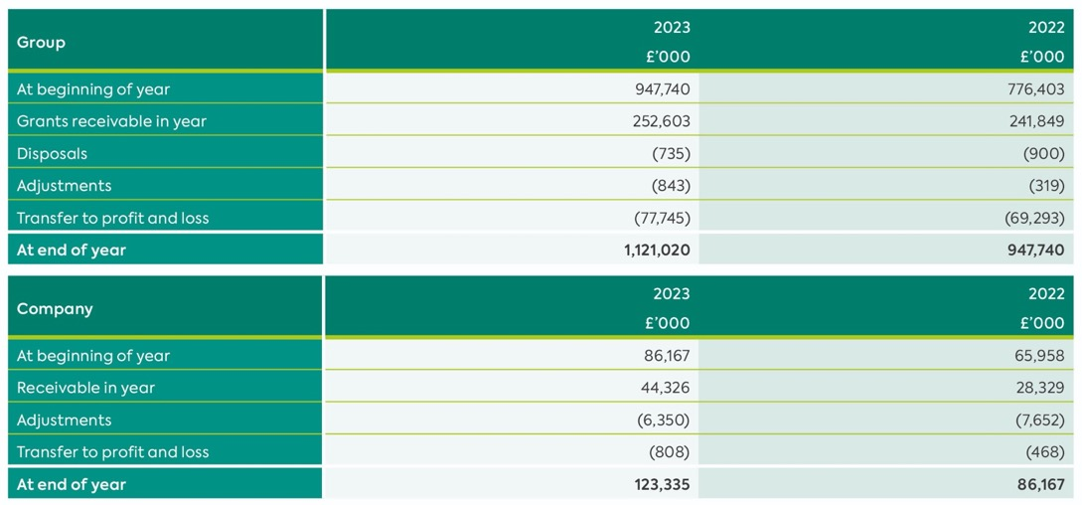

20. Cash and Cash Equivalents
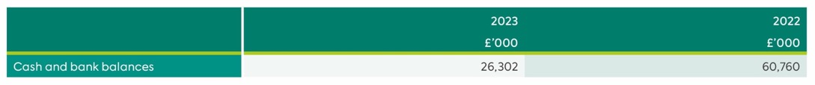

21. Employee Benefits
(i) Description of the Schemes
NILGOS Scheme
The Company participates in the Northern Ireland Local Government Officers’ Superannuation (“NILGOS”) scheme. The NILGOS scheme is a multi-employer defined benefit scheme, the assets of which are held in a separate fund.

Under the scheme, members are entitled to post-retirement benefits varying between one eightieth (plus lump sum of three eightieths) and one sixtieth of final pensionable salary on attainment of a retirement age of 65 years for service up to 29 March 2015 and to post-retirement benefits of one forty-ninth of pensionable salary in respect of each year on attainment of retirement age for service from 1 April 2015.

The NILGOS scheme exposes the group to actuarial risks such as: investment risk, interest rate risk, longevity risk and salary risk.

The pension cost and funding arrangements are assessed in accordance with the advice of qualified actuaries using the projected unit credit method (an accrued benefits valuation method in which the scheme liabilities make allowances for projected earnings). The latest triennial valuation of the entire NILGOS scheme was at 31 March 2022. The market value of the assets at the date of the valuation was £10,231 million and represented 111% of benefits accruing to members after allowing for expected future increase in earnings and pensions. The employer contribution rate had been set at 19.5% following the previous valuation. The employer contribution rate for the year commencing 1 April 2023 and subsequent years has been set at 19%.

The Directors have obtained an update from the 31 March 2022 NILGOS valuation to 26 March 2023 using the major assumptions set out below. This update was prepared by qualified actuaries employed by Mercer Limited.
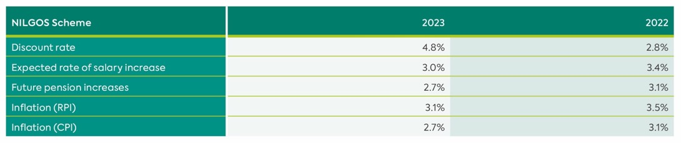

Mortality Assumptions
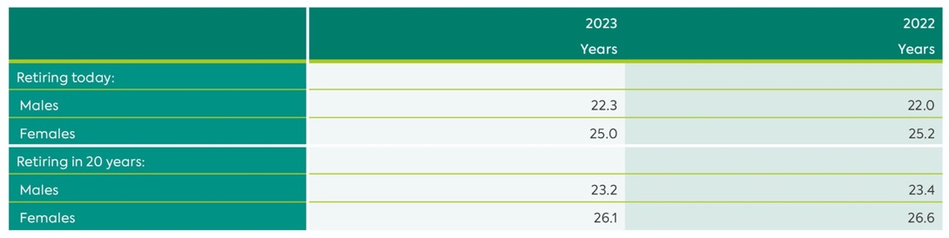

Significant actuarial assumptions for the determination of the defined benefit obligation are discount rate, expected salary increase and mortality. The sensitivity analysis below has been determined based on reasonably possible changes of the assumptions occurring at the end of the reporting period assuming all other assumptions are held constant.

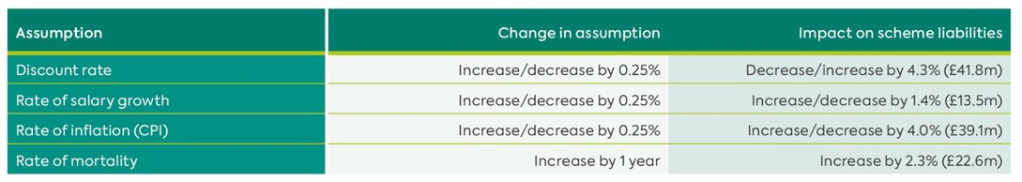

In reality one might expect interrelationships between the assumptions, especially between discount rate and expected salary increases that both depend to a certain extent on expected inflation rates. The above analysis does not take the effect of these interrelationships into account.

Executive Scheme
This defined benefit scheme provides additional benefits for certain senior employees, with the assets being held in a separately administered fund. Pension costs and funding arrangements are assessed by a qualified actuary. The latest available full actuarial valuation was as at 1 April 2021. The scheme is closed to new entrants.

Ulsterbus/Citybus Retirement & Death Benefits Plan (1997)
The assets of this defined benefit scheme are held in a separate fund and although the scheme has no active members, a qualified actuary performs triennial actuarial valuations. The latest available actuarial valuation was at 31 March 2021. The scheme has no active members and is closed to new entrants.

The latest available full actuarial valuations of the Executive and Ulsterbus/Citybus schemes have been updated using the major assumptions as set out below.

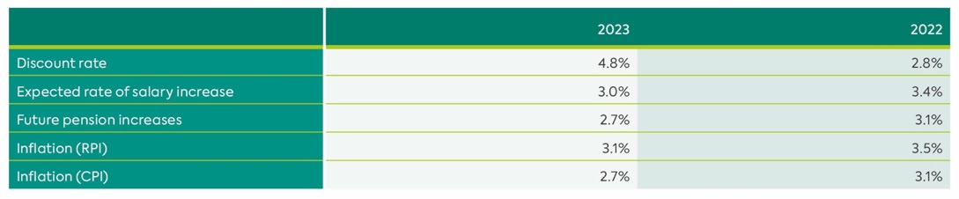

(ii) Amounts Recognised in Income
Amounts recognised in income in respect of these defined benefit schemes are as follows:

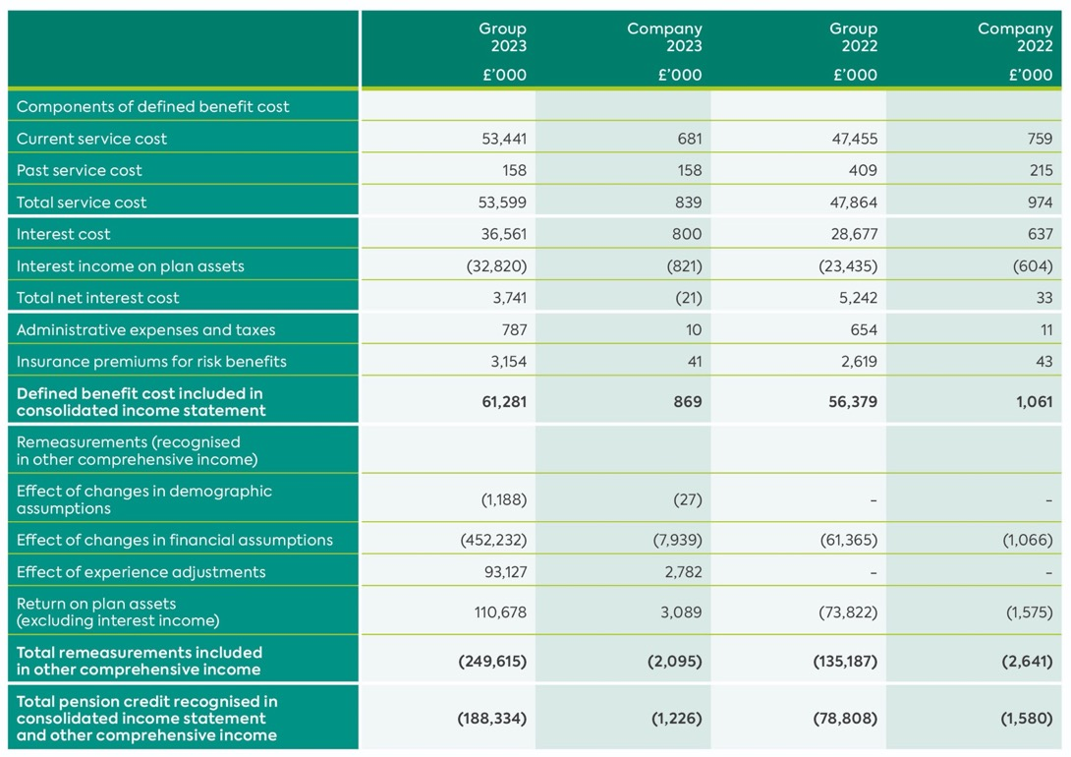
Of the expense for the year (total service cost), £42.9m (2022: £39.1m) has been included in cost of sales and the remainder has been included within administrative expenses.

The actual return on plan assets for the Group was negative £77.9m (2022: positive £97.3m); Company: negative £2.3m (2022: positive £2.2m).

The gross cumulative amount of actuarial gains and losses recognised in other comprehensive income is gains of £252.6m (2022: gains of £3.0m).

Expected contributions to the schemes in the next annual reporting period are £31.2m.

(iii) Amounts Included within the Balance Sheet
The amount included in the balance sheet arising from the Group and Company’s obligations in respect of its defined benefit retirement benefit schemes is as follows:

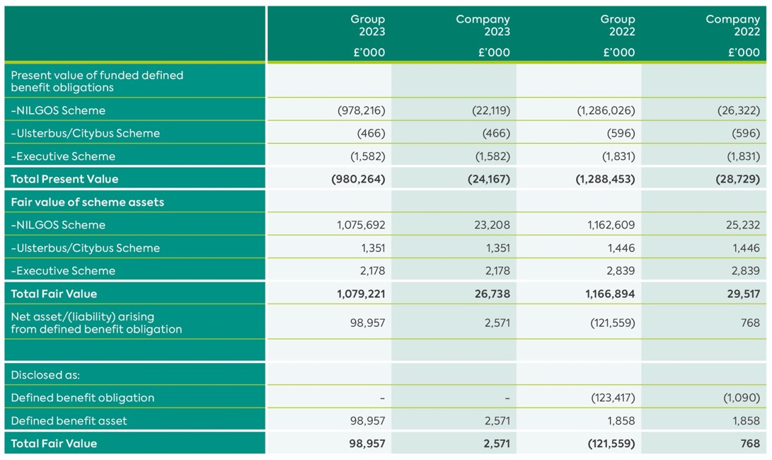

(iv) Movements in Present Value of Defined Benefit Obligation
Movements in the present value of defined benefit obligation in the current year were as follows:

NILGOS Scheme
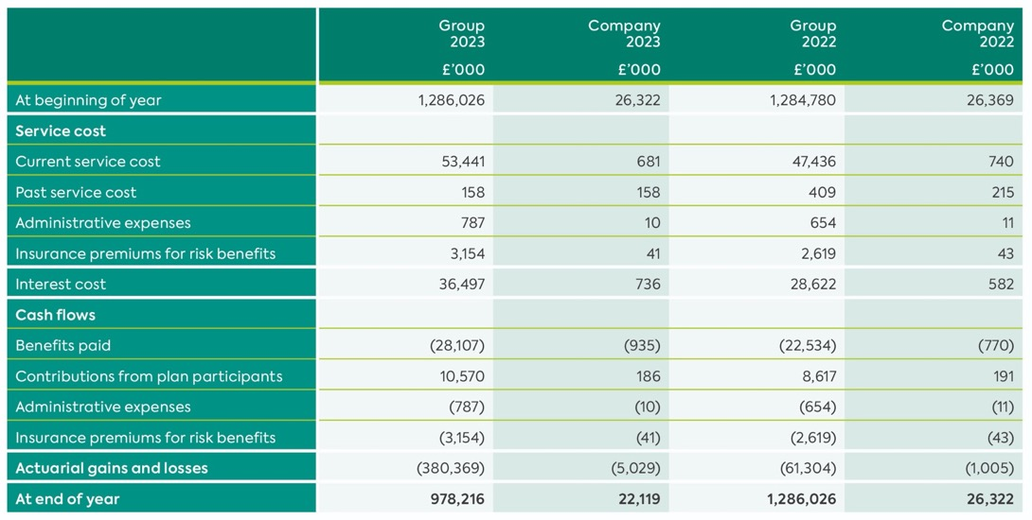

Ulsterbus/Citybus Scheme
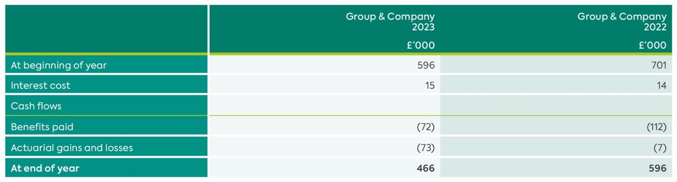

Executive Scheme
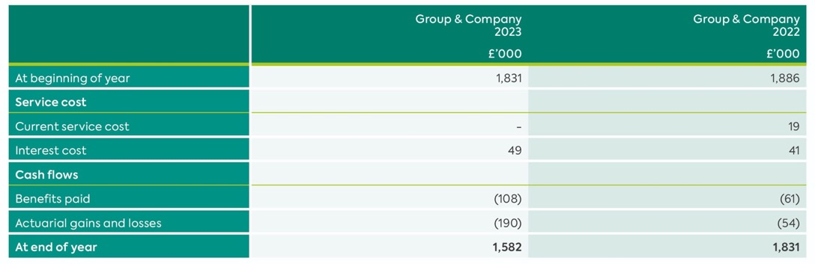

(v) Movements in Fair Value and Analysis of Scheme Assets
Movements in the fair value of scheme assets were as follows:

NILGOS Scheme
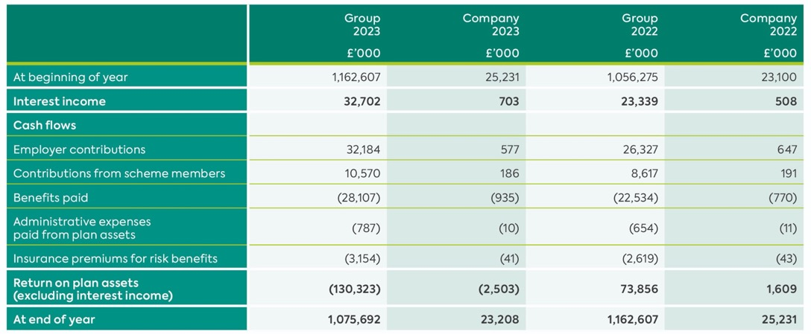

Ulsterbus/Citybus Scheme
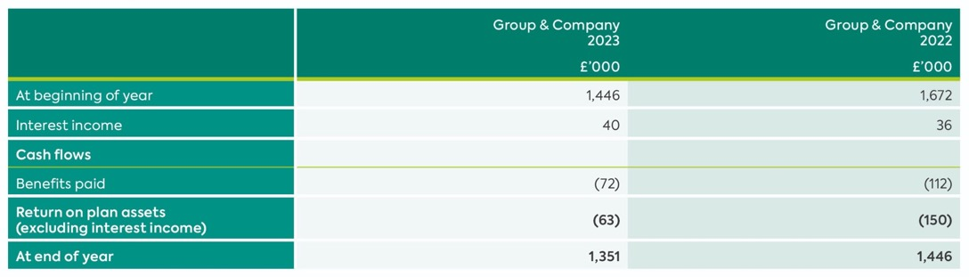

Executive Scheme
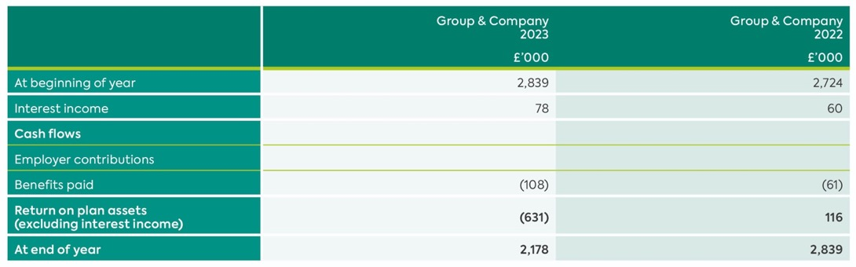

The average duration of the benefit obligation at the end of the reporting period is c17 years (2022: c20 years).

The major categories of plan assets at the end of the reporting period for each category are as follows:

Fair Value of Assets
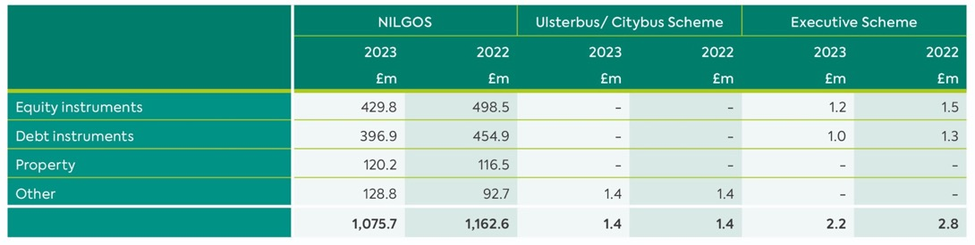
Substantially all plan assets are classified as level 2 instruments.

22. Directors’ and Employees’ Staff Costs
Staff Costs
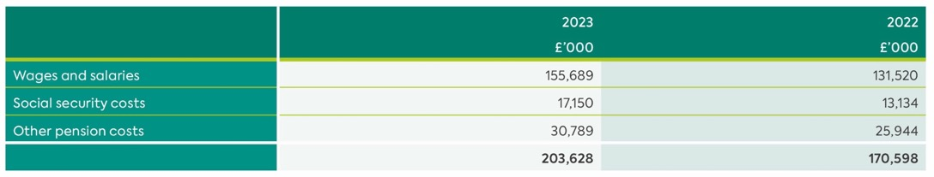

Company
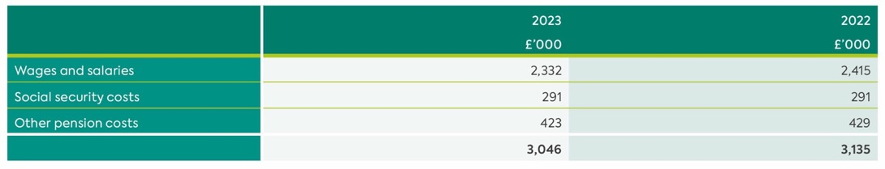

Number of Employees (Group)
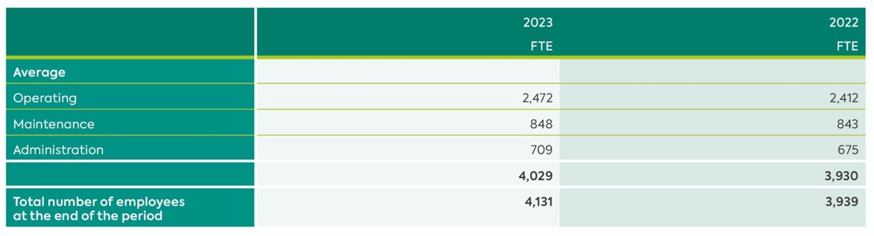
The increase in administration is due to project management support required for the ongoing extensive programme of capital works.

Staff costs exclude voluntary exit scheme costs of £nil (2022: £nil).

Number of Employees (Company)
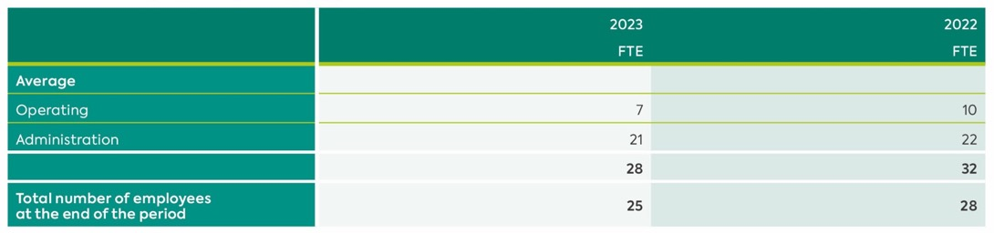

Directors’ Emoluments (Excluding Non-Executive Directors)
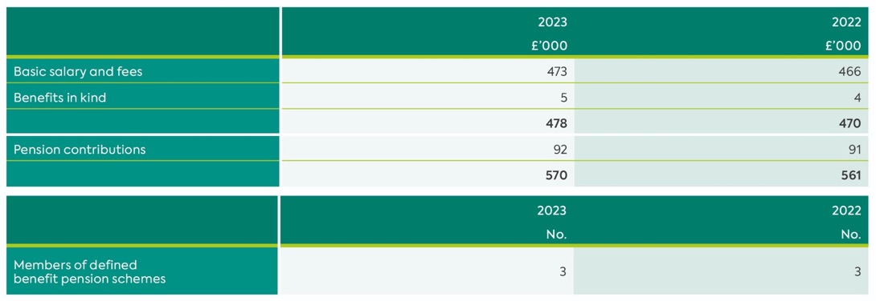

The emoluments in respect of the highest paid Director in each year were as follows:
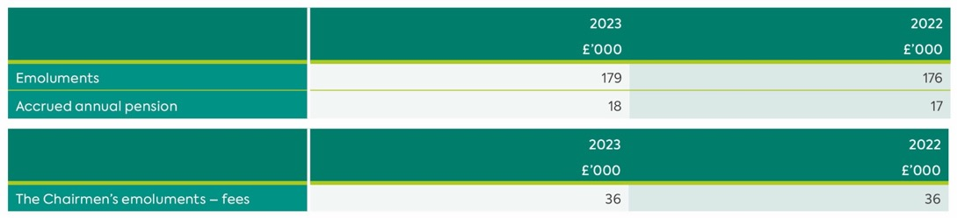

The emoluments of the other non-executive Directors fell within the following bands:
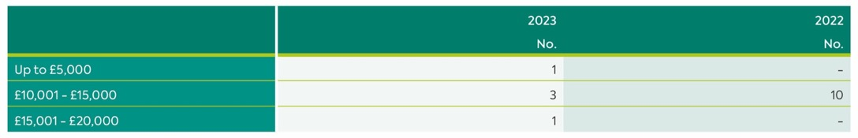

23. Financial Instruments
(a) Overview
This note provides details of the Group’s financial instruments. Except where otherwise stated, the disclosures in this note exclude retirement benefit assets and obligations.

Liabilities or assets that are not contractual (such as income taxes that are created as a result of statutory requirements imposed by governments, prepayments, deferred government grants, provisions and deferred income) are not financial assets or financial liabilities and accordingly are excluded from the disclosures provided in this note.

Details of the significant accounting policies and methods adopted for each class of financial asset and financial liability are disclosed in the accounting policies note.

(b) Categories and Carrying Value of Financial Instruments
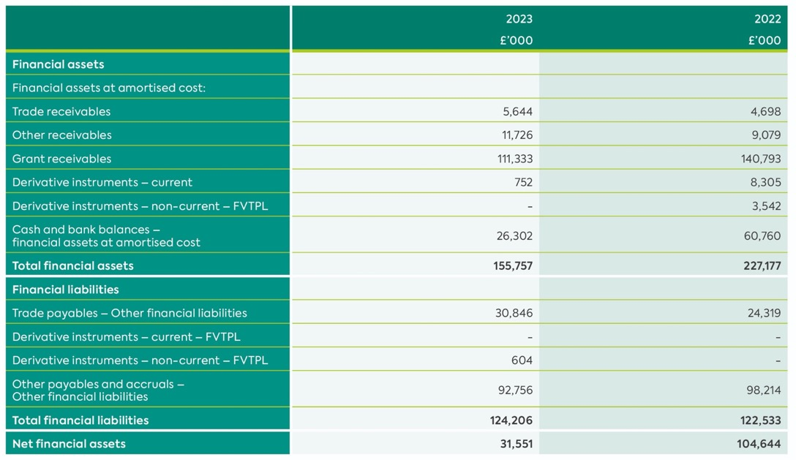

The Directors consider that the carrying amount of financial assets and financial liabilities recorded at amortised cost approximates their fair value. Given the short average time to maturity, no specific assumptions on discount rates have been made in relation to loans and receivables and financial liabilities at amortised cost.

The fair value of derivative financial instruments is calculated using discounted cash flow analysis performed using the applicable yield curve for the duration of the instruments.

(c) Fair Value Measurements Recognised in the Balance Sheet
Financial instruments that are measured in the balance sheet at fair value are disclosed by level of the following fair value measurement hierarchy:

Level 1 – Quoted prices (unadjusted) in active markets for identical assets or liabilities;
Level 2 – Inputs other than quoted prices included within Level 1 that are observable for the asset or liability
either directly (that is, as prices) or indirectly (that is, derived from prices); and
Level 3 – Valuation techniques that include inputs for the assets or liability that are not based on observable data (that is, unobservable inputs).

The following table presents the Group’s financial instruments that are measured subsequent to initial recognition at fair value within the hierarchy.

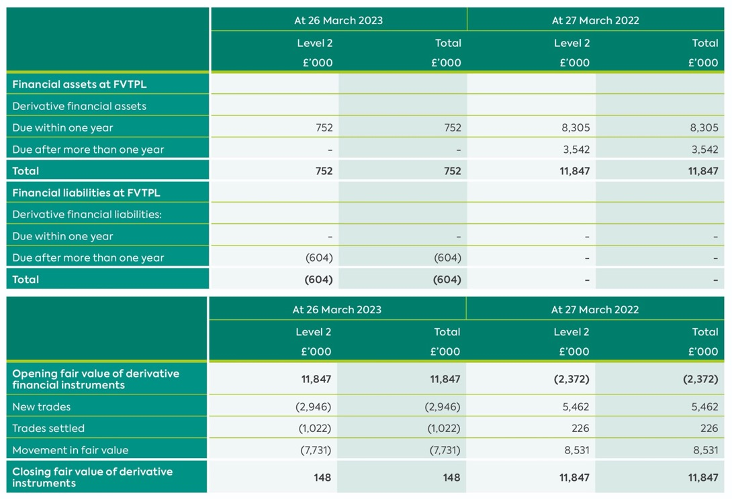

(d) Fair Value Adjustments Recognised in Income
Fair value adjustments are recognised in the income statement as fair value adjustment on fuel derivative.

(e) Financial Risk Management Objectives
The Group’s activities expose it to a variety of financial risks, principally:

- Market risk – mainly price risk.
- Credit risk and
- Liquidity risk

The Group’s overall financial risk management programme focuses on the unpredictability of financial markets and seeks to reduce the likelihood and/or magnitude of adverse effects on the financial performance and financial position of the Group. The Group uses derivative financial instruments to reduce exposure to fuel price risk. The Group does not hold or issue derivative financial instruments for speculative purposes.

This note presents qualitative information about the Group’s exposure to each of the above risks, including the Group’s objectives, policies and processes for measuring and managing risk. There have been no significant changes to these matters during the year ended 26 March 2023.
This note also provides summary quantitative data about the Group’s exposure to each risk.

The Board have approved policies on fuel hedging, energy procurement and treasury management which guide management in managing risk in these areas. Group finance is responsible for ensuring these policies are implemented. Certain financial risk management activities (for example, the management of credit risk arising from trade and other receivables) are devolved to the management of individual business units.

(i) Market Risk
Market risk is the risk that changes in market prices, such as commodity prices, interest rates and exchange rates will affect the Group’s financial performance and/or financial position. The objective of the Group’s management of market risk is to manage and control market risk exposures within acceptable parameters. The Group does not consider currency risk or interest
rate risk to be material due to low levels of foreign currency transactions and its borrowings being limited to its overdraft.
The Group enters into derivative financial instruments in the ordinary course of business in order to manage market risk, in the form of fuel price risk. All such transactions are carried out within the guidelines set by the Board. Market risk exposures are measured using sensitivity analysis.

There has been no change to the Group’s exposure to market risks or the manner in which these risks are managed and measured.

Foreign Currency Translation Risk
Foreign currency translation risk is the risk that the fair value or future cash flows of a financial instrument will fluctuate because of changes in foreign exchange rates. This risk for the Group is not considered to be material.

Interest Rate Risk
Interest rate risk is the risk that the fair value or future cash flows of a financial instrument will fluctuate because of changes in market interest rates. It is considered that the Group has no exposure in this area.

Given that the group has certain financial instruments held in fixed rate derivatives there is an exposure to interest rate, however it is not considered to significant given the current interest rates and length of maturity.

Fuel Price Risk
The Group is exposed to fuel price risk. The Group’s normal operations as at 26 March 2023 consume approximately 39 million litres of diesel fuel per annum. As a result, the Group is exposed to movements in the underlying price of fuel.

The Group’s objective in managing fuel price risk is to reduce the risk that movements in fuel prices result in adverse movements in its profit and cash flow. The Group has a policy of managing the volatility in its fuel costs by maintaining an ongoing fuel hedging programme whereby derivative financial instruments are used to fix or cap the variable unit cost of a percentage of anticipated fuel consumption. The fuel derivatives hedge the underlying fuel price. The Group’s residual exposure to fuel price risk is measured by quantifying the element of projected future fuel costs, after taking account of derivative financial instruments in place, which varies due to movements in fuel prices. Group Finance is responsible for the processes
for measuring and managing fuel price risk.
The Group’s overall fuel costs include the impact of delivery margins, fuel taxes and fuel tax rebates. These elements of fuel costs are not managed as part of the Group Finance’s fuel price risk management and are managed directly by business unit management.

The Group uses a number of fuel derivatives to hedge against movements in price of the different types of fuel used in bus and rail operations. The fuel derivatives hedge the underlying commodity price (denominated in US$), they also hedge the currency risk due the commodity
being priced in US$ and the functional currency of the two divisions being pounds sterling.

Volume at risk for the year ended 26 March 2023 is 39 million litres (2022: 39 million litres) for which 91% is hedged (2022: 83%).

The following tables detail the notional principal amounts and remaining terms of fuel derivative financial instruments outstanding as at the reporting date:

Economic Hedging of Cashflows
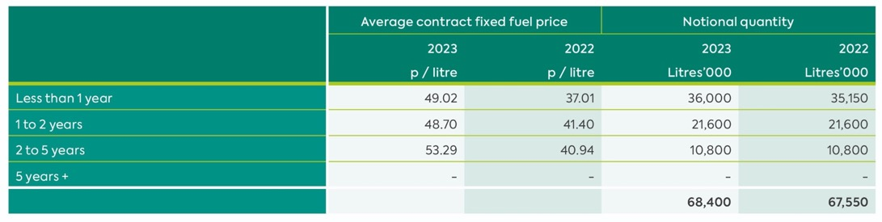

The fair value of fuel derivatives is further analysed by division as follows:
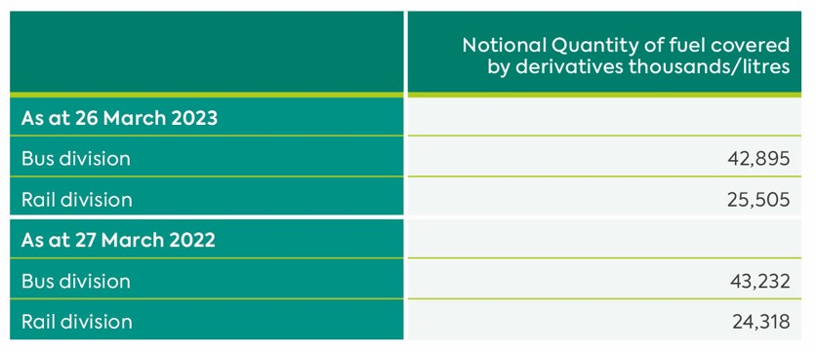

At 26 March 2023, and 28 March 2022 the projected fuel costs (excluding premia payable on fuel derivatives, delivery margins, fuel taxes and fuel tax rebates) for the next twelve months were:

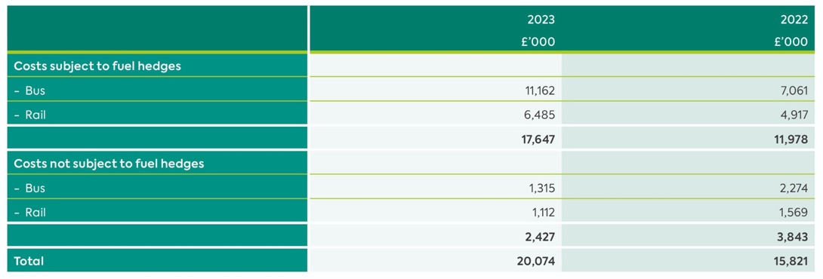

Given the ongoing crisis in Ukraine and the associated volatility in market price of fuel, management deem 50% (2022 50%) to be a reasonable benchmark for sensitivity analysis purposes. If all the relevant (unhedged volume) fuel prices were 50% (2022 50%) higher at the balance sheet date, the profit before tax would be reduced by:

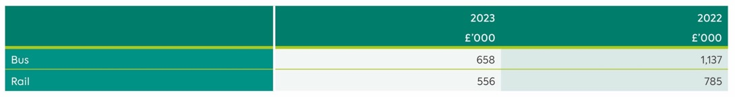

(ii) Credit Risk
Credit risk is the risk of financial loss to the Group if a customer or counterparty to a financial instrument fails to meet its contractual obligations.

Credit risk is managed by a combination of Group Finance and business unit management and arises from derivative financial instruments and deposits with banks and financial institutions, as well as credit exposures to amounts due from outstanding receivables.

The Group’s objective is to minimise credit risk to an acceptable level whilst not overly restricting the Group’s ability to generate revenue and profit. It is the Group’s policy to invest cash assets safely and profitably. To control credit risk, counterparty credit limits are set by reference
to published credit ratings.

Trade receivables consist largely of government grants and receivables, for which credit risk is considered limited. The Group’s largest credit exposures are to the Education Authority, the Department of Education and the Department for Infrastructure, all of which the Group considers unlikely to default on their respective liabilities to the Group.

The credit risk on liquid funds and derivative financial instruments is limited because the counter parties are banks with high credit ratings assigned by international credit rating agencies. The Group defines an Approved Counterparty as any counterparty currently satisfying the counterparty credit risk policy criteria which has been named and received specific approval from the Board.
In determining whether a financial asset is impaired, the Group takes account of:

- The fair value of the asset at the balance sheet date and where applicable, the historic fair value of the asset.
- In the case of receivables, the counterparty’s typical payment patterns.
- In the case of receivables, the latest information on the counterparty’s creditworthiness such as available financial statements and credit ratings.

The carrying amount of financial assets recorded in the financial statements, which is net of impairment losses, represents the Group’s maximum exposure to credit risk as no collateral or other credit enhancements are held.

(iii) Liquidity Risk
Liquidity risk is the risk that the Group will encounter difficulty in meeting its financial obligations as they fall due. The Group’s objective in managing liquidity is to ensure, as far as possible, that it will always have sufficient liquidity to meet its liabilities when due, under both normal and stressed conditions, without incurring unacceptable losses or risking damage to the Group’s reputation.

The funding policy is to finance the Group through a mixture of cash generated by the business and funding provided by its sponsor the Department for Infrastructure.

As of 26 March 2023, the Group’s credit facilities were £10,000,000 (2022: £10,000,000) including utilisation for the issuance of bank guarantees, bonds etc. This facility is guaranteed by the Department for Infrastructure until further notice.

Although there is an element of seasonality in the Group’s bus and rail operations, the overall impact of seasonality on working capital and liquidity is not considered significant. The Board expects the Group to be able to meet current and future funding requirements through free cash flow and continued funding from its sponsor Department which has been frontloaded to assist with cashflow during the COVID-19 pandemic.
The following tables detail the Group’s remaining contractual maturity for its non-derivative financial liabilities with agreed repayment periods. The tables have been drawn up based on the undiscounted cash flows of financial liabilities based on the earliest date on which the Group can be required to pay.

The tables include both interest and principal cash flows. To the extent that interest flows are floating rate, the undiscounted amount is derived from interest rate curves at the balance sheet date. The contractual maturity is based on the earliest date on which the Group may be required to pay.

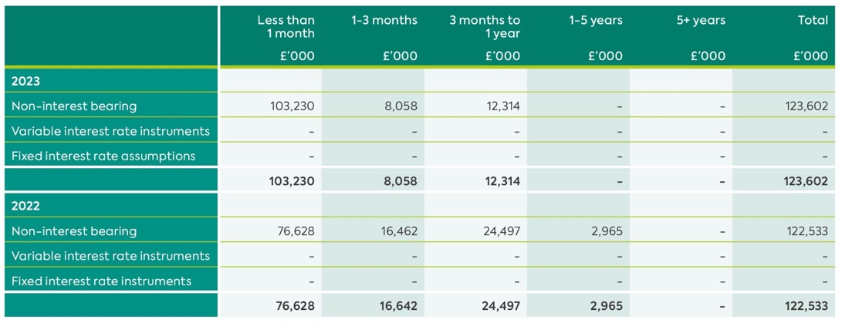

The following table details the Group’s expected maturity for its non-derivative financial assets. The tables below have been drawn up based on the undiscounted contractual maturities of the financial assets including interest that will be earned on those assets. The inclusion of information on non-derivative financial assets is necessary to understand the Group’s liquidity risk management as the liquidity is managed on a net asset and liability basis.

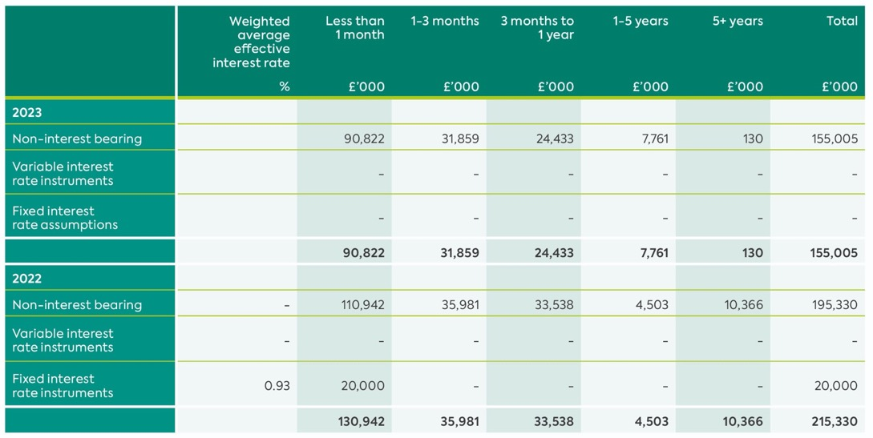

The following table details the Group’s liquidity analysis for its derivative financial instruments based on contractual maturities. The table has been drawn up based on the undiscounted net cash inflows and outflows on derivative instruments that settle on a net basis. When the amount payable or receivable is not fixed, the amount disclosed has been determined by reference to the projected interest rates as illustrated by the yield curves existing at the
reporting date.

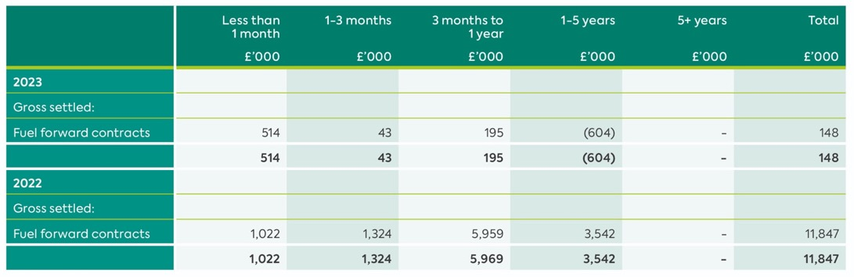

24. Related Party Transactions
The Company is a Public Corporation sponsored by the Department for Infrastructure, its controlling party. The Department is regarded as a related party. During the year, the Company and its subsidiaries have had various material transactions with the Department including:

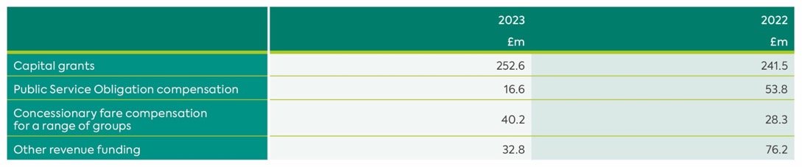

The balance owed to the Group by the Department at the year-end was £14.1m (2022: £35.2m).

Balances and transactions between the Company and its subsidiaries, which are related parties, have been eliminated on consolidation and are not disclosed in this note.

In addition, as detailed in note 2 (“Inherited Pension and Compensation Payments”) to the financial statements, due to a statutory obligation the Company administers on behalf of the Department various pension schemes for which the Department funds any deficits.

The remuneration of the Executive and Non-Executive Directors, who are the key management personnel of the Group, is set out below in aggregate for each of the categories specified in IAS 24 ‘Related Party Disclosures’.

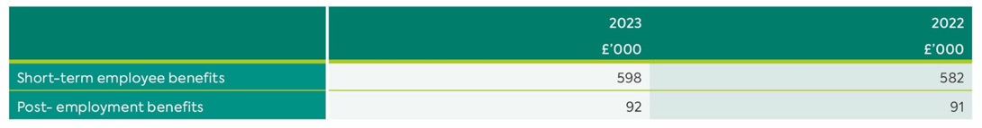

25. Post Balance Sheet Events
No matters have arisen since the period end, to the date of this report, that require adjustment to, or disclosure in, the financial statements.

This publication is available in a range of alternative formats, for example large print, braille or audio tape. Please call Translink Contact Centre 028 9066 6630.

translink.co.uk

