2030 Strategy

Leading the Transformation of Transport in Northern Ireland

- 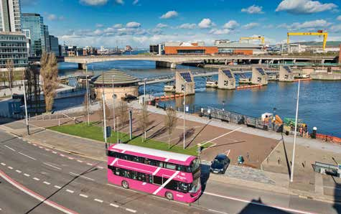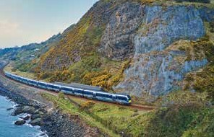translink.co.uk

Translink has ambitious plans.
An effective and successful public transport network is vital for the economic, social and environmental well-being of our society.
That’s why we are committed to continuing the transformation of public transport.

- Better.Connected


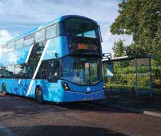Why Better.Connected?

Better... Connected...

means we will strive for excellence in everything we do. Continually improving the quality and accessibility of our services through innovation and an unwavering focus on our customers. It also means accelerating action on the
climate challenge, helping to ensure a cleaner environment. If more people use public transport and active travel modes, we can reduce congestion and reduce pollution and greenhouse gases.
is what we want for our people and communities. This means leading the development of an integrated transport network, linking services and transport modes. Connected also allows the enabling of the wider policy objectives of the NI Executive Government. We will provide the
everyday mobility that ensures social inclusion. We will connect people with work, education, health, shops, sport, leisure, social and entertainment. We will connect communities and bring friends and family closer together.

Delivering the previous 5-year ‘Get on Board’ strategy means we have already made significant progress. We want to ensure a positive legacy for future generations, and we understand that there is still much to do.

Our vision remains to make Translink your first choice for travel, today for tomorrow. To achieve this, it is our mission to lead the transformation of transport in Northern Ireland. This strategy, covering the period to 2030, sets out how we will do it and outlines our four strategic objectives of Continuous Improvement, Customer Focus, Climate Action and Connecting Communities.

- translink.co.uk

Building
on the past
Translink leads a vital public service for the people of NI. We have already started a public transport transformation for a better connected, healthier
and greener NI. Through the delivery of a 5-year ‘Get on Board’ strategy we had a clear vision to make
Translink your ‘First Choice for Travel’. We delivered

Looking
to the future

strong results right across the business, they include: COVID-19 has had a dramatic impact on
us all. It has made us realise what is truly
important in our lives. Family, community, and

Over 84.5 million passenger journeys in 2019, the highest in over 20 years
Removing over 70 million car journeys a year
Saving 100k tonnes of CO₂ annually

Our investment delivered notable passenger service improvements:
- Quality brands and improved services such as Glider and Urby
- New stations, including the North West Transport Hub and good progress towards the Belfast Transport Hub
- Better trains and low/zero emission buses and coaches
- Much improved maintenance capacity to keep our network safe
- Significant development and growth in park and ride usage
- An ambitious programme to create a fully integrated, contactless ticketing system.

We have shown that through a combination of investment, innovation and imagination we can:
- Help the government deliver on its wider commitments
- Connect communities and improve economic and social wellbeing.
- Encourage more people to change to more sustainable public transport modes
- Support climate action and enhance the quality of air we breathe.
our health and wellbeing. It has also shone a spotlight on issues around climate and air
quality. The lockdowns gave us a glimpse of a cleaner and less congested Northern Ireland.

Climate change remains the biggest threat we all face, and air pollution is a serious risk to personal health. So, an efficient, effective and popular integrated public transport network, will be vital to combat the climate crisis and to drive the change towards a healthier, more active and better quality of life for future generations.

This new strategy is aligned with Government policies as set out in the draft Programme for Government (PfG) including the NI Executives united aim ‘To improve the wellbeing for all of our people’.

It has been devised within the context of the Department for Infrastructure’s (DfI), Regional Development Strategy for 2035 and the Planning for the Future of Transport – Time for Change strategy and other developing transportation plans.

Our actions are benchmarked, working with Business in the Community through the CORE standard. We also closely align with the UN Sustainable Development Goals to deliver a more sustainable world by 2030 and beyond.

So, it recognises how public transport can contribute to a better quality of living, a stronger economy, improved health and a cleaner environment.

- Better.Connected

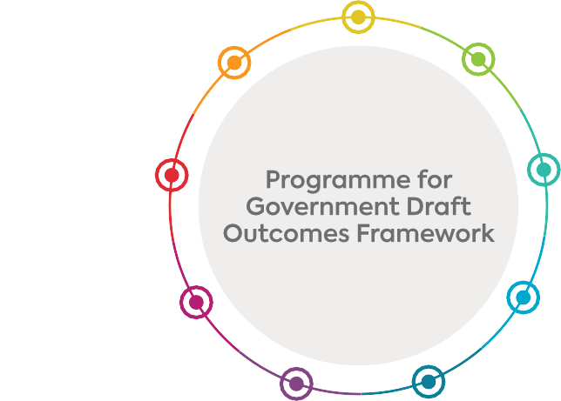

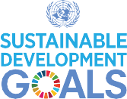

1
NO POVERTY
2
ZERO HUNGER
3
GOOD HEALTH AND WELL-BEING
4
QUALITY EDUCATION
5
GENDER EQUALITY
6
CLEAN WATER AND SANITATION
7
AFFORDABLE AND CLEAN ENERGY
8 ECONOMIC GROWTH
DECENT WORK AND
9
INDUSTRY, INNOVATION AND INFRASTRUCTURE
10
REDUCED INEQUALITIES
11
SUSTAINABLE CITIES AND COMMUNITIES
12 CONSUMPTION
RESPONSIBLE
AND PRODUCTION
13
CLIMATE ACTION
14
LIFE BELOW WATER
15
LIFE
ON LAND
16 AND STRONG
PEACE, JUSTICE
INSTITUTIONS
17 FOR THE GOALS
PARTNERSHIPS

- translink.co.uk

Vision Mission Core Values Strategic Objectives

Our Vision:
Your first choice for travel, today for tomorrow.

Our Mission:
To lead the transformation of transport in Northern Ireland:

we will create the advanced public transport services and integrated networks which connect people and communities, enhance the economy and improve health and the environment.

- Better.Connected

The Translink Spirit

Our Translink Spirit underpins everything that we do and helps ensure we are Better.Connected. It shapes our culture and the way we do things. Our people are encouraged to be respectful and inclusive
of everyone, to work together, to connect with customers and stakeholders, to motivate each other and to do things better. Our Spirit guides us to act responsibly, with integrity, and innovation and to succeed in delivering on our goals and creating ‘wellbeing for all’. Keeping customers and staff safe remains at the core of how we work.

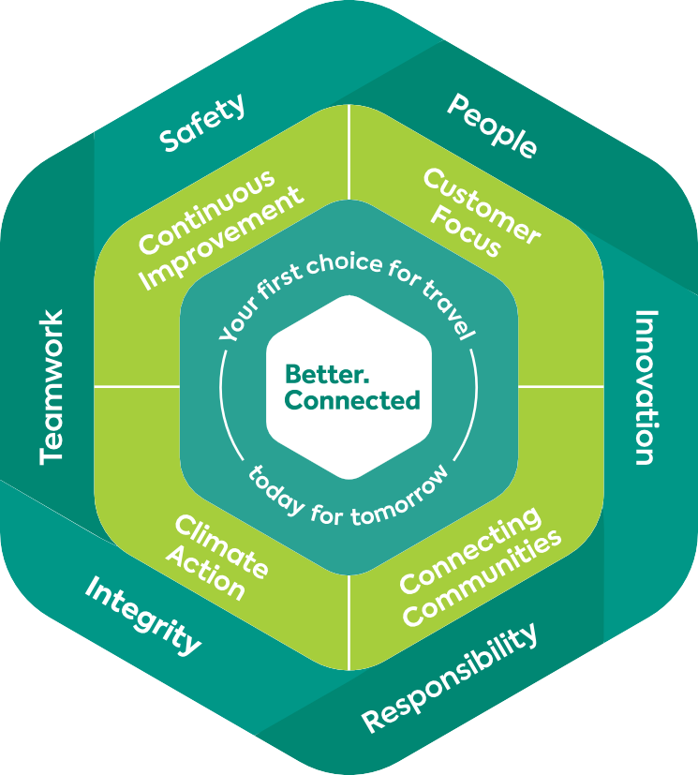P R
S
Safety
We put safety first by taking care of the people around us.
T
Teamwork
We work together to deliver the best results.
We encourage collaboration to build and
nurture valuable partnerships.

People
Our people make the difference in the service customers receive. We respect one another and have a culture based on Equality, Diversity and Inclusion.

Innovation
We seek out new ideas and creative solutions to business challenges and are agile and responsive to the changing needs of our stakeholders.

Responsibility
We are responsible for our actions. We are good neighbours and corporate citizens
in the communities where we operate.

Integrity
Our actions are fair, ethical and trustworthy, underpinned by an inclusive culture.

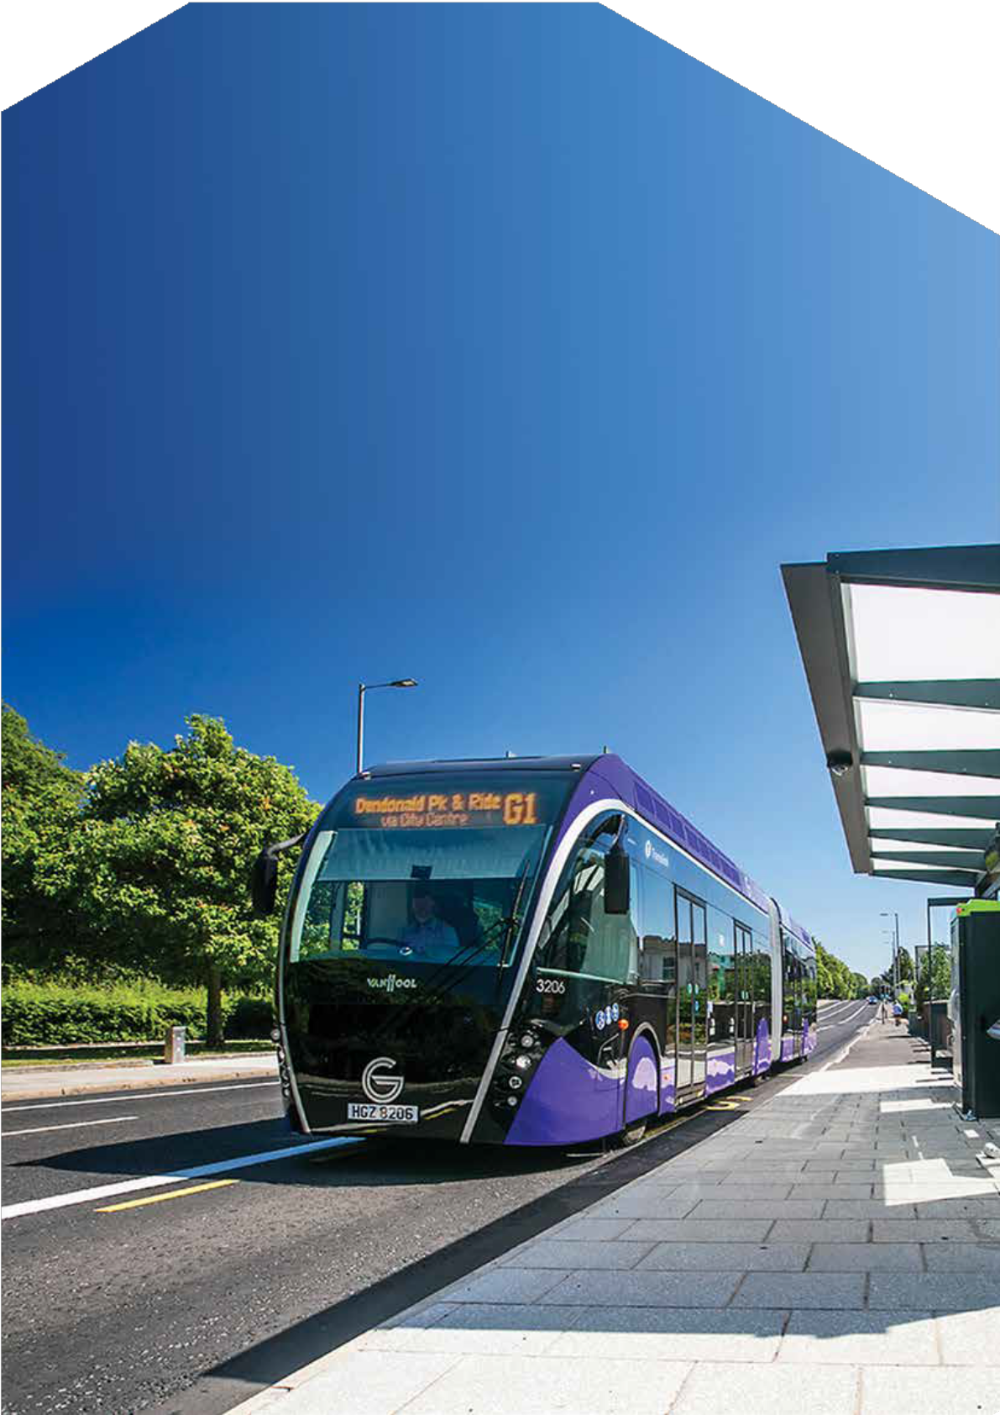
- translink.co.uk

Continuous Improvement

This is how we’ll deliver an excellent service for all our passengers.
Our goals are to aim for zero safety incidents and set high standards for punctuality and reliability.

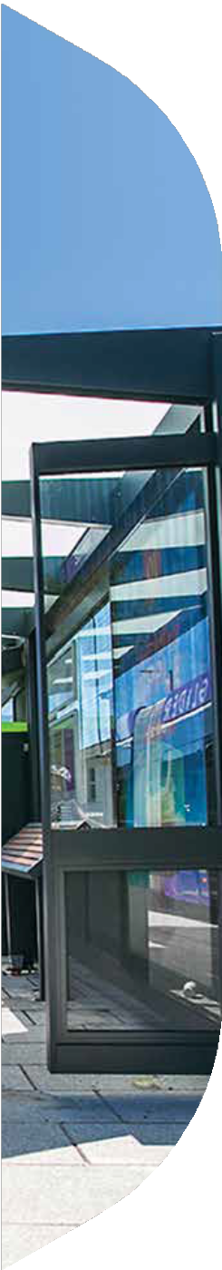
- Better.Connected

Even better safety performance
Safety is our number one priority. Our aim is to have zero safety incidents. We will work to ensure everyone gets home safe and healthy every day. This includes customers, employees, contractors, the public and indeed anyone impacted by what we do.

Our Safety, Health and Environmental Management System, will meet the highest international standards compatible with ISO. It is designed for continuous improvement and we will continue to create and boost a positive safety culture where all employees play a role in its successful delivery.

Better reliability and timeliness
Our integrated transport system will ensure that all the parts come together to keep Northern Ireland moving forward and on time. Our Passenger’s Charter will set high standards for punctuality and reliability, with >95% punctuality and
>99.5% reliability on the 12,500 services we deliver every day. We will invest in cutting edge technology to improve services, maximise resources and transform performance.

Better asset management
Our Asset Management System will meet the highest international standards compatible with ISO to support all investment decisions. We will optimise effectiveness and performance by better planning, operation and maintenance, maximising the value of each asset over its lifecycle. This will bring improved efficiency across the organisation.

Investing in our people
Our people are the face of Translink. They provide the human connection with passengers and stakeholders. We will expand our Investor in People programme, helping
to create a talented, diverse and inclusive workforce, empowered with the skills to ensure they are the best they can be.

Better benchmarking and monitoring
We will embed a continuous improvement culture in everything we do through benchmarking, analytics and use of technology. We will work closely with the Consumer Council NI and DfI to independently monitor performance
and deliver on our Passenger’s Charter and value for money.

- translink.co.uk

Customer Focus

This is how we will meet and exceed customer expectations and attract new customers.
Our goal is to deliver high levels of customer satisfaction and continually improve our Net Customer Sentiment Score.


- Better.Connected

Better customer experience
When passengers travel with Translink, we want their experience to be the best it can be. So, customer satisfaction is built into our Passenger’s Charter. We have set a target to achieve >90% customer satisfaction across all our services and work to continually improve our Net Customer Sentiment Score.

Better customer information
We will continue to improve the way we provide and receive information about our services. Whether provided face to face or on-line we will ensure information is clear, easy to access and where relevant tailored and personalised. For us the customer journey will start as you plan your trip and end with the opportunity to feedback.

Better handling of complaints
When things go wrong, we will do our best to put them right and will set out in our Passenger’s Charter our responsibilities and our commitments to respond to complaints.

Better facilities
We will continue to transform public transport through a programme of upgrades and enhancements. Our stations, halts and bus shelters will be attractive and high quality.

Park and Ride facilities are increasingly vital for our integrated transport network. We will plan and develop these in line with the DfI Regional Strategic Transport Network Plan.

Better fleet
We will continuously improve our fleet to deliver safe, clean, accessible and attractive public transport for our customers. Alongside daily, weekly and monthly maintenance
and cleaning programmes, we will seek out examples of best practice and introduce innovative methods. Our fleet renewal programme will ensure buses, coaches and trains are leading edge and high quality.
They will feature the latest technologies to deliver high levels of accessibility and customer satisfaction.

Better ticketing and fares
We will develop customer led, innovative ticketing solutions with a focus on, ease of use, integration, convenience and value. We want to use ticketing to encourage integration and boost public transport usage. As a key part of this commitment, we will roll out Account Based Ticketing/ Contactless Tap On Tap Off ticketing
and continue to expand our mobile app technologies.

Every year, in partnership with stakeholders, we will review fares to deliver value for money for our customers. We will continue to innovate to offer best value with new products, fare offers, new payment options and capping fares to offer customers flexibility, integration, convenience and simplicity to attract more users.

Better accessibility
We will work to ensure our services and facilities are accessible to all. This means creating a consistent customer experience for everyone ensuring accessible public transport for people with all levels of abilities. This includes enhancements to our vehicles, station improvements, introducing new changing places facilities, upgrades to rail halts and employee training. In addition, there are exciting developments planned to advance our digital passenger information to provide easier accessible route planning for passengers.

Customer-led branding
Our brand strategy will be customer led, informed by research. We will project the Translink name more clearly. Our brands will recognise the need for consistent and positive service delivery. Our branding will aim to visually connect our modes and services across Northern Ireland.

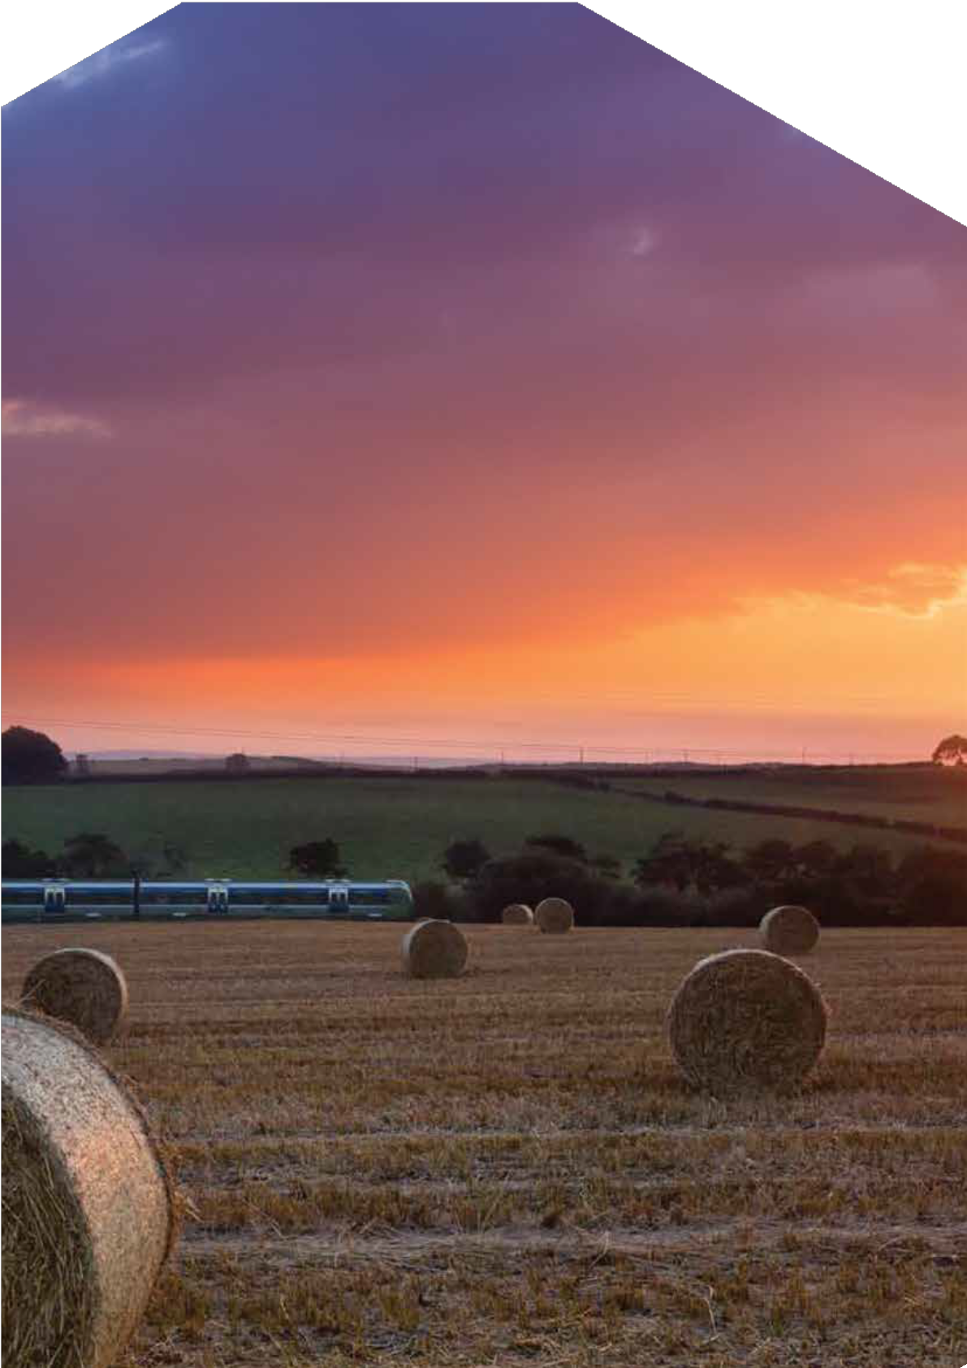
- translink.co.uk

Climate Action

This is how we will reduce emissions by 50% by 2030 and play a leading role in promoting zero emission transport across NI.
Our goal is to deliver a 50% reduction in our current emissions by 2030. This is in line with our Climate Action Pledge and using Science Based Targets.

- Better.Connected


Urgent action on climate change
Climate change is the most pressing environmental challenge of our time. There’s overwhelming scientific evidence that we must act now. The scale of the challenge demands a step-change in how we live and work, and we all have a duty to act quickly and decisively to reduce emissions.
Transport has a significant role to play in reaching net zero both regionally and globally. Translink will lead the transformation and accelerate towards net zero emissions in public transport in NI. This will create a path for a healthier, greener and more sustainable future for generations to come. We will make the most efficient use of resources, driving out waste and protecting and enhancing our natural heritage.
Although we aim to make significant progress during the next strategy period, we are looking beyond 2030 and far into the future. We want to be net zero by 2040, climate positive by 2050 and we will promote zero emission technology across the transport sector.
We have been benchmarked as Platinum status in the Business in the Community Northern Ireland Environmental Benchmarking Survey and we will continue to benchmark Translink with the very best organisations in carbon emission reduction.
Action on sustainable infrastructure Incorporating the potential for electric and hydrogen technologies, we will develop a rail infrastructure plan focused on decarbonising the rail network.
Our energy strategy will seek to reduce emissions for buildings, facilities and infrastructure, such as signalling and telecommunications. We aim to change the way we design, build and operate our
infrastructure and assets so we can minimise our whole-life carbon and air pollution emissions. This will make an important contribution to overall emission reduction targets and look after the safety and wellbeing of our passengers, neighbours and employees.
We will enhance engagement with key policy makers (DfI Transport Plans, Council Local

Development Plans, and Department for Economy Air Quality and Energy Strategies), to shape policies and promote measures for the reallocation of sustainable road space encouraging a modal shift to greener, active and healthier travel modes.

Action on sustainable bus fleet
We will embrace zero/low emission technology and innovations to decarbonise public transport. This will build on the programme of zero emission bus replacement which started in 2021/22. By mid 2022, we will have introduced over 100 Zero Emission vehicles, (80 Battery Electric and 23 Hydrogen Fuel Cell Electric Vehicles) - the first of their kind in Ireland.
A further 38 Battery Electric vehicles are also on order to be added to the fleet in 2023. We will develop a bus procurement plan, to meet the target of net zero by 2040.

Action on sustainable rail fleet
Our rail fleet will transition from diesel to electric/hydrogen technology. We will identify and embrace zero emission technology to create a cleaner fleet with the aim to meet the target of net zero by 2040.
Our plans will align with the Network Utilisation Strategy for the rail network in Northern Ireland and the Enterprise Development Strategy developed in partnership with Iarnrod Eireann.
We will engage with key stakeholders including local and central government and industry to promote and increase the uptake in zero- emission technology. This will encourage a whole system approach, reducing costs and supporting the global ‘Race to Zero’ campaign.

Climate Resilience
In preparing for climate changes, we are taking steps to assess, plan, design, build and upgrade our infrastructure to ensure we can operate
in a way that anticipates, prepares for, and adapts to changing climate conditions such as flooding and other impacts of extreme weather such as high temperatures. These actions will ensure it can withstand, respond to, and recover rapidly from disruptions caused by climatic conditions.


- translink.co.uk

Connecting Communities

This is how we will connect people and opportunities through our infrastructure and services.
Our goal is to increase passenger journeys towards 100million p.a. and aim to ensure high levels of accessibility to public transport connections in Northern Ireland.


- Better.Connected

Connecting with stakeholders
We are committed to the NI Executive’s draft Programme for Government
and the United Nation’s Sustainable Development Goals. We recognise the importance of working closely with our stakeholders to deliver these shared goals for the people of NI and for future generations.

Connected network development Using the DfI’s Regional Strategic Transport Network Plan as a guide we will lead the development of an integrated and sustainable public
transport network for Northern Ireland, making the most efficient use of the current rail and bus network and defining future plans to upgrade the network. Our goal is to provide high levels of network coverage across Northern Ireland ensuring more than 80% of people in Northern Ireland have access to a public transport connection.

Connected services
Linking with public health policy, public transport can play an important role in encouraging active travel. We will work with key stakeholders including the DfI, local Councils, Public Health Agency and Sustrans to improve the integration of public transport and active travel.

We will also continue to review our network and refine and enhance services and timetables in line with changing demands, demographics and new travel habits. Enhancing accessibility will also be a key focus as will providing cost effective rural services to help sustain local towns across the region.

Connected infrastructure
In line with industry standards, we will maintain and enhance our infrastructure to deliver a safe and sustainable public transport network today and for future generations. This includes all aspects of our railway (permanent way, structure and signalling) our buildings, stations, halts, park & rides and shelters.

Rail Network
In conjunction with the DfI and other stakeholders we will input to the ‘All Island Strategic Rail Review’, to consider the rail network and to view how it can be improved for everyone. We will
look for opportunities to enhance rail across NI.

We will work with Iarnrod Eireann and other stakeholders to enhance the Belfast to Dublin Enterprise service, to include hourly services as soon as possible.

Bus Network
In conjunction with the DfI, we will
work to promote and extend bus priority schemes, park and ride and Glider phase 2.

Belfast Transport Hub
We will work to deliver the Belfast Transport Hub and Weavers Cross, a transport led regeneration project which is a hugely important NI Executive Flagship Project and a key driver of economic growth. It will have immense environmental significance and social value for Belfast and Northern Ireland.

These network enhancements will ensure the development of a connected and sustainable public transport network for future generations.

- 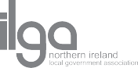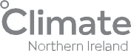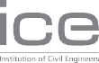translink.co.uk

Across the 11 council areas, the Northern Ireland Local Government Association (NILGA) knows that the pandemic has heightened the focus on
accessible, quality, sustainable public transport. This will be substantially improved through collaboration across all tiers of government to deliver the transformed transport infrastructure of the future. As we continue to recover, public transport in all areas must play a key role in helping us rebuild our
communities, our local economies and reconnect our people. NILGA, therefore, supports Translink’s vision for the investment in, advancement and further integration of public transport services across each of our 11-member council areas.

Alison Allen NILGA

Translink are taking Climate Action and the role of the transport sector seriously by including Climate Action and setting Science Based Targets to reduce emissions by 50% by 2030 and play a leading role in promoting zero emission transport across NI. This will help transform Northern Ireland supporting the journey to a vibrant low–carbon economy
that values the people and the environment of Northern Ireland, benefitting current and future generations.

Dr Jade Berman Climate NI

The Institution of Civil Engineers shares an aim with Translink to drive infrastructure to Net Zero
emissions at pace and to ensure sustainable, resilient infrastructure and strategic planning longer-term.

Jenny Green ICE Director

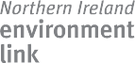Stakeholder Support

Tourism NI welcomes Translink’s ‘Better. Connected’ strategy for public transport as part of a ‘green’ recovery to build towards their Net Zero ambitions in the years ahead. Sustainable public transport will play an increasingly important part of Northern Ireland’s tourism offer as we seek to attract visitors who want to travel easily and sustainably across all parts of the province. We look forward to working in collaboration with Translink in the achievement of their goals that in turn support the further growth of Northern Ireland as a must-see destination.

John McGrillen Tourism NI

NIEL would like to compliment Translink on the very positive and ambitious climate action targets... and welcomes the targets for Translink to be net zero by 2040, climate positive by 2050 and to promote zero emission technology across the transport sector.

Craig McGuicken
NI Environment Link

- 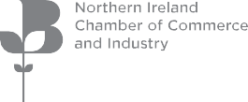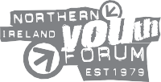Better.Connected

Investment in public transport has an important role to
play in economic growth. NI Chamber is therefore very supportive of Translink’s vision for an advanced, integrated public transport network which supports people and businesses across Northern Ireland.

A vibrant, future-focused economy must be supported by bus and rail infrastructure, which is accessible, reliable and supports climate action goals. ‘Better.Connected’ sets out the kind of public transport network businesses and potential investors need to support their aspirations – actioning the plan as quickly as possible is strategically important for the region as a whole.

Ann McGregor NI Chamber

Sustrans welcomes Translink’s commitment to Climate Positivity in the years ahead, which requires a modal
shift to sustainable modes. Integrating walking and cycling opportunities with public transport is vital for this transition to protect our environment.

Caroline Bloomfield Sustrans Northern Ireland

COPNI welcomes Translink’s’ new strategy and fully supports the goals and principles set out in the strategy... COPNI welcomes the strategy’s focus on ‘Connecting Communities’. Loneliness and social isolation of older people is a growing source of concern for COPNI. All age groups are affected
by this issue which can have a severe impact on health and wellbeing, with older persons being some of the worst affected.

Evelyn Hoy
CEO to the Commissioner for Older People NI

As Translink Youth Forum members, we look forward to and support the Better. Connected strategy, as we want Northern Ireland to be better connected for all, including young people. It’s important for us as young people to see engagement, community and climate
at the very centre of this strategy. Alongside this, development, innovation and care must also be at the core. As TYF members, we look forward to working alongside Translink to ensure that Northern Ireland becomes better connected.

Lauren McAreavey NI Youth Forum

We welcome the ambitious actions and targets...
of a 50% reduction in current emissions by 2030, net zero by 2040 and to be climate positive by 2050...
As consumers become more environmentally aware and concerned about how their transport choices affect climate change, they are likely to have an increasing appreciation for sustainable transport options.

Noyona Chundur CCNI

- translink.co.uk

Conclusion

Over the next decade, the challenge for transport in NI is formidable. To rise to that challenge, Translink will be committed and consistent. We recognise how fundamental public transport is to the success of NI in so many ways. So, we know we have to deliver the change and improvements needed.

This strategy is an ambitious roadmap, setting out the vital steps and actions to deliver a sustainable mobility network for Northern Ireland. With a clear focus on climate action and air quality, it puts sustainability at the heart of decision making.

Public transport brings people and communities together and creates opportunities and choices which will be vital to make our region economically competitive, socially inclusive and renowned as one of the top locations in Europe for sustainable transport.

A better and connected NI depends upon the successful delivery of this strategy.





