ID
FOR RAIL TICKET OFFICE USE ONLY

NI Railways Station Name: Date Received:
Ref No:

Staff Signature/Staff No:
College/University Card Letter
Photo ID

Payment Method
(£6 replacement card only)

Credit/Debit Card Cash
+
student railcard
FOR HEAD OFFICE USE ONLY
Date received: Approved:
Staff signature/Staff No:

Reference No:

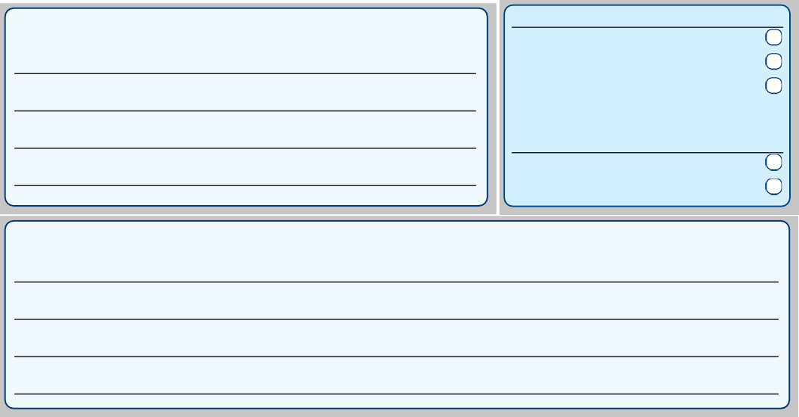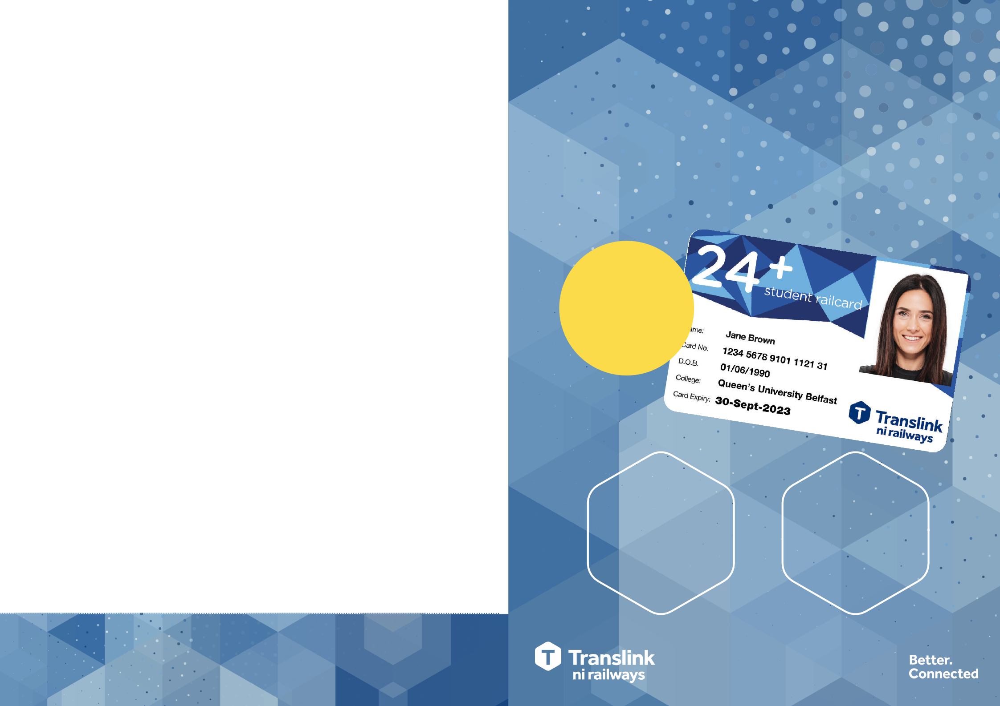Terms & Conditions
24
- 24+ Student Railcard is a Translink smartcard which entitles the card holder to special discounted fares on NI Railways within Northern Ireland and cross border. Translink special services are excluded. No further discount is available on promotional fares. No discounts are available on Translink bus services.
- 24+ Student Railcards cannot be loaded with journeys or periods of travel, it is used to obtain reduced train fares. Without a valid working card customers cannot obtain 24+ Student Railcard discounted fares.
- 24+ Student Railcards are available for all full time students aged 24 years and over in Northern Ireland, the Republic of Ireland and Great Britain. Part time or evening students or those on training courses are not eligible.
- 24+ Student Railcard holders have to re-apply for a new card annually. 24+ Student Railcards remain valid until the expiry date printed on the card.
- 24+ Student Railcards are photo-personalised and are therefore NOT transferable and become invalid if used by another person. Fraud or abuse of a 24+ Student Railcard may result in its withdrawal and / or prosecution of the offender.
- 24+ Student Railcards and corresponding tickets must be retained by the passenger until the rail journey is complete and must be presented if requested by authorised Translink personnel.
- If a 24+ Student Railcard is damaged, lost or stolen the appropriate adult full fare will be charged, and is
non-refundable. Applications for replacements cards can be made in writing to the address below (returning the card if applicable). A replacement card costs £6.00 (subject to change) and Translink will send a new card to you within 7-10 working days.
- If a 24+ Student Railcard is faulty and the ticket machine is unable to read the information stored on the card the appropriate adult full fare will be charged. Applications for replacements cards can be made in writing to the address below returning the card. Translink will test the card and if it is found to be faulty Translink will replace
*T&Cs apply.
the card free of charge and send a new card to you within 2 weeks. If the card is deemed to be damaged and not faulty, a replacement card fee currently £6.00 (subject to change) will be charged. Adult fares purchased whilst the 24+ Student Railcard is being replaced may be refunded up to the valid discount. To apply for a refund, customers should retain and submit any valid adult fare tickets purchased.
- 24+ Student Railcards are subject to Translink’s operating terms and conditions.
- 24+ Student Railcards remain the property of Translink. If lost cards are found they should be returned to the address below.
Translink Pass Office, Floor 1, 22 Great Victoria Street, Belfast, BT2 7LX. 028 9035 4074

FREE CARD

until further notice

1/3
OFF
*
Single, day return, weekly and monthly NIRailways tickets

50%
*
OFF
Enterprise fares

Application Form
24
+
stud
ent railcard
NI Railways travel is even better with a 24+ Student Railcard
If you are 24 years of age or over and in full-time education you can get great savings on NI Railways with a massive 1/3 off single, day return, weekly and monthly tickets plus up to 50% off Enterprise fares.
STUDENT DETAILS (PLEASE PRINT)
Title: Mr Miss Ms
Mrs
Forename(s):

Surname:

Date of Birth:

Postcode:

Address Line 1:

Address Line 2:

Town/City:

County:

Email:

Mobile Number:
(or home phone number including area code if mobile not available)

University/College:

ATTACH PASSPORT PHOTO WITH
PAPERCLIP HERE (PRINT NAME
AND DATE OF BIRTH ON REVERSE)

The 24+ Student Railcard is valid from 1 September until 30 September the following year.

Who can apply?
  - Students aged 24 years or over on a
full-time course in Northern Ireland, the
Republic of Ireland and Great Britain.
x Part-time or evening students or those on training courses are not eligible.

How to get your card?
To get your card fill out the application form on the reverse and take it to your nearest main NI Railways Station. You will also need to bring along the following:
+ 1 colour passport sized photograph (name & date of birth must be written on
the reverse of the photo).
RECEIPT

Reference No: Date received:
+ College/University Photo ID confirming Full-Time Attendance (a registration receipt/
letter from your College/University confirming full-time attendance PLUS a valid passport or driver’s licence will be accepted in the absence of College Photo ID).
+ Proof of age & identity (any one of the following): Birth/Adoption Certificate, Passport,
Driving Licence, Any Student ID Card (which shows DOB), Official Letter from College (which confirms DOB). You will receive your 24+ Student Railcard within 2 weeks. Postal applications cannot be accepted. Remember, you need to get a new card every year.

Always carry your 24+ Student Railcard with you when travelling. Your card must be electronically validated on a ticket machine every time you travel. If you are unable to produce a valid card you will be required to buy a new ticket at the full price and may be liable for prosecution.

DECLARATION BY COLLEGE/UNIVERSITY
(Only to be completed if you are unable to provide College/University ID proving your full-time attendance).
“I declare that the applicant named is a
full-time student attending this College/University for a minimum of one academic year.”
Official Signature: College/University Seal or Stamp:
An email from the College/University proving full time study will also be accepted

Your privacy is important to us. For further information please see Translink’s Privacy Policy:

http://www.translink.co.uk/ Translink-Footer/Privacy- Policy/

Bring your completed form to a main NI Railways train station
To save on bus travel why not get a Smartlink card!

